# Acknowledgments

We thank the authors who agreed to summarise their research into chapters for this publication:

**Alison Anlezark**Manager Advancement Services, University of Adelaide

**Dr Jenny Chesters**  
Lecturer/Research Fellow, MSGE, The University of Melbourne  
Dr Chesters’ research interests include: inequality in educational attainment according to socioeconomic status, transitions between education and employment throughout the life course, and social stratification.

**Emerick Chew**Data Analyst, National Surveys, National Centre for Vocational Education Research

**Dr Grant Cooper**  
Lecturer, School of Education, RMIT

**Dr David D Curtis**  
Principal, Transforming Education (Australia) and Associate Professor (Adjunct) College of Education Psychology & Social Work, Flinders University  
<https://www.flinders.edu.au/people/david.curtis>

**Adjunct Professor Tom Karmel**  
Future of Employment and Skills research centre, University of Adelaide  
Research interest: the link between education and the labour market.

**Dr Helen Law**  
Postdoctoral researcher, Department of Sociology, University of Tübingen  
Dr Helen Law is a postdoctoral researcher in the Department of Sociology at the University of Tübingen. She is a recipient of the Marie Skłodowska-Curie Actions Individual Fellowship from the European Commission. She completed her PhD in sociology at the Australian National University. Her research interests focus on gender differences in educational and occupational choices, educational inequalities and quantitative methods.

**Dr Jung-Sook Lee**  
Senior Lecturer, School of Social Sciences, University of New South Wales  
<https://research.unsw.edu.au/people/dr-jung-sook-lee>

**Professor Philip Parker**  
Deputy Director and Program Lead, Institute for Positive Psychology and Education, Australian Catholic University  
Philip Parker is the Deputy Director of the Institute for Positive Psychology and Education at the Australian Catholic University. His research is on the way psychology and society interact and how this interaction affects people’s life chances. He is particularly interested in educational inequality.

**Associate Professor Francisco Perales**Institute for Social Science Research, The University of Queensland

**Dr Cain Polidano**  
Senior Research Fellow, Melbourne Institute of Applied Economic and Social Research, University of Melbourne  
<https://melbourneinstitute.unimelb.edu.au/staff/research>

**Rasika Ranasinghe**Office of the South Australian Productivity Commission (OSAPC)

**Dr Joanna Sikora**  
School of Sociology, Australian National University

**Dr John Stanwick**Senior Research Fellow, National Research, National Centre for Vocational Education Research

**Domenico Tabasso**  
Technical Office (Economist), Research Department, International Labour Organization  
<https://sites.google.com/site/domtabasso/>

**Associate Professor Wojtek Tomaszewski**  
Research Group Leader, Institute for Social Science Research, The University of Queensland

**Dr Ning Xiang**  
Institute for Social Science Research, The University of Queensland





25 years of LSAY:

Research from the   
Longitudinal Surveys   
of Australian Youth

Edited by Cameron Forrest and Charlotte Scobie

NCVER

LONGITUDINAL SURVEYS OF AUSTRALIAN YOUTH

The views and opinions expressed in this document are those of the author/project team and do not necessarily reflect the views of the   
Australian Government or state and territory governments.

### Publisher’s note

The views and opinions expressed in this document are those of the authors and do not necessarily reflect the views of the Australian Government, state and territory governments or NCVER. Any interpretation of data is the responsibility of the author/project team.

To find other material of interest, search VOCEDplus (the UNESCO/NCVER international database <[http://www.voced.edu.au](http://www.voced.edu.au/)>) using the following keywords: aspirations; attainment; career choice; career guidance; data analysis; educational level; employment; entry into working life; gender; higher education; longitudinal data; longitudinal study; outcomes; outcomes of education and training; participation; pathways; qualifications; school leavers; secondary education; socioeconomic background; survey; tertiary education; transition from education and training to employment; transition from secondary to further education and training; university; VET in schools; vocational education and training; young worker; youth; youth transitions.

P:\PublicationComponents\logos\Social Media\InBug-16px_0.pngP:\PublicationComponents\logos\Social Media\Twitter_blackbox.png

**© Commonwealth of Australia, 2020**

G:\pub_prod\PublicationComponents\logos\Creativecommons\CC BY logo.eps

With the exception of the Commonwealth Coat of Arms, the Department’s logo, any material protected by a trade mark and where otherwise noted all material presented in this document is provided under a Creative Commons Attribution 3.0 Australia <http://creativecommons.org/licenses/by/3.0/au> licence.

The details of the relevant licence conditions are available on the Creative Commons website (accessible using the links provided) as is the full legal code for the CC BY 3.0 AU licence <http://creativecommons.org/licenses/by/3.0/legalcode>.

The Creative Commons licence conditions do not apply to all logos, graphic design, artwork and photographs. Requests and enquiries concerning other reproduction and rights should be directed to the National Centre for Vocational Education Research (NCVER).

This document should be attributed as Forrest, C & Scobie, C 2019, *25 years of LSAY: Research from the Longitudinal Surveys of Australian Youth,* NCVER, Adelaide.

This work has been produced by NCVER on behalf of the Australian Government and state and territory governments, with funding provided through the Australian Government Department of Education, Skills and Employment.

COVER IMAGE: GETTY IMAGES.

ISBN 978-1-925717-37-2

TD/TNC 137.02

Published by NCVER, ABN 87 007 967 311

Level 5, 60 Light Square, Adelaide SA 5000  
PO Box 8288 Station Arcade, Adelaide SA 5000, Australia

**Phone** +61 8 8230 8400 **Email** [ncver@ncver.edu.au](mailto:ncver@ncver.edu.au)   
**Web** <https://www.ncver.edu.au> <<https://www.lsay.edu.au>>

**Follow us:** <https://twitter.com/ncver> <https://www.linkedin.com/company/ncver>

# Foreword

The Longitudinal Surveys of Australian Youth (LSAY) are a series of nationally representative surveys of young people, which follow their transitions from compulsory schooling to post-school education and into employment. The survey program is administered by the National Centre for Vocational Education Research (NCVER) on behalf of the Australian Government Department of Education, Skills and Employment.

LSAY commenced in 1995 and follows over 10 000 young Australians from each of six cohorts from the ages of 15 to 25. As one of the few longitudinal surveys in the world with multiple cohorts, LSAY gives researchers and policymakers insight into the diverse pathways taken by young people in Australia and how these have changed over time.

This publication presents research highlights from the past 25 years of the LSAY program, with a focus on schooling, VET in schools programs, the influences of socioeconomic status and demographics on later opportunities, and pathways taken from school into further education and the workforce. This publication is not an exhaustive reflection of LSAY’s long research history but aims to showcase the value of the data. Research has been chosen to demonstrate the broad utility of LSAY, and we are grateful to the authors both within and outside NCVER for agreeing to showcase their research.

More than 300 studies have been published using LSAY data, and an additional 2400 studies have cited work published under the LSAY research program. Interest in LSAY data continues to increase, with 2018 and 2019 setting consecutive records for numbers of applications from prospective researchers.

The past two and half decades of LSAY research have generated a wealth of interesting, insightful, and sometimes surprising findings. With the newest cohort incorporating even more diverse modules about life experiences and the issues facing those making the transition from secondary school through to employment, LSAY continues to be an invaluable resource for learning about the experiences of young people in Australia.

Simon Walker  
Managing Director, NCVER

# Executive summary

## *25 years of LSAY: Research from the Longitudinal Surveys of Australian Youth*

### Edited by Cameron Forrest and Charlotte Scobie, NCVER

The Longitudinal Surveys of Australian Youth (LSAY) are a series of nationally representative surveys of young people that follow their transitions from compulsory schooling to post-school education and employment. The program has been conducted since 1995 and comprises six separate cohorts of more than 10 000 young Australians each.

LSAY aims to understand the lives of young people, and as a longitudinal dataset spanning more than 25 years, it provides detailed information relating to the transitions and pathways of young people. Survey items focus on education, employment, and changes in life circumstances as young people leave school and prepare to enter the work force.

The content of the LSAY datasets can be loosely organised into four major areas:

* Demographics, such as gender, country of birth, indigeneity, socioeconomic status, and parents’ education and occupation levels
* Education, including school characteristics, subject choice, post-school plans, higher education, and vocational education and training (VET)
* Employment, including hours worked, wages and benefits received, job-seeking methods, and job satisfaction
* ‘Social’, which broadly includes living arrangements, marital status, financial difficulties, volunteering activities, and life satisfaction.

This is by no means an exhaustive list. A complete record of all LSAY items can be found in the online dictionary and variable listing (<https://www.lsay.edu.au/publications/user-support-and-documentation>).

Table 1 summarises the characteristics of the samples comprising the LSAY program. To date, there have been six LSAY cohorts: the first began in 1995 and is referred to as Y95; further cohorts commenced in 1998, 2003, 2006, 2009, and 2015. These are referred to as Y98, Y03, Y06, Y09, and Y15 respectively. The Y95 and Y98 cohorts were drawn from representative samples of Year 9 students, with an average age of 14.5 years. Since 2003, LSAY participants have commenced the program at age 15 years, when they participate in the Programme for International Student Assessment (PISA) while at school. Respondents are then interviewed once per year for a further 10 years, taking part in their final surveys at age 25.

LSAY is recognised as one of Australia’s eight core national longitudinal data sets (Department of Social Services 2016). As one of the few longitudinal surveys in the world with multiple cohorts, LSAY gives researchers, policymakers, and those with an interest in youth issues insight into the diverse pathways taken by young people in Australia. Further detail concerning the history and structure of the LSAY program is provided by Moore and Semo (2019).

Table 1 Cohorts of the LSAY

|  |  |  |  |  |  |
| --- | --- | --- | --- | --- | --- |
| **Cohort abbreviation** | **Cohort description** | **Survey period** | **Age when first surveyed** | **Age range during survey period** | **Sample size in initial year** |
| Y95 | Attended Year 9 in 1995 | 1995–2006 | 14.5 years | 14.5–25.5 years (average) | 13 613 |
| Y98 | Attended Year 9 in 1998 | 1998–2009 | 14.5 years | 14.5–25.5 years (average) | 14 117 |
| Y03 | Aged 15 and participated in PISA | 2003–13 | 15 years | 15–25 years | 10 370 |
| Y06 | Aged 15 and participated in PISA | 2006–16 | 15 years | 15–25 years | 14 710 |
| Y09 | Aged 15 and participated in PISA | 2009–19 | 15 years | 15–25 years | 14 251 |
| Y15 | Aged 15 and participated in PISA | 2015–25 (ongoing) | 15 years | 15–25 years | 14 530 |

### 25 years of LSAY

This publication presents research highlights from the past 25 years of the LSAY program. LSAY data have proven especially valuable to policy-oriented research focusing on youth transitions, from school to further education and the labour force. The six cohorts have also allowed for investigations of changes in youth circumstances over time, providing insight into the social and economic contexts that affect successful transitions into adulthood.

In late 2018, the National Centre for Vocational Education Research (NCVER) identified the previous research that best demonstrated the broad coverage of the LSAY data. The authors of those studies were invited to submit summaries for inclusion in this publication.

A total of 14 submissions have been organised into the following six sections:

* Research using LSAY: reflections from Tom Karmel
* Socioeconomic status and family background
* VET in schools
* School experiences, maths, and expectations of enrolling in university
* Employment and post-school outcomes
* An overview of school-to-work transitions.

### Research using LSAY: reflections from Tom Karmel

The first section is written by Dr Tom Karmel who served as Managing Director of NCVER from 2002 to 2013, during which time he was involved in 10 pieces of research using LSAY data. In describing these studies, the chapter demonstrates the varied uses of the LSAY data and serves as exposition for the chapters that follow.

Findings from selected studies showed:

* Undertaking VET programs in Year 11, but not continuing to Year 12, had a positive effect on post-school outcomes for girls in particular
* Apprenticeships are more likely to be undertaken by young men who are less academically inclined and from lower socioeconomic backgrounds
* Completing Year 12 is not generally sufficient for young people in terms of later employment and wellbeing outcomes, and further study is required for the best paths to success
* Young people with more education, ability, and experience have more opportunities to move to high-skilled jobs, while females and part-time workers are more likely to remain in low-skilled jobs
* Intentions to complete Year 12 are most strongly associated with academic performance, immigration background, and parental expectations
* Students whose parents want them to attend university are 11 times more likely to plan to attend university, and four times more likely to plan to complete Year 12
* After controlling for tertiary entrance ranks (TERs), the school attributes with the strongest influence on later university attendance are sector, socioeconomic make-up, and proportion of students from non-English speaking backgrounds
* Students from low socioeconomic backgrounds benefit more from attending high quality schools than students from high socioeconomic backgrounds.

### Socioeconomic status and family background

The second section of this publication consists of three chapters, which collectively demonstrate the utility of LSAY in allowing researchers to assess the effects of student demographics on later academic and labour market success.

The first chapter, *Student insights, trajectories and equity considerations* written by Dr Grant Cooper, summarises a study published in 2018 that used LSAY data to investigate the extent to which demographic factors predict participation in science subjects among students over the age of 16 years. The main findings were:

* Higher socioeconomic status and coming from a foreign or first-generation background had positive effects on participation in science subjects
* Indigenous students were less likely to participate in science subjects
* When controlling for other factors, gender had a non-significant effect on participation in science subjects.

The second chapter, *Inequality in higher education and labour market benefits for young Australians*, is written by Dr Jung-Sook Lee. It summarises a study published in 2014 that used LSAY data to investigate the influence of family background on the likelihood of attaining a university degree, as well as the labour market benefits of tertiary education. The main findings were:

* University degrees result in higher income growth rates, with no effect on weekly pay at age 22 years, but higher weekly pay by age 25
* Compared with Year 12 completion, obtaining a university degree improved mean annual income at age 25 by about $7 000 for men and $10 000 for women
* University ‘prestige’ had a significant effect on occupational prestige, but not income
* Young people who studied health-related disciplines had the highest income and occupational prestige, while the lowest was among those who studied arts, humanities, and social sciences
* Young people whose parents had university degrees and higher occupational prestige were more likely to obtain a university degree themselves.

The third chapter, *Associations between educational attainment and both family and school SES* written by Dr Jenny Chesters, summarises a study published in 2019 that used LSAY data to assess whether resources in the school environment can compensate for a lack of resources in the home environment. The main findings were:

* Both student and school socioeconomic status were positively associated with academic achievement at age 15 years and likelihood of enrolling in a bachelor degree
* Students from low socioeconomic backgrounds had higher levels of academic achievement at age 15 years if they attended high-socioeconomic schools
* Students from high socioeconomic backgrounds were only half as likely to enrol in a bachelor degree if they attended a low-socioeconomic school, as compared with attending a high-socioeconomic school.

### VET in schools

The third section of this publication comprises two chapters, which together showcase the capacity for LSAY researchers to explore early involvement in vocational education and training. The first chapter, *Student transfer between VET and higher education*, is written by Dr David Curtis. It summarises a study published in 2006 that used LSAY data to investigate rates of student transfer between the vocational and higher education sectors. It then makes an additional contribution by revisiting those analyses using 2016 LSAY data, to determine whether rates of inter-sectoral transfer have changed over time. The main findings were:

* Most students undertake only one post-school program, but those who undertake a second program are most likely to do so in the same sector as the first
* While participation rates in both VET and higher education increased between 2006 and 2016, rates of transfer between sectors remained similar
* Transfers from VET to higher education typically involve students moving from lower level qualifications to higher level qualifications in the same field.

The second chapter, *Initial outcomes from VET in Schools programs in Australia*, is written by Dr Cain Polidano and Domenico Tabasso. It summarises a study published in 2014 that used LSAY data to estimate the education and employment outcomes for participants in VET in Schools programs, in their first year after leaving school. The main findings were:

* Participation in VET in Schools programs resulted in 14% higher rates of school completion
  + It was also associated with lower rates of enrolment in higher education, and higher rates of participation in VET courses at certificate III level and above, in the first year out from school
* VET in Schools programs with workplace learning components yielded higher rates of full-time employment, being in a job that the participant would like as a career, and higher income ($25/week) in the first year out from school.

### School experiences, maths, and expectations of enrolling in university

The fourth section of this publication comprises three chapters that examine the effects of school experiences and beliefs about one’s abilities on later educational pathways. The first chapter, *Schools and career guidance key to widening university participation*, is written by A/Prof Wojtek Tomaszewski, A/Prof Francisco Perales and Dr Ning Xiang. It summarises a study published in 2017 that used LSAY data to investigate the roles of socioeconomic background, school experiences, and career guidance on university enrolment. The main findings were:

* Students from low socioeconomic backgrounds were less likely to enrol in university than students from high socioeconomic backgrounds by age 25 (35% vs. 64%)
* Good student-teacher relationships, a positive learning culture, and some forms of career guidance increase the likelihood of students from all backgrounds enrolling in university
* The effects of student-teacher relationships and talks from career advisors on university enrolment were greater for students from lower socioeconomic backgrounds.

The second chapter, *The underrepresentation of women in maths-intensive fields of study* written by Dr Helen Law, summarises a study published in 2018 that used LSAY data to examine the influence of occupational expectations and self-assessed maths competence at age 15 on subject choice in Year 12 and later participation in maths-intensive bachelor degrees. The main findings were:

* Men were about four times more likely than women to choose a maths-intensive bachelor degree program
* 25% of men expected a maths-intensive career when they were 15 years old, compared with 7% of women
* The gender gap in enrolling in a maths-intensive university course could be reduced by about 28% if women were as likely as men to expect maths-oriented careers, to have the same level of confidence in their maths competence while at school, and to take advanced maths and physical science subjects in Year 12.

The third chapter, *Juxtaposing maths self-efficacy and self-concept as predictors of long-term achievement outcomes*, is written by Dr Philip Parker. It summarises a study published in 2014 that used LSAY data to investigate the roles that mathematics self-efficacy and self-concept have on later academic achievement and course selection. The main findings were:

* Mathematics self-concept and self-efficacy were both predicted by academic achievement
* Even when controlling for prior achievement, both mathematics self-concept and self-efficacy predicted university entrance scores
* Mathematics self-efficacy was a significant predictor of university entry, and mathematics self-concept was a significant predictor of choosing to participate in a university course with a focus in science, technology, engineering or mathematics (STEM).

### Employment and post-school outcomes

The fifth section of this publication contains four chapters that have a particular focus on employment and other labour market outcomes. The first chapter, *Adolescent occupational expectations*, is written by Dr Joanna Sikora. It draws on several studies, published between 2011 and 2018, that have used LSAY data to investigate the influences of educational plans, occupational plans, gender, and socioeconomic background on later outcomes. The main findings were:

* 56% of boys and 66% of girls planned to become professionals at age 15 years, both of which are significantly higher than the actual proportions observed in the adult population
* More than one quarter of participants had failed to achieve their occupational expectations at age 15 years by the time they were 25 years old, with similar proportions failing to realise their expectation of completing university
* Students from lower socioeconomic backgrounds were more likely to downwardly adjust their educational and occupational expectations over time
* Occupational uncertainty at age 15 increased the likelihood of occupational uncertainty at age 22 by 45%
* The gender gap in expectations of STEM careers remained relatively stable between 1999 and 2015, with computing, engineering, and mathematics appealing to relatively few young women
* Females were less likely than males to retain career plans concerning computing and engineering (19% vs. 32%).

The second chapter, *Who takes a gap year and why?* written by Dr John Stanwick, summarises a paper published in 2012 that used LSAY data to investigate the incidence, predictors, and outcomes of gap-year taking. The main findings were:

* Incidence of gap-year taking has increased between 1999 and 2009, from 10% of school leavers to 24%
* There was a greater occurrence of gap-year taking among respondents who were employed in Year 12, with little difference between males and females
* About half of gap-year takers worked during their gap year, while as many as 25% reported some form of non-university study
* Gap-year takers appear to still be ‘catching up’ to students who do not take a gap year by age 24 years, with 12% fewer completing their course and 11% more still studying their first university course by then.

The third chapter, *Does combining school and work affect school and post-school outcomes?*, is written by Alison Anlezark. It is based on a report published in 2011 that used LSAY data to explore the effects of combining school and work on young people, and the extent to which students who work are able to manage competing demands. The main findings were:

* Almost half of all students in Years 9 through to 12 combined part-time work and school, with slightly higher rates for females
* Those students who worked while at school did so for 11 to 12 hours per week on average
* Working for more than 15 to 20 hours per week while at school had a negative impact on school and post-school study outcomes
* Working for around five hours per week while at school had a positive impact on post-school full-time employment.

The fourth chapter, *Young people not in education, employment or training (NEET)* written by Dr Cameron Forrest, is based on a report published in 2017 that used two cohorts of LSAY data to investigate the incidence, predictors, and outcomes of being persistently not in education, employment, or training. The main findings were:

* On average, respondents spent two to four months in the NEET state between ages 15 and 24; this was used as further justification to consider only those periods which were six months or longer to be problematic
* The main demographic factors associated with persistent NEET periods of six months or longer were having children and Year 12 non-completion
* Respondents who were persistently NEET as teenagers were between 3 and 5 times more likely to experience persistently NEET periods in adulthood.

### School-to-work transitions

The final section of this publication comprises one chapter, written by Rasika Ranasinghe and Emerick Chew. It uses sequence analysis to identify the different types of pathways young people take in the transition from school to the labour force. The main findings were:

* Young peoples’ transitions could be categorised into five main pathways: higher education and work, early entry to full-time work, a mix of higher education and VET, mixed and repeatedly disengaged, and mostly working part-time
* The second pathway, which included those respondents who engaged in VET as an early route to employment, yielded the highest rates of employment by age 25 years (97.4%)
* The fourth pathway, which was characterised by labour market churning and repeated disengagement, was associated with low socioeconomic status and low mathematics achievement.

## Summary and the future of LSAY

Since 1995, LSAY has provided a rich data source on the pathways of young Australians. In this collection of papers, we present research highlights spanning two decades of LSAY’s history. Although the ‘core’ LSAY data record academic- and employment-related outcomes, wider research interest has been facilitated by the inclusion of detailed demographic information, as well as topics such as participation in VET in Schools programs, career advice and aspirations, subject choice, gap years, and NEET periods, among many others.

While the studies summarised in the following 14 chapters highlight these strengths, they represent only a small fraction of the research interest in LSAY during the past two decades. As of November 2019, some 345 studies have been published using LSAY data, while an additional 2458 studies have cited work published under the LSAY research program that ran from 1995 to 2013. It is not an exaggeration to state that research interest in LSAY has never been higher. Consecutive records were set in 2018 and 2019 for requests from prospective researchers to access LSAY data. Multiple users have expressed their desire to see the program extended beyond the age of 25 years to enable even longer-term analyses.

As a retrospective celebration of more than 25 years of LSAY’s research history, what is largely missing from these highlights is a discussion of current directions. The latest LSAY cohort, Y15, saw the introduction of several new topics, aimed at measuring soft skills, personality, wellbeing, caring duties, ‘gig’ work, homelessness, social support, as well as an expanded focus on volunteering and other topics. For the first time, LSAY data will be linked with administrative VET records, with additional linkages planned for the National Assessment Program – Literacy and Numeracy (NAPLAN), senior secondary results, and higher education. A recently completed series of consultations with data users identified several other emerging areas of research interest, and NCVER will continue to consult with data users on future directions for the survey.

The LSAY program has a long and proud research history, but the future promises to be brighter still.

## References

Department of Education 2016, *A Review of the Longitudinal Surveys of Australian Youth*, Commonwealth of Australia, Canberra.

Moore, J & Semo, R 2019, ‘An introduction to the Longitudinal Surveys of Australian Youth (LSAY)’, *Longitudinal and Life Course Studies*, vol.10, no.10, pp. 109-23.

Contents

Acknowledgments 1

Foreword 6

Executive summary 7

Tables and figures 16

Research using LSAY: reflections from Tom Karmel 19

Section 2: Socioeconomic status and family background 28

Student insights, trajectories and equity considerations: using the LSAY to examine demographic predictors of participation in senior secondary science 30

Inequality in higher education and labour market benefits for young Australians 34

Associations between educational attainment and both family and school SES 40

Section 3: VET in Schools 45

Student transfer between VET and higher education 46

Initial outcomes from VET in Schools programs in Australia 56

Section 4: School experiences, maths, and expectations of enrolling in university 63

Schools and career guidance key to widening university participation 64

The underrepresentation of women in maths-intensive fields of study: the role of teenage occupational expectations, self-assessed maths competence and subject choice in Year 12 69

Juxtaposing maths self-efficacy and self-concept as predictors of long-term achievement outcomes 75

Section 5: Employment and post-school outcomes 79

Adolescent occupational expectations: two decades of LSAY-based research 80

Who takes a gap year and why? 87

Does combining school and work affect school and post-school outcomes? 92

Young people not in education, employment or training (NEET) 103

Section 6: An overview of school-to-work transitions 109

School-to-work transitions: untangling the pathways 110

# Tables and figures

## Tables

1 Cohorts of the LSAY 8

2 Descriptive statistics 31

3 Results of logistic regression predicting students’ participation in a science subject 32

4 The effects of the prestige of universities and fields of study on log gross weekly pay and occupational prestige among young people 37

5 Family background predicting the selection of universities 38

6 Family background predicting fields of study 38

7 Effects of student SES and school SES on PISA scores 42

8 Likelihood of enrolling in a bachelor’s degree according to student SES and school SES 43

9 Percentages of the Y95 cohort undertaking post-school programs, both first and subsequent 48

10 Unemployment rates and apprenticeship commencements by selected age groups, 2006−16 50

11 Trends in tertiary education commencements, 2006−16 51

12 Frequencies of students’ first post-school study programs for the LSAY Y06 cohort 53

13 Estimates of transfers between VET and higher education for the LSAY Y06 cohort 53

14 Sample of analysis 57

15 Student characteristics by gender: proportions and means 71

16 Factors affecting enrolment in maths-intensive university degree programs: (1) coefficients from logit models and (2) percentage of the gender gap explained 72

17 Percentage of the gender gap in the choice of a maths- intensive major explained by each factor: the KHB method 72

18 Model results: adjusted for covariates 77

19 Gap-year taking over time by study status (%) 88

20 The main activities of gap-year takers at average age of 18.7 years, 2006−07 and 2009−10 89

21 Percentage of respondents working in each school year level, Y03, 2003–07 95

22 Summary statistics of working and working hours by year level, Y03 cohort 95

23 Average hours worked in Year 12 by student characteristics, by gender 96

24 Predicted probability of Year 10 to Year 11 retention by hours worked in Year 10 97

25 Predicted probability of Year 11 to Year 12 retention by hours worked in Year 11 97

26 Mean TER scores by hours worked in Year 12, males 98

27 Mean TER scores by hours worked in Year 12, females 98

28 Significant predictors of persistently NEET periods between ages 20 and 24 107

29 Average marginal effects on pathway outcomes. Change in the probability of following a certain pathway for a given characteristic compared with the reference category 119

## Figures

1 Percentage of 15 to 19-year-olds and 20 to 24-year-olds in full-time education (1986−2018) 19

2 Estimated growth of gross weekly pay by education 35

3 Estimated growth of occupational prestige by education 36

4 Probabilities of attaining a bachelor’s or higher degree by parental degree and parental occupational prestige 37

5 Association between student SES and school SES 41

6 Education outcomes of VET in Schools programs in the first year out from school compared with outcomes of ‘matched’ comparison groups 59

7 Labour market outcomes of VET in Schools programs in the first year out from school compared to outcomes of ‘matched’ comparison groups 60

8 Job outcomes of VET in Schools programs in the first year out from school compared with outcomes of ‘matched’ comparison groups for those full-time employed 61

9 University enrolment rates by socioeconomic background 66

10 University enrolment rates by school factors 67

11 Key factors that may influence a student’s chance of choosing a maths-intensive university major 70

12 Simplified hypothesised model 76

13 Occupational plans LSAY Y09 81

14 Prevalence of talent loss in LSAY Y98 82

15 Occupational uncertainty LSAY Y06 83

16 Gender gap in science-related career expectations 84

17 Stability of science-related career expectations LSAY Y06 85

18 Proportion of 15 to 19-year-olds at school who are employed, August 1986–2008 94

19 Predictive probability of undertaking further study by hours worked in Year 12 99

20 Predictive probability of post-school employment by hours worked in Year 12 100

21 Factors considered in the derivation of NEET status 104

22 Size of the NEET groups (ages 15−24) in Y03 and Y06 across the full survey period 105

23 Size of the NEET groups (ages 15−19) in Y03 and Y06 between waves 1 and 5 105

24 Visualising the pathways 114

Pathway 1: Higher education and full-time work   
(60% of the sample) 114

Pathway 2: Early entry to full-time work   
(23% of the sample) 115

Pathway 3: Mix of higher education and VET  
(8% of the sample) 116

Pathway 4: Churning and NILF (5% of the sample) 117

Pathway 5: Mostly working part-time (4% of the sample) 118

# Research using LSAY: reflections from Tom Karmel

*Tom Karmel was Managing Director of NCVER from 2002 to 2013*

Twenty five years of the Longitudinal Surveys of Australian Youth (LSAY) is worth celebrating, but it is also worth reflecting that longitudinal surveys of Australian youth go back far longer (see Karmel 2013). There have been four such surveys, beginning with the Youth in Transition Survey (YITS), conducted by the Australian Council for Education Research (ACER) and followed by the Australian Longitudinal Survey (ALS, the responsibility of the short-lived Bureau of Labour Market Research), the Australian Youth Survey (AYS) and, finally, LSAY, currently managed by the National Centre for Vocational Education Research (NCVER) and previously by ACER.

The motivation behind the creation of this collection of surveys was the rapid increase in the unemployment rate in the 1970s as a result of two oil price shocks. Young people bore the brunt of the economic downturn, given that they were the new entrants or aspiring entrants into the labour market. Prior to this, the transition from school to the labour market was not much of an issue for the simple reason that jobs for school leavers were easy to obtain. There were multiple entry paths into apprenticeships, banks, the public service and so on. Year 12 completion was not necessary for entry into many of these pathways.

Figure 1 Percentage of 15 to 19-year-olds and 20 to 24-year-olds in full-time education (1986−2018)

Source: Australian Bureau of Statistics (2019).

From the introduction of the longitudinal youth surveys, transitions have been of high policy importance. The labour market continues to evolve, and there is no reason to believe that this will not continue to be the case. Associated with this change, educational participation continues to increase, with full-time education becoming the dominant activity of 15 to 19-year-olds and increasingly important for 20 to 24-year-olds (see figure 1).

These changes have brought various policy challenges relating to groups who are educationally disadvantaged. While there is no doubt that the better-educated are more successful in the labour market, it is not so clear that increasing levels of educational participation have benefited those who are educationally disadvantaged. In addition, it may be the case that increasing education participation in higher education will have implications for vocational education and training (VET).

It is these issues that make LSAY such an important resource. Three aspects underpin its utility:

* a rich characterisation of the social and economic background of young people
* measures of academic achievement at age 15 years obtained from the Programme for International Student Assessment (PISA)
* observations over time that enable analyses of pathways and transitions.

In addition, LSAY contains school-level data, which allow for the analysis of the impact of schools on outcomes. I should also add that the introduction of new cohorts has enabled the analysis of the impact of policy and structural changes on youth transitions.

I was involved in some 10 pieces of research, dating back to 2006, and will spend the rest of this short paper summarising the findings. I group the research into four areas:

* VET
* pathways
* aspirations and social capital
* the impact of schools.

## Vocational education and training

The first paper, *Have school vocational education and training programs been successful?* (Anlezark, Karmel & Ong 2006), looked at a policy initiative promoting VET programs at school as a way of engaging those who were not so academically inclined. It focused on the outcomes in terms of Year 12 retention or full-time engagement with employment or learning, or part-time employment together with part-time study. The main findings were:

* Participation in school VET programs had a positive effect on Year 10 to Year 11 retention but a negative effect on Year 11 to Year 12. Overall, the effect on Year 10 to Year 12 retention was negative but the magnitude was too small to be of any significance.
* There was a clear positive impact (larger for girls) on post-school outcomes for students undertaking VET programs in Year 11 but not going on to Year 12. It appears that the VET programs enabled some students to engage with the world of work very successfully, such that they did not return to school for Year 12.
* VET in Schools programs provide a clear vocational pathway for boys studying building and engineering. However, for other students the pathways were not so direct, with different types of VET studied inside and outside the school environment.

The paper raised two policy questions:

* Should school VET programs be offered in Year 10 rather than being concentrated in Years 11 and 12?
* Should school VET programs be better aligned with the world of work or, alternatively, concentrate on broad prevocational skills?

The second and third papers on this topic have elements in common, in the sense that they deal with interactions between VET and traditional academic education. The first of these, *The vocational equivalent to Year 12* (Lim & Karmel 2011), addressed an issue of high policy relevance as governments promoted school retention. It had been recognised that traditional academic schooling was not attractive to a substantial section of the cohort who were being encouraged to complete schooling. Hence the notion emerged that there needed to be a ‘vocational equivalent to Year 12’. The two qualifications mooted were a certificate II or a certificate III. The paper focused on outcomes by age 25 years − further study and full-time employment − with the premise that qualifications could be considered equivalent if they have similar outcomes. Rather than compare outcomes for all students, the study compared those undertaking vocational qualifications with those completing Year 12 who had either no tertiary entrance rank (TER) or were in the lower half of the tertiary entrance rank distribution. This was done on the basis that the vocational alternative was typically promoted for the less academically inclined.

The findings challenged the notion of a vocational equivalent:

* For males, all pathways (including early school leaving with no further VET study) were equivalent to Year 12 completion in terms of employment outcomes. This suggests that equivalence has no meaning in this context.
* For females, certificate IIIs, but not certificate IIs, were equivalent in terms of full-time employment or study.
* In terms of further study outcomes, neither certificate IIs nor IIIs were equivalent to completing Year 12.

The conclusion is that vocational pathways must be considered as an alternative not a literal equivalent. However, if governments require a ‘vocational equivalent’ for rhetorical purposes, it should be at least certificate III level.

The third paper, *The impact of increasing university participation on the pool of apprentices* (Karmel, Roberts & Lim 2014), was written at a time when university participation was growing strongly following the *Bradley review* (Bradley et al. 2008). Maintaining the strength of the apprenticeship systems has been a long-standing aim of all Australian governments, and the motivation behind the research was to test an argument that increasing participation at university could quite possibly attract students who otherwise would have been apprentices. The paper compared two cohorts from LSAY, the first in Year 9 in 1995 and the second aged 15 years in 2006. Thus, the cohorts were approximately 10 years apart, over which period university participation had increased substantially. The controls used for the analysis (restricted to young men) were reading and mathematics at age 15 and socioeconomic status. The main findings were:

* Young men are less likely to undertake an apprenticeship if they are academically inclined.
* Apprenticeships are more likely to be undertaken by young men from a lower socioeconomic background.
* The growth in university participation has come from academically lower-performing young men with a higher socioeconomic status.

The conclusion was that the expansion of higher education would have little effect on the ‘quality’ of potential apprentices. However, a further finding was that those in the best position to take advantage of opportunities in both apprenticeship and university places, do so, irrespective of whether the position is measured by mathematics and reading achievement or socioeconomic status − education expansion is of least benefit to those who are disadvantaged.

The final paper, *Socioeconomic disadvantage and participation in tertiary education: preliminary thoughts* (Karmel & Lim 2013), is a little different, being largely concerned with how socioeconomic status should be measured for the purposes of education policy. This is an important issue because much of education policy is directed towards the issue of disadvantage.

Typically, socioeconomic status is measured for practical reasons by the Socio-Economic Indexes for Areas (SEIFA), compiled by the Australian Bureau of Statistics (ABS). LSAY data enable us to compare this area-based measure with a socioeconomic status index based on actual family characteristics, noting LSAY’s very rich bank of socioeconomic variables.

Of some concern is that we find that SEIFA measures are very poor in classifying individuals by socioeconomic status (SES; see also Lim & Gemici 2011). Nevertheless, SEIFA measures perform quite well in measuring the aggregate relationship between socioeconomic status and educational participation.

An implication of SEIFA’s poor classificatory ability is that any policy that targets funding based on SEIFA will result in funds being badly misdirected.

The reason for including this paper under the topic heading of vocational education and training is that, among other things, it exploits the SES measure to examine how well the VET sector serves low-SES students, and includes some work pertinent to the likely effects of expanding higher education.

Some simple tabular analyses indicate that VET does a good job for low-SES individuals and is not overly biased towards lower-level qualifications for this group. In addition, the group most likely to be affected by an expansion in the higher education sector will be those who are not currently undertaking post-school study rather than those who are currently undertaking VET. The paper also observes that SEIFA would be a very poor measure to implement any expansion in higher education aimed at low-SES individuals.

## Pathways

One of the obvious benefits of a longitudinal survey is that it enables pathways to be examined.

*Which paths work for which young people?* (Karmel & Lui 2011) examines whether those who are less academic benefit from completing Year 12 and post-school education and training to the same extent as the more academically inclined. The research looks at the education path chosen, rather than necessarily completed. The interest lies in how the route an individual chooses affects the later employment, wages, job status, financial wellbeing and happiness of young people, based on the 1995 cohort of LSAY.

The analysis suggested that, on average, completing Year 12 is no longer enough; rather, young people today need to have Year 12 plus further study to put them on a path to success. For males, an apprenticeship after Year 12 is an attractive route, as is university study; for females, the best choice is university, even for those with lower levels of academic orientation.

I am not suggesting that everyone should be forced to complete Year 12 and continue to further study. While the best paths involve Year 12 and certain types of post-school study, it is also the case that paths that include Year 12 do not necessarily lead to superior outcomes, relative to those involving leaving school before Year 12. In addition, things are not black and white − the choice of path is not always of consequence. For males, paths only have salience for satisfaction with life, the occupational status of full-time workers and the pay of full-time workers. For engagement with full-time work or study, full-time employment, financial wellbeing, and satisfaction with work, the paths do not really matter. That is, the transition from school to adulthood can work well − in relation to these outcome measures − for young men following any of the paths. For females, educational paths matter for attaining full-time engagement and pay for full-time workers and occupational status for full-time workers, but do not matter for financial wellbeing, satisfaction with life and job status for part-time workers.

The second paper on this topic has a much narrower focus. *Starting out in low-skill jobs* (Karmel, Lu & Oliver 2013) investigates whether a low-skill job can establish a solid foundation for success in the labour market or whether it can have a ‘scarring’ effect on the individuals. In this context low skill is defined as level 4 or 5 of the skill levels allocated by the ABS.

The main findings were:

* Not surprisingly, starting out in a low-skill job yields lower wages than starting out in a higher-skilled job. Five years after leaving full-time education, the wage penalty still exists, but this scarring diminishes over time. However, any job is better than no job: the wage penalty after five years of having no job a year after leaving full-time education is worse than taking a low-skill job.
* Again, not surprisingly, young people who possess high human capital (education, ability and experience) have more opportunities to move to a high-skill job. Males are more likely to make the transition to high-skill jobs than females. Young people who are part-time workers are likely to remain in low-skill jobs, although part-time or casual low-skill jobs can be a positive pathway for young people to progress into full-time or permanent positions.
* There is no evidence to suggest that young people choose to stay in low-skill jobs for positive reasons such as high job satisfaction or relatively high wages.

## Aspirations and social capital

Most would accept that having aspirations and a high level of social capital are important factors behind success in life. From a policy point of view, what counts is how aspirations and social capital can be promoted for those from a disadvantaged background. *The factors affecting the educational and occupational aspirations of young Australians* (Gemici et al. 2014) shows just how important parents and peers are to young people’s aspirations:

* The most influential factors for students’ aspirations for completing Year 12 include their academic performance and immigration background and whether their parents expect them to go to university.
* Students whose parents want them to attend university are four times more likely to plan to complete Year 12 and 11 times more likely to plan to attend university compared with those whose parents expect them to choose a non-university pathway [[1]](#footnote-2).
* The higher education plans of peers also have a strong influence: students whose friends plan to attend university are nearly four times more likely to plan to attend university.
* Two of the strongest predictors of occupational aspirations are parental influences and academic performance.

One interesting finding is that the job aspirations of 15-year-olds are somewhat unrealistic. By age 25 years, the age until which data are available for analysis, a significant portion of young people fall short of what they set out to achieve in terms of occupation.

From a policy point of view the findings throw out a challenge. How can the view of parents with low aspirations for their children be influenced?

In recent times social capital has received considerable attention because it is seen as having the potential to address many of the problems facing modern society, including the poor educational outcomes of considerable numbers of young people. *Social capital and youth transitions: do young people’s networks improve their participation in education and training?* (Semo & Karmel 2011) explores the relationship between social capital at age 15 years and participation in education and training at age 17 years. The issue is whether social capital is yet another factor which advantages the already advantaged, or whether social capital operates separately from family background. We found that:

* Social capital influences educational participation *over and above* the effects of background characteristics such as parents’ education levels, parental occupation, geographic location, cultural background, school sector and academic achievement.
* For both males and females, participation in a diverse range of activities has the greatest influence on participation in education and training, followed by the strength of the relationship students have with their teachers. Increasing rates of participation in sport also increase educational participation for females.

The finding that social capital matters for school education is a very positive one: it implies that activities that promote and encourage engagement at school can go some way to redressing economic and social disadvantage.

## Effect of schools

Most of the research based on LSAY, including all of the papers mentioned above, tends to be at the individual level, with controls pertaining to academic achievement at age 15 years and socioeconomic characteristics. However, LSAY also collects data on a range of school characteristics. This provides the opportunity to disentangle the impact of the school from the characteristics of the student.

*The impact of schools on young people’s transition to university* (Gemici, Lim & Karmel 2013) exploits this feature of LSAY to investigate the impact of schools on tertiary entrance rank and the probability of going to university.

The main findings were:

The attributes of schools *do* matter. Although young people’s individual characteristics are the main drivers of success, school attributes are responsible for almost 20% of the variation in TER.

* Of the variation in TER attributed to schools, the measured characteristics account for a little over a third. The remainder captures ‘idiosyncratic’ school factors that cannot be explained by the available data and that can be thought of as a school’s overall ‘ethos’; no doubt, teacher quality and educational leadership are important here.
* The three most important school attributes for TER are sector (that is, Catholic and independent vs government), gender mix (that is, single-sex vs co-educational) and the extent to which a school is ‘academic’. For TER, the average socioeconomic status of students at a school does not emerge as a significant factor, after controlling for individual characteristics, including academic achievement from the PISA test.
* However, the characteristics of schools do matter for the probability of going to university, even after controlling for TER. Here, the three most important school attributes are the proportion of students from non-English speaking backgrounds, school sector, and the school’s socioeconomic make-up.

The paper also constructs distributions of school performance (in relation to TER and the probability of going to university), which control for individual characteristics. The differences between high-performing and low-performing schools are sizeable. There is also considerable variation within school sectors, with the government sector having more than its share of low-performing schools.

A second paper, *The impact of school academic quality on low socioeconomic status students* (Lim, Gemici & Karmel 2013), builds on the measure of school quality derived in the first paper and explores whether students from low socioeconomic backgrounds benefit to a greater or lesser extent from attending high-quality schools when compared with their more advantaged peers. The main findings were:

* Academic school quality has a considerable differential effect on school completion for those who come from the lowest socioeconomic band. It also has a differential effect for those with low academic achievement at age 15 years.
* A differential effect is also seen in relation to the impact of academic school quality on tertiary entrance rank and the probability of going to university.
* Coming from a high socioeconomic background insulates students from early school leaving, even if they are weak performers and attend a non-academic school.

The conclusion is that the quality of the school matters and that students from a low socioeconomic background benefit even more from attending a school of high academic quality than do those from a high socioeconomic background.

## Final comment

The 10 papers I have covered demonstrate the value of LSAY. Its longitudinal nature, rich set of background characteristics, measures of academic achievement, and collection of school characteristics enable it to be used to address difficult questions. And the coverage of different cohorts over a long time period means that policy and structural changes can be examined. Finally, there is no doubting its policy relevance: all the papers I covered look at issues which matter to policymakers.

In some cases, the findings reinforce what could be described as stylised facts; for example, the importance of socioeconomic status, but in many instances the analysis throws light on issues that we know little about. Some of the findings are surprising, some not. Even in the latter case, this type of analysis using LSAY is very useful because it enables quantification of effects. Something may be blindingly obvious, but it is important to know how important the ‘obvious’ is. The analysis also enables us to tease out relationships. The world is complicated and LSAY enables us to understand some of the complexities. What is true for one group of people may not hold for others.

Some findings may be controversial. For example, I suspect that some people were not pleased with our findings that VET in Schools programs did not increase Year 12 retention or that VET certificates were not equivalent in any useful sense to completion of Year 12. But that is what is interesting about empirical research.

LSAY of course has its limitations. One often highlighted is the extent of sample attrition. My view is that it limits the use of LSAY to underpin estimates of the numbers of people with particular characteristics but does not matter too much for the multivariate analysis of the type with which I have mostly been involved. Conditioning on background characteristics largely looks after the fact that attrition is not random (the less successful tend to drop out from the survey). A second limitation, which is difficult to overcome, is the fact that cohorts are not surveyed after the age of 25 years. What we really want to know is the effect of education and early transitions on adults over their lives, and 25 years old is too young to measure this, especially as the typical length of education continues to increase. Putting that to one side, however, there is no doubt about the utility of the LSAY program. And as I pointed out in Karmel (2013), we will never have found out all there is to know, for the simple reason that each cohort of young people faces an ever-changing world.

## References

Anlezark, A, Karmel, T & Ong, K 2006, *Have school vocational education and training programs been successful?*, NCVER, Adelaide.

ABS (Australian Bureau of Statistics) 2019, *Labour force* (table 3), cat.no.6291.0.55.001, <https://www.abs.gov.au/AUSSTATS/abs@.nsf/DetailsPage/6291.0.55.001Dec%202018?OpenDocument>.

Bradley, D, Noonan, P, Nugent, H & Scales, B 2008, *Review of Australian higher education: final report*, the Bradley review, Department of Education, Employment and Workplace Relations, Canberra.

Gemici, S, Bednarz, A, Karmel, T & Lim, P 2014, *The factors affecting the educational and occupational aspirations of young Australians*, LSAY research report no.66, NCVER, Adelaide, <http://www.lsay.edu.au/publications/2711.html>.

Gemici, S, Lim, P & Karmel, T 2013, *The impact of schools on young people’s transition to university*, LSAY research report no.61, NCVER, Adelaide, <http://www.lsay.edu.au/publications/2541.html>.

Karmel, T 2013, ‘Are we there yet? Overview of the Longitudinal Surveys of Australian Youth’, paper presented at the Longitudinal Surveys of Youth research forum: *Are We There Yet? Youth Transitions in Australia,* 11 April 2013, Sydney, <https://www.lsay.edu.au/publications/search-for-lsay-publications/2619>.

Karmel, T & Lim, P 2013, *Socioeconomic disadvantage and participation in tertiary education: preliminary thoughts*, NCVER occasional paper, NCVER, Adelaide.

Karmel, T, Lu, T & Oliver, D 2013, *Starting out in low-skill jobs*, LSAY research report no.64, NCVER, Adelaide, <http://lsay.edu.au/publications/2649.html>.

Karmel, T & Lui, S H 2011, *Which paths work for which young people?,* LSAY research report no.57, NCVER, Adelaide.

Karmel, T, Roberts, D & Lim, P 2014, *The impact of increasing university participation on the pool of apprentices*, LSAY research report no.67, NCVER, Adelaide, <http://www.lsay.edu.au/publications/2720.html>.

Lim, P & Gemici, S 2011, *Measuring the socioeconomic status of Australian youth*, Technical paper, NCVER, Adelaide, <https://www.voced.edu.au/content/ngv%3A46204>.

Lim, P, Gemici, S & Karmel, T 2013, *The impact of school academic quality on low socioeconomic status students*, LSAY research report no.63, NCVER, Adelaide, <http://www.lsay.edu.au/publications/2640.html>.

Lim, P & Karmel, T 2011, *The vocational equivalent to Year 12*, LSAY research report no.58, NCVER, Adelaide, <http://www.lsay.edu.au/publications/2416.html>.

Semo, R & Karmel, T 2011, *Social capital and youth transitions: do young people’s networks improve their participation in education and training?*, NCVER, Adelaide.

# Section 2: Socioeconomic status and family background

The background characteristics captured within the Programme for International Student Assessment (PISA) and Longitudinal Surveys of Australian Youth (LSAY) are a common source of interest for researchers and policymakers. Having representative data across the 10-year period means that we can identify the pathways taken by students and can therefore provide an evidence base for the creation of policies or programs that can encourage students − or be the base for early interventions.

Socioeconomic status is obtained through questions asked in PISA. This is done by using the Socio-Economic Indexes for Areas (SEIFA) and the PISA Index of Economic, Social and Cultural Status (ESCS).  
  
SEIFA is used by the Australian Bureau of Statistics (ABS, 2018), which explains the indexes as follows:

SEIFA are a set of indexes created from summarising the diverse population, family and household characteristics related to socio-economic advantage and disadvantage collected in the Census of Population and Housing, and provide a ranking of areas in Australia.   
  
The 2016 SEIFA Index of Relative Socio-economic Advantage and Disadvantage (IRSAD) is a general measure of both relative socio-economic advantage and disadvantage at the area level. It uses a range of different Census variables including income, education, employment, occupation and housing characteristics. An area with a low score on this index reflects relatively high levels of socio-economic disadvantage, whilst an area with a high score on this index indicates high levels of advantage …  
  
It is important to remember that indexes are assigned to geographic areas, not individuals. For example, it is possible for a relatively advantaged person to reside in an area which may have a low score on some or all of the indexes. It is also possible for there to be pockets of advantage and disadvantage within a single area.

Lim and Gemici (2011) argued that the measurement of socioeconomic status (SES) has received a great deal of policy attention in Australia in terms of participation in education, as mentioned above, while Karmel and Lim (2013) suggest that, despite performing poorly when classifying individuals by SES, SEIFA measures provide an effective measurement of the aggregate relationship between SES and education participation.

ESCS is defined in the Organisation for Economic Co-operation and Development’s (OECD) glossary as follows:

The Programme for International Student Assessment (PISA) index of economic, social and cultural status was created on the basis of the following variables: the International Socio-Economic Index of Occupational Status (ISEI); the highest level of education of the student’s parents, converted into years of schooling; the PISA index of family wealth; the PISA index of home educational resources; and the PISA index of possessions related to “classical” culture in the family home.

The next three chapters look at the family background or socioeconomic status of students, with a focus on how coming from a lower-SES background influences education pathways.

## References

ABS (Australian Bureau of Statistics) 2018, *Socio-economic advantage and disadvantage, <* [*https://www.abs.gov.au/ausstats/abs@.nsf/Lookup/by%20Subject/2071.0~2016~Main%20Features~Socio-Economic%20Advantage%20and%20Disadvantage~123*](https://www.abs.gov.au/ausstats/abs@.nsf/Lookup/by%20Subject/2071.0~2016~Main%20Features~Socio-Economic%20Advantage%20and%20Disadvantage~123)*>.*

Karmel, T & Lim, P 2013, *Socioeconomic disadvantage and participation in tertiary education: preliminary thoughts*, NCVER occasional paper, NCVER, Adelaide.

Lim, P. & Gemici, S 2011, *Measuring the socioeconomic status of Australian youth,* Technical Paper, NCVER, Adelaide.

OECD (Organisation for Economic Co-operation and Development) 2019, *PISA index of economic, social and cultural status,* Glossary of statistical terms, <https://stats.oecd.org/glossary/detail.asp?ID=5401>.

# Student insights, trajectories and equity considerations: using the LSAY to examine demographic predictors of participation in senior secondary science

*Grant Cooper, RMIT*

*The analysis in this chapter draws on a 2018 journal article by G Cooper, A Berry and J Baglin, ‘Demographic predictors of students’ science participation over the age of 16: an Australian case study’,* Research in Science Education, *DOI: 10.1007/s11165-018-9692-0*.

## Background

Science, technology, engineering and maths (STEM) literacies are viewed by governments, industry and others as crucial to growth, fostering innovation and promoting global competitiveness. There are, however, concerns about disparities between supply and demand in the so-called STEM-labour pipeline (Hobbs, Clark & Plant 2018). As part of the response, education reform has been viewed as one way of addressing the predicted mismatch between STEM labour market demand and domestic supply. Reliable and representative student data are an important ‘resource’ as stakeholders try to address some of the challenges and/or barriers associated with STEM education in Australia and, indeed, globally. The policy and initiatives focusing on the improvement of STEM-education outcomes and participation need to be evidence-based. Data that offer insights into students’ educational and career trajectories, especially longitudinal studies, are an important resource for stakeholders as they implement change. The dataset of interest in this publication is the Longitudinal Surveys of Australian Youth (LSAY). Analysing students’ science participation in senior secondary science, this brief chapter draws on an analysis by Cooper, Berry and Baglin (2018). In this piece of work, Cooper and colleagues used the LSAY data to examine whether, and to what extent, demographic factors predict students’ participation in science over the age of 16 years (post-16). Subject selection during this stage in students’ lives is crucial, given that such choices may have a profound impact on their future pathways.

While there is a lack of space to examine in detail the Cooper, Berry and Baglin (2018) study, the reader is encouraged to access this paper for a more complete discussion on the various components of the study, particularly if they are interested in reading more about science participation in Australia. Here, the findings of the Cooper, Berry and Baglin study are used to demonstrate the potential for LSAY to offer valuable insights into students’ educational and career pathways.

The last two decades have seen considerable declines in the proportion of high school students choosing senior science courses in many post-industrial countries, including Australia (Kennedy, Lyons & Quinn 2014). Commonly, learners perceive that science and science education offer little relevance both to themselves and to the society in which they live (Dillon 2009). Adding to concerns about falling participation rates in science education are the student groups who have traditionally been underrepresented in science, particularly as the year level increases (UNESCO 2017). Such groups include those from low-socioeconomic status (SES) backgrounds (Fullarton et al. 2003; Gorard & See 2009), Indigenous Australians (Dreise & Thomson 2014), and females in the physical sciences (Higgins 2018). Ancestry backgrounds have been associated with a disadvantage in academic achievement in countries such as the USA and parts of Europe, while an immigrant advantage has been observed in countries with selective immigration policies, including Australia and Canada (Akther & Robinson 2014). Cooper, Berry and Baglin (2018) examined four demographic predictors of science participation, including SES, Indigenous status, gender and ancestry/background. The results below are drawn from the 2009 cohort of the LSAY survey (Y09). Y09 was selected because it was the latest publicly available LSAY dataset that aligned with the aim of the study when the project started.

## Results

As shown in table 2, approximately 57% of the study participants were female, while nearly 43% were male. Indigenous students comprised just over 5% of the sample, which is higher than the estimate in the total Australian population (approximately 3%). About 58% of the sample were categorised as Australian-born, nearly one-third were first-generation individuals and the remainder had foreign-born ancestry. Over 7000 students were included in the analysis; the relatively large sample size, which includes participants from across Australia, is a clear strength of the LSAY datasets.

Table 2 Descriptive statistics

|  |  |  |
| --- | --- | --- |
|  | **Frequency** | **Percentage (%)** |
| *Gender* |  |  |
| Female | 4 065 | 57.44 |
| Male | 3 013 | 42.56 |
| *Indigenous status* |  |  |
| Non-Indigenous | 6 716 | 94.88 |
| Indigenous | 362 | 5.12 |
| *Ancestry/background* |  |  |
| Australian-born | 4 151 | 58.64 |
| First generation | 2 274 | 32.13 |
| Foreign-born | 6 53 | 9.23 |
| *Self-reported participation in Science* |  |  |
| Yes | 4 150 | 58.63 |
| No | 2 928 | 41.37 |

Source: Cooper, Berry and Baglin (2018). Reprinted with permission from Copyright clearance center: Springer Nature, Research in Science Education © 2018.

Multiple logistic regression was the technique used for analysis. Odds ratios (OR) are reported in table 3 and measure the degree of association between each predictor and the outcome. This model was statistically significant (*Χ*2(5) = 269.79, *p* < .001). The predictors explained 5% (Nagelkerke *R*2) of the variance in students’ post-16 science participation and correctly classified 60.9% of cases (relative to 58.6% when no independent variables were added).

The results indicated that SES was a significant predictor of students’ post-16 science participation (OR = 1.51). Also, Indigenous students were significantly less likely than non-Indigenous students to report post-16 participation in a science subject (OR = .53). There was however a non-significant difference in the odds of females (compared with males) reporting participation in a science subject (OR = 1.03). Compared with Australian-background students, first-generation students were more likely to report participation in a science subject (OR = 1.35). Furthermore, foreign-background students were also significantly more likely to report participation in a science subject than those from an Australian background (OR = 1.68).

Table 3 Results of logistic regression predicting students’ participation in a science subject

|  |  |  |  |  |  |  |  |  |
| --- | --- | --- | --- | --- | --- | --- | --- | --- |
|  | **B** | **SE** | **Likelihood ratio χ2** | **df** | **p** | **95% CI** |  |  |
|  |  |  |  |  |  | OR | LB | UB |
| SES | .42 | .03 | 147.06 | 1 | <.001\*\* | 1.51 | 1.41 | 1.62 |
| Indigenous | -.63 | .11 | 31.70 | 1 | <.001\*\* | .53 | .42 | .66 |
| Gender1 | .04 | .05 | .50 | 1 | .47 | 1.03 | .94 | 1.14 |
| Aus-bkg2 | - | - | 52.76 | 2 | <.001\*\* | - | - | - |
| Firstgen-bkg | .30 | .05 | - | 1 | <.001\*\* | 1.35 | 1.21 | 1.50 |
| Foreign-bkg | .52 | .09 | - | 1 | <.001\*\* | 1.68 | 1.40 | 2.01 |

*SE* standard error, *CI* confidence interval, *OR* odds ratio, *LB* lower bound, *UB* upper bound, *Aus-bkg* Australian background, *Firstgen-bkg* First-generation background, *Foreign-bkg* Foreign background

\*\*Significant p< .001

1 Female category (relative to male)

2 Reference category.

Source: Cooper, Berry and Baglin (2018). Reprinted with permission from Copyright clearance center: Springer Nature, Research in Science Education © 2018.

The analysis of the LSAY data indicated that being Indigenous was the strongest negative predictor of post-16 science participation in this study. Additionally, as students’ SES status increased, so too did the likelihood of students’ post-16 participation in a science subject. An interesting finding of this study was the non-significant difference in the odds of either gender reporting participation in a science subject. This is a limitation of the study, as the variables used in the model did not allow the researchers to differentiate between different types of science subjects within schools (for example, physics or biology). In subsequent analysis of the Y15 cohort, gender was identified as a significant predictor of science participation at the domain level (Cooper & Berry 2020). For instance, in biology, females are over-represented while in physics, they are under-represented. Similarly, other studies report female underrepresentation in physics subject participation at the senior secondary level (Fullarton et al. 2003; Higgins 2018) and more broadly in other STEM-related subjects (for example, engineering). Differences in ancestry background and science participation were also noted, possibly highlighting the effect of skilled-migration policy, the cultural valuing of science in Australia and/or influences on students’ science participation.

## The value of the LSAY?

The dataset is a secondary data source (that is, the authors did not collect the data in the course of their research) and has what may be viewed as advantages and disadvantages within the context of its use. In relation to the Cooper, Berry and Baglin (2018) study, there were several advantages in using this data set, including its representative scope, the potential to generate new insights, relative ease of access and its free access. Broadly speaking however, it is important to be mindful that stakeholders should be cautious with secondary data source analysis because the data are likely to have been originally collected for different research aims, the data set may be relatively old and there may be limited control over data quality (Cheng & Phillips 2014). None of these were relevant concerns in relation to use of the LSAY dataset.

While a thorough discussion of the results can be found in Cooper, Berry and Baglin (2018), a key message in this chapter is the considerable value of the LSAY initiative. While demographics cannot be changed, the narratives within the LSAY data, together with careful analysis, show a variety of student insights and trajectories. This evidence base is of value to a variety of stakeholders, who may use these data to justify funding decisions, policy changes and/or curriculum initiatives. Consequently, it could be argued that the LSAY initiative has significant potential to promote notions of fairness and inclusion in schools, important elements worth advancing in our education system and beyond.

## References

Akther, A & Robinson, J 2014, ‘Immigrant students’ academic performance in Australia, New Zealand, Canada and Singapore’, Joint AARE-NZARE 2014 Conference, Brisbane, 2014, <http://www.aare.edu.au/publications-database.php/9559/immigrantstudents-academic-performance-in-australia-new-zealand-canada-and-singapore>.

Cheng, H G & Phillips, M R 2014, ‘Secondary analysis of existing data: opportunities and implementation’, *Shanghai Archives of Psychiatry*, vol.26, no.6, pp. 371-375.

Cooper, G & Berry, A 2020, ‘Demographic predictors of senior secondary participation in biology, physics, chemistry and earth/space sciences: students’ access to cultural, social and science capital’, *International Journal of Science Education*, vol.42, no.1, pp. 151-166, DOI: 10.1080/09500693.2019.1708510.

Cooper, G, Berry, A & Baglin, J 2018, ‘Demographic predictors of students’ science participation over the age of 16: an Australian case study’, *Research in Science Education*, DOI: 10.1007/s11165-018-9692-0.

Dillion, J 2009, ‘On scientific literacy and curriculum reform’, *International Journal of Science Education*, Part B, vol.4, no.3, pp.201−13.

Dreise, T & Thomson, S 2014, ‘Unfinished business: PISA shows indigenous youth are being left behind’, Australian Council for Educational Research, <http://research.acer.edu.au/cgi/viewcontent.cgi?article=1037&context=indigenous\_education>.

Fullarton, S, Walker, M, Ainley, J & Hillman, K 2003, *Patterns of participation in Year 12*, LSAY research reports, no.33*,* Australian Council For Educational Research, Camberwell, Vic., <http://research.acer.edu.au/lsay\_research/37/>.

Gorard, S & See, B 2009, ‘The impact of socio-economic status on participation and attainment in science’, *Studies in Science Education*, vol.45, no.1, pp.93−129, <https://doi.org/10.1080/03057260802681821>.

Higgins, J 2018, ‘Why not physics? A snapshot of girls’ uptake at A-level’, an Institute of Physics report, <https://www.iop.org/publications/iop/2018/file\_71495.pdf>.

Hobbs, L, Clark, J C & Plant, B 2018, ‘Successful students − STEM program: teacher learning through a multifaceted vision for stem education’, in R Jorgensen & K Larkin (eds), *STEM education in the junior secondary: the state of play*, Springer, Singapore.

Kennedy, JP, Lyons, T & Quinn, F 2014, ‘The continuing decline of science and mathematics enrolments in Australian high schools’, *Teaching Science*, vol.60, no.2, pp.34−46.

UNESCO (United Nations Educational, Scientific and Cultural Organization) 2017, ‘Cracking the code: girls’ and women’s education in science, technology, engineering and mathematics (STEM)’, unesdoc.unesco.org, <http://unesdoc.unesco.org/images/0025/002534/253479E.pdf>.

# Inequality in higher education and labour market benefits for young Australians

*Jung-Sook Lee, University of New South Wales*

*The analyses in this section have been drawn from a research article by Lee published in 2014, entitled ‘The attainability of university degrees and their labour market benefits for young Australians’,* Higher Education*, vol.68, no.3, pp. 449-69.*

Higher levels of education provide many benefits in the labour market. More educated people enjoy higher income, increased opportunities for employment, better job security, and higher occupational prestige (Leigh 2008; Leigh & Ryan 2008; Miller, Mulvey & Martin 2006; OECD 2012; Rummery, Vella & Verbeek 1999). The benefits of higher education, however, are not equally distributed among university graduates (Gerber & Cheung 2008). The prestige of universities and fields of study have been identified as possible sources of this heterogeneity. In education literature, these factors are referred to as the vertical dimension (that is, difference by years or levels of education) and the horizontal dimension (that is, difference by quality or types of education) of stratification in education (for example, Gerber & Cheung 2008). Despite the Australian Government’s endeavour to ensure quality education for all (Ministerial Council on Education, Employment, Training and Youth Affairs 2008), inequality in education persists (ABS 2011), and this may contribute to the intergenerational transmission of social status in Australian society. Therefore, using data from the Longitudinal Surveys of Australian Youth (LSAY) Y95, I estimated the labour market benefits of education and investigated the influence of family background on the attainment of a university degree. I examined both vertical and horizontal stratification in education and considered both monetary and non-monetary benefits.

## Benefits of education in the labour market

Individuals with a university degree enjoyed an income advantage over those without, even after controlling for ability, individual characteristics, and family background (figure 2). At age 22 years, the mean gross weekly pay of young people with a bachelor’s or higher degree did not differ significantly from that of Year 12 completers. However, income growth rates for young people with a bachelor’s or higher degree were higher than those of others. As a result, income gaps between young people with a bachelor’s or higher degree and the rest increased by age 26 years (in 2006). At age 26, men with a university degree had a 14.4% higher mean income ($6668/year more) than men with Year 12 completion and a 17.9% higher mean income ($8276/year more) than men without Year 12, all else being equal. At age 26 years, women with a university degree had a 24.2% higher mean income ($10 220/year more) than women with Year 12 completion and a 33.8% higher mean income ($14 313/year more) than women without Year 12. The mean income of female university graduates was comparable to the mean income of male university graduates, whereas the mean income of other women was relatively lower than that of men with the same educational levels.

Figure 2 Estimated growth of gross weekly pay by education

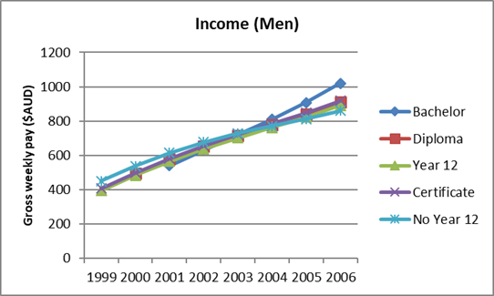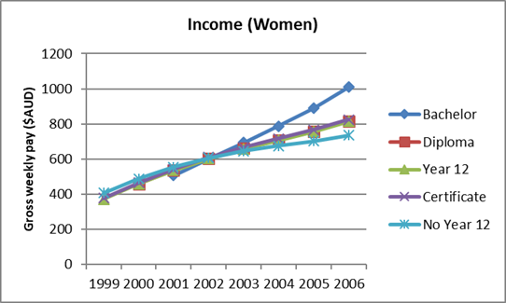

A university degree had large positive effects on occupational prestige for both men and women, even after controlling for ability, individual characteristics and family background (figure 3). Male and female university graduates had significantly higher occupational prestige at age 22 years than non-graduates and experienced faster growth. As a result, by the age of 26 years, individuals with a university degree had average occupational prestige equivalent to nursing professionals or financial investment advisers (49.6 points for men and 51.6 points for women), whereas individuals without Year 12 had average occupational prestige comparable with communications tradespersons or travel agents (27.7 points for men and 31.9 points for women), all else being equal.

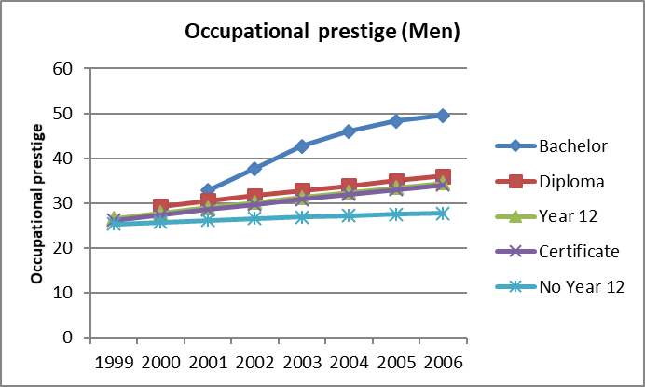Figure 3 Estimated growth of occupational prestige by education

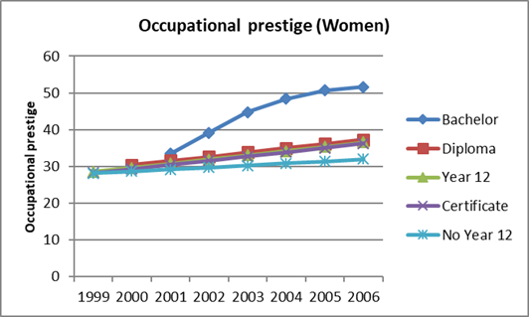

Income and occupational prestige among university graduates differed by the prestige of universities and fields of study, although the effects varied by outcome examined. Other things being equal, the prestige of universities did not have significant effects on income. However, the prestige of universities had a significant effect on the occupational prestige of male graduates even after controlling for fields of study and other covariates (table 4). Compared with graduates of gumtree (second-tier) universities, graduates of sandstone universities (the most prestigious) had significantly higher occupational prestige, while graduates of other universities (the least prestigious universities) had significantly lower occupational prestige.

Fields of study significantly predicted both income and occupational prestige (table 4). When other things were equal, young people who studied health-related disciplines generally enjoyed high income and occupational prestige, whereas people who studied arts/humanities/social sciences had the lowest. Income differences between these extremes averaged 15.2% for men and 21.9% for women and differences on occupational prestige 9.31 points for men and 9.14 points for women. Patterns were similar for men and women.

Table 4 The effects of the prestige of universities and fields of study on log gross weekly pay and occupational prestige among young people

|  |  |  |  |  |  |  |  |  |  |  |
| --- | --- | --- | --- | --- | --- | --- | --- | --- | --- | --- |
|  |  | |  | **Log gross weekly pay** | | |  | **Occupational prestige** | | |
|  |  | |  | Men |  | Women |  | Men |  | Women |
|  | | University prestige (gumtrees) | |  |  |  |  |  |  |  |
|  |  | | Sandstones | 0.015 |  | -0.013 |  | 1.81\* |  | 1.94 |
|  |  | | Unitechs | 0.053 |  | -0.009 |  | 0.86 |  | 1.06 |
|  |  | | Other | 0.020 |  | -0.042 |  | -2.26\* |  | -1.61 |
|  | | Fields (AHSS) | |  |  |  |  |  |  |  |
|  |  | | EngSci | 0.090\* |  | 0.062\* |  | 4.39\*\*\* |  | 4.56\*\*\* |
|  |  | | Business | 0.108\* |  | 0.153\*\*\* |  | 2.61\*\* |  | 2.94\* |
|  |  | | Health | 0.152\*\* |  | 0.219\*\*\* |  | 9.31\*\*\* |  | 9.14\*\*\* |
|  |  | | Other | 0.075 |  | 0.141\*\*\* |  | 9.84\*\*\* |  | 10.53\*\*\* |

Note*:* Reference groups are in parentheses. Sandstones (or Group of Eight) are the older and most prestigious universities; gumtrees are the second-tier universities, established prior to 1987; unitechs are the large institutes of technology; other universities are those that achieved university status after 1987 and private universities. AHSS refers to arts, humanity, and social science; EngSci refers to engineering and sciences.

\* *p* < .05, \*\* *p* < .01, \*\*\* *p* < .001.

## The influence of family background on educational attainment

Multilevel logistic regression results showed that the probabilities of attaining a university degree were significantly predicted by family background (figure 4). All else equal, the odds of attaining a university degree were 2.12 times greater for individuals who had a parent with a degree. For every 10 additional points of parental occupational prestige, the odds of obtaining a university degree were 1.11 times greater. For example, the probability of attaining a university degree at age 26 years was 57% among young people who had parents with a degree and higher occupational prestige but only 28% among young people who had parents with no degree and lower occupational prestige.

Figure 4 Probabilities of attaining a bachelor’s or higher degree by parental degree and parental occupational prestige

Note: Degree refers to having one or more parents with a bachelor’s or higher degree. Med OP refers to parental occupational prestige at the mean; High OP and Low OP are one standard deviation above and below the mean, respectively. All other variables were held at their means.

Family background significantly predicted the level of prestige of graduates’ universities (table 5). The odds of getting a university degree from sandstones relative to gumtrees were 1.72 times greater for individuals who had parents with a degree. When other variables were held constant, the odds of getting a degree from other universities relative to gumtrees decreased by 9% if parental occupational prestige was increased by 10 points.

Table 5 Family background predicting the selection of universities

|  |  |  |  |  |  |  |
| --- | --- | --- | --- | --- | --- | --- |
|  |  | **Odds ratios** | | | | |
|  |  | Sandstone |  | Unitechs |  | Other |
|  |  | vs Gumtree |  | vs Gumtree |  | vs Gumtree |
| Parental occupational prestige | | 1.00 |  | 1.00 |  | 0.99\* |
| Parental university degree | | 1.72\*\*\* |  | 0.97 |  | 1.02 |

Note: \* *p* < .05, \*\*\* *p* < .001.

Fields of study did not differ significantly by family background, except for one (table 6). The odds of majoring in other areas relative to arts/humanities/social sciences were 40% lower for young people who had parents with a degree. The ‘other’ category includes many different disciplines, and this makes an interpretation of this result difficult.

Table 6 Family background predicting fields of study

|  |  |  |  |  |  |  |  |  |
| --- | --- | --- | --- | --- | --- | --- | --- | --- |
|  |  | **Odds ratios** | | | | | | |
|  |  | Engineering |  | Business |  | Health |  | Other |
|  |  | vs. AHSS |  | vs. AHSS |  | vs. AHSS |  | vs. AHSS |
| Parental occupational prestige | | 1.00 |  | 1.00 |  | 1.01 |  | 1.00 |
| Parental university degree | | 0.79 |  | 0.86 |  | 0.71 |  | 0.60\* |

Note: AHSS refers to Arts/Humanity/Social Science. \* *p* < .05.

## Summary

Young people benefited from a university degree in the labour market, even after controlling for ability, individual characteristics and family background. University graduates earned a higher income, and the income benefits of a university degree increased as time went by. Occupational prestige was substantially higher for university graduates than non-graduates. The patterns were almost identical for men and women. Income and occupational prestige varied among university graduates, however. The prestige of universities had some effects on the occupational prestige of male graduates, even after controlling for fields of study. In other words, even with the same major, male graduates from more prestigious universities had jobs with higher occupational prestige than their counterparts who had graduated from less prestigious universities. However, when fields of study and other covariates were included, the prestige of universities did not predict income significantly. Fields of study, however, had significant effects on income and occupational prestige for both men and women.

The probabilities of attaining a university degree differed significantly by family characteristics. Young people from more advantaged family backgrounds (that is, parents with degrees or higher occupational prestige) had significantly higher probabilities of attaining a university degree. Getting a degree from the most prestigious Australian universities was significantly predicted by family background (that is, parental occupational prestige, parental education). However, fields of study were not significantly predicted by parental occupational prestige or parental education.

These findings indicate that vertical stratification in higher education plays an important role in the intergenerational transmission of social status in Australia. A university degree has significant labour market benefits for young people, and the income and occupational disadvantages that young people from low socioeconomic backgrounds experience are largely derived from a lack of opportunity to gain a university degree.

## References

ABS (Australian Bureau of Statistics) 2011, ‘Perspectives on education and training: social inclusion, 2009’, ABS cat.no.4250.0.55.001, <http://www.abs.gov.au/ausstats/abs@.nsf/Lookup/4250.0.55.001Main+Features32009>.

Gerber, TP & Cheung, S Y 2008, ‘Horizontal stratification in postsecondary education: forms, explanations, and implications’, *Annual Review of Sociology*, vol.34, pp.299−318.

Lee, J-S 2014, ‘The attainability of university degrees and their labour market benefits for young Australians’, *Higher Education*, vol.68, no.3, pp.449−69.

Leigh, A 2008, ‘Returns to education in Australia’, *Economic Papers*, vol.34, pp.233−49.

Leigh, A & Ryan, C 2008, ‘Estimating returns to education using different natural experiment techniques’, *Economics of Education Review*, vol.27, pp.149−60.

Miller, P, Mulvey, C & Martin, N 2006, ‘The returns to schooling: estimates from a sample of young Australian twins’, *Labour Economics*, vol.13, pp.571−87.

Ministerial Council on Education, Employment, Training and Youth Affairs 2008, *Melbourne Declaration on Educational Goals for Young Australians*, viewed 24 May 2019, <http://www.curriculum.edu.au/verve/\_resources/National\_Declaration\_on\_the\_Educational\_Goals\_for\_Young\_Australians.pdf>.

OECD (Organisation for Economic Co-operation and Development) 2012, *Education at a glance 2012: OECD indicators*, OEDC Publishing, <http://www.oecd.org/edu/EAG%202012\_e-book\_EN\_200912.pdf>.

Rummery, S, Vella, F & Verbeek, M 1999, ‘Estimating the returns to education for Australian youth via rank-order instrumental variables’, *Labour Economics*, vol.6, pp.491−507.

# Associations between educational attainment and both family and school SES

*Jenny Chesters, The University of Melbourne*

*The analyses in this section have been drawn from a 2019 paper by Chesters, entitled ‘Alleviating or exacerbating disadvantage: does school attended mediate the association between family background and educational attainment?’,* Journal of Education Policy*, vol.34, no.3, pp. 331-50. DOI: 10.1080/02680939.2018.1488001.*

In Australia, the persistence of inequality in educational attainment related to social origin is the subject of an ongoing debate about how education systems reproduce rather than alleviate social inequality. The existence of predictable patterns in levels of educational attainment according to family background indicates that educational inequality is derived from structural inequalities within society, and, in particular, within education systems. Researchers tend to explain this association as an outcome of the ability of highly educated parents to facilitate the development of their children’s cognitive skills and to provide them with the necessary cultural capital for success at school (Bourdieu 1986). Furthermore, they can provide a home environment conducive to intellectual development and encourage their children’s participation in educationally appropriate extracurricular activities (Lareau 2011). Resource compensation theory (Parcel, Dufur & Zito 2010) posits that high levels of resources in the school environment can partially compensate for low levels of resources in the home environment.

## Method

The data used for the empirical analysis come from the Longitudinal Surveys of Australian Youth (LSAY) 2009 (Y09) cohort (Department of Education and Training 2015). The data were collected from 14 251 students aged 15 years attending secondary schools located throughout Australia in 2009. All the participants in the Y09 project were originally part of the Programme for International Student Assessment (PISA) study.

The outcome variables are: level of academic achievement at age 15 (PISA score); and enrolment at university. The predictor variables are: student socioeconomic status (SES); and school SES. I include three control variables: year level at age 15 years; sex; and type of school attended. The academic achievement at age 15 years variable is derived from an index constructed by taking the mean of one plausible value for each domain of the PISA tests. The distribution ranges from 134 to 848, with a mean of 513 and a standard deviation of 96. The PISA index was divided into quartiles, with the lowest scores allocated to Quartile 1 and the highest scores allocated to Quartile 4. The enrolment at university variable is coded 1 for those enrolled in a bachelor’s degree in any year between 2010 and 2013; and 0 for all other cases.

The main predictor variable is PISA’s index of economic, social and cultural status (ESCS). The individual ESCS distribution is divided into quartiles, with students in Quartile 1 being the most disadvantaged and students in Quartile 4 being the most advantaged. To measure school SES, I added the ESCS values for individual students at each school and calculated the mean based on the assumption that the students selected to participate in PISA, and therefore LSAY, in each school are representative of the school population. Given that the PISA team randomly selected the students within each school, this is a reasonable assumption. The school ESCS distribution is divided into quartiles, with schools in Quartile 1 being the most disadvantaged and schools in Quartile 4 being the most advantaged. To examine the associations between academic achievement and both family and school SES, I construct a composite variable from student SES and school SES. The variable has 16 categories, one for each student SES quartile in each school SES quartile. For example: Quartile 1 student\*Quartile 1 school; Quartile 1 student\*Quartile 2 school; Quartile 1 student\*Quartile 3 school; Quartile 1 student\*Quartile 4 school.

Due to differences between the education systems of different states/territories, students were in various year levels in 2009; therefore, a variable for year level in 2009 is included. Sex is coded 0 for male and 1 for female. The school type variable divides schools into three categories: government, Catholic, and independent.

## Associations between SES and PISA scores

The graph in figure 5 shows that, as school SES increases, the percentage of the student population from low-SES families declines. Just 6% of students in the highest SES schools (Quartile 4 schools) were low-SES students (Quartile 1 students), whereas 52% of students in Quartile 4 schools were high-SES students (Quartile 4 students). Almost half (47%) of the students attending Quartile 1 schools were low-SES students, whereas just 6% of students attending low-SES schools were high-SES students.

Figure 5 Association between student SES and school SES

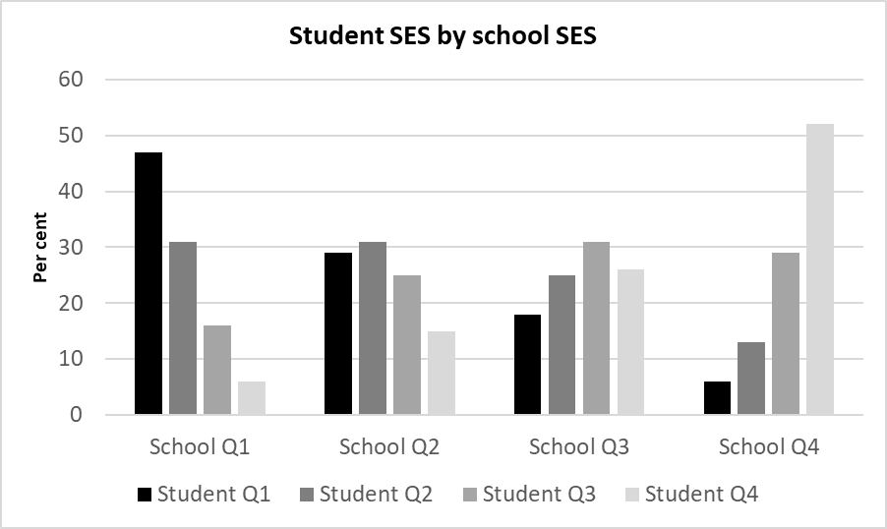

## Educational achievement at age 15

To examine whether the SES of the school attended mediates the association between family SES and educational achievement, I construct a series of linear regression models. The results of the three models are presented in table 7. The results for Model 1 show that student SES is positively associated with PISA scores, net of year level in 2009 and sex. As student SES quartile increases, students’ PISA scores increase. In the second model, I replace student SES with school SES and additionally include school sector. Students attending high-SES schools (school Quartile 4) scored, on average, 82 points higher than students attending low-SES schools (school Quartile 1). In Model 3, I replace school SES with the composite student SES\*school SES variable. Net of sex, year in 2009 and school sector, low-SES students attending high-SES schools scored, on average, 75 points higher than low-SES students attending low-SES schools, indicating, that for low-SES students, attending schools with more affluent peers mediates the association between SES and academic achievement. Overall, these results indicate that family SES and school SES are positively, and cumulatively, associated with academic achievement.

Table 7 Effects of student SES and school SES on PISA scores

|  |  |  |  |  |  |  |  |  |  |  |  |  |  |  |  |  |  |
| --- | --- | --- | --- | --- | --- | --- | --- | --- | --- | --- | --- | --- | --- | --- | --- | --- | --- |
|  | **Model 1** | | |  | **Model 2** |  | | | | **Model 3** | | | | | | | |
| **Student SES Quartile** | **Coef.** | | **Std. err.** | | **Coef.** | **Std. err.** | | | | **Coef.** | | | | **Std. err.** | | | |
| Quartile 1 (ref.) |  |  |  | |  | |  | | | |  | | | |  | | | | |
| Quartile 2 | 29.02\*\*\* | | 3.42 | |  |  | | |  | | | |  | | | |
| Quartile 3 | 51.86\*\*\* | | 3.60 | |  |  | | |  | | | |  | | | |
| Quartile 4 | 77.72\*\*\* | | 3.72 | |  |  | | |  | | | |  | | | |
| **School SES** |  |  |  | |  | |  | | | |  | | | |  | | | | |
| Quartile 1 (ref.) |  |  |  | |  | |  | | | |  | | | |  | | | | |
| Quartile 2 |  |  |  | | 28.99\*\*\* | | 4.76 | | | |  | | | |  | | | | |
| Quartile 3 |  |  |  | | 47.01\*\*\* | | 5.18 | | | |  | | | |  | | | | |
| Quartile 4 |  |  |  | | 81.56\*\*\* | | 7.15 | | | |  | | | |  | | | | |
| **Family\*school SES** |  |  |  | |  | |  | | | |  | | | |  | | | | |
| Q1student\*Q1school (ref.) |  |  |  | |  | |  | | | |  | | | |  | | | | |
| Q1student \*Q2school |  |  |  | |  | |  | | | | 30.93\*\*\* | | | | 6.87 | | | | |
| Q1student \*Q3school |  |  |  | |  | |  | | | | 39.14\*\*\* | | | | 6.96 | | | | |
| Q1student \*Q4school |  |  |  | |  | |  | | | | 74.76\*\*\* | | | | 13.06 | | | | |
| Q2student \*Q1school |  |  |  | |  | |  | | | | 31.76\*\*\* | | | | 5.63 | | | | |
| Q2student \*Q2school |  |  |  | |  | |  | | | | 47.17\*\*\* | | | | 6.41 | | | | |
| Q2student \*Q3school |  |  |  | |  | |  | | | | 61.17\*\*\* | | | | 6.62 | | | | |
| Q2student \*Q4school |  |  |  | |  | |  | | | | 81.14\*\*\* | | | | 8.46 | | | | |
| Q3student \*Q1school |  |  |  | |  | |  | | | | 42.89\*\*\* | | | | 7.41 | | | | |
| Q3student \*Q2school |  |  |  | |  | |  | | | | 58.96\*\*\* | | | | 6.54 | | | | |
| Q3student \*Q3school |  |  |  | |  | |  | | | | 74.94\*\*\* | | | | 6.66 | | | | |
| Q3student \*Q4school |  |  |  | |  | |  | | | | 103.30\*\*\* | | | | 8.61 | | | | |
| Q4student \*Q1school |  |  |  | |  | |  | | | | 65.55\*\*\* | | | | 8.45 | | | | |
| Q4student \*Q2school |  |  |  | |  | |  | | | | 78.74\*\*\* | | | | 7.09 | | | | |
| Q4student \*Q3school |  |  |  | |  | |  | | | | 89.05\*\*\* | | | | 6.54 | | | | |
| Q4student\*Q4school |  |  |  | |  | |  | | | | 116.64\*\*\* | | | | 7.59 | | | | |
| **Sector** |  |  |  | |  | |  | | | |  | | | |  | | | | |
| Government (ref.) |  |  |  | |  | |  | | | |  | | | |  | | | | |
| Catholic |  |  |  | | -4.48 | | 4.68 | | | | -3.76 | | | | 4.55 | | | |
| Independent |  |  |  | | 3.41 | | 6.22 | | | | 1.06 | | | | 6.07 | | | |
| **Grade level 2009** |  |  |  | |  | |  | | | |  | | | |  | | | |
| Grade 9 | -36.11\*\*\* | | 4.17 | | -37.43\*\*\* | | | 3.97 | | | | -35.95\*\*\* | | | | 3.85 | | |
| Grade 10 (ref.) |  | |  | |  | | |  | | | |  | | | |  | | |
| Grade 11/12 | 22.98\*\*\* | | 3.23 | | 24.62\*\*\* | | | 3.10 | | | | 24.22\*\*\* | | | | 3.00 | | |
| **Sex Female =1** |  | 2.60 | 2.40 | | -2.72 | | 2.29 | | | | -1.96 | | | | 2.19 | | | |
| Constant | 506.74\*\*\* | | 3.66 | | 508.00\*\*\* | | | 3.95 | | | | 483.15\*\*\* | | | | 4.93 | | |
| n= | 5 787 | | |  | 5 787 | | |  | 5 787 | | | |  | | | |
| Adjusted R-squared | 0.1448 | | |  | 0.1583 | | |  | 0.1980 | | | |  | | | |

\*p<0.05; \*\*p<0.01; \*\*\*p<0.001.

## Associations between SES and enrolling in a bachelor’s degree

To examine whether the SES of the school attended mediates the association between family SES and the likelihood of enrolling in a bachelor’s degree, I construct logistic regression models and present the results in table 8. The results for Model 1 show that, as student SES quartile declines, the likelihood of enrolling in a bachelor’s degree declines, net of PISA score quartile and sex. In the second model, student SES is replaced by school SES and school sector is also included. The results show that students attending low-SES schools were one-third as likely as their peers attending high-SES schools to enrol at university, after controlling for level of academic achievement at age 15 years, school sector and sex. In the third model, school SES is replaced by the student SES\*school SES composite variable. The reference category is high-SES students attending high-SES schools. Low-SES students attending low-SES schools were only one-fifth as likely as high-SES students attending high-SES schools to enrol at university, net of PISA quartile, school sector and sex. High-SES students attending low-SES schools were only half as likely as high-SES students attending high-SES schools to start a bachelor’s degree, net of PISA quartile, school sector and sex. In other words, the likelihood of students with similar levels of academic achievement at age 15 years attending university was dependent upon both their SES and that of their school peers.

Table 8 Likelihood of enrolling in a bachelor’s degree according to student SES and school SES

|  | **Model 1** | |  | **Model 2** | |  | **Model 3** | | | | | | |
| --- | --- | --- | --- | --- | --- | --- | --- | --- | --- | --- | --- | --- | --- |
| **Student SES Quartile** | **Odds ratio** | | **Std. err.** | **Odds ratio** | | **Std. err.** | **Odds ratio** | | **Std. err.** | | | | |
| Quartile 4 (ref.) |  |  |  | |  |  |  | | | |  |
| Quartile 1 | 0.33\*\*\* | | 0.03 |  | |  |  | |  | | | | |
| Quartile 2 | 0.38\*\*\* | | 0.03 |  | |  |  | |  | | | | |
| Quartile 3 | 0.64\*\*\* | | 0.55 |  | |  |  | |  | | | | |
| **School SES** |  |  |  | |  |  |  | | | |  |
| Quartile 4 (ref.) |  |  |  | |  |  |  | | | |  |
| Quartile 1 |  |  |  | | 0.36\*\*\* | 0.05 |  | | | |  |
| Quartile 2 |  |  |  | | 0.36\*\*\* | 0.04 |  | | | |  |
| Quartile 3 |  |  |  | | 0.55\*\*\* | 0.06 |  | | | |  |
| **Student\*school SES** |  |  |  | |  |  |  | | | |  |
| Q4student\*Q4school (ref.) |  |  |  | |  |  |  | | | |  |
| Q1student \*Q1school |  |  |  | |  |  | 0.21\*\*\* | | | | 0.05 |
| Q1student \*Q2school |  |  |  | |  |  | 0.17\*\*\* | | | | 0.03 |
| Q1student \*Q3school |  |  |  | |  |  | 0.16\*\*\* | | | | 0.05 |
| Q1student \*Q4school |  |  |  | |  |  | 0.29\*\*\* | | | | 0.08 |
| Q2student \*Q1school |  |  |  | |  |  | 0.19\*\*\* | | | | 0.03 |
| Q2student \*Q2school |  |  |  | |  |  | 0.18\*\*\* | | | | 0.03 |
| Q2student \*Q3school |  |  |  | |  |  | 0.34\*\*\* | | | | 0.05 |
| Q2student \*Q4school |  |  |  | |  |  | 0.39\*\*\* | | | | 0.08 |
| Q3student \*Q1school |  |  |  | |  |  | 0.31\*\*\* | | | | 0.06 |
| Q3student \*Q2school |  |  |  | |  |  | 0.32\*\*\* | | | | 0.05 |
| Q3student \*Q3school |  |  |  | |  |  | 0.41\*\*\* | | | | 0.06 |
| Q3student \*Q4school |  |  |  | |  |  | 0.61\*\*\* | | | | 0.09 |
| Q4student \*Q1school |  |  |  | |  |  | 0.50\* | | | | 0.15 |
| Q4student \*Q2school |  |  |  | |  |  | 0.40\*\*\* | | | | 0.07 |
| Q4student \*Q3school |  |  |  | |  |  | 0.44\*\*\* | | | | 0.07 |
| **Sector** |  |  |  | |  |  |  | | | |  |
| Government (ref.) |  |  |  |  | |  |  | | | |  |
| Catholic |  |  |  | 1.24 | | 0.15 | 1.26 | | | | 0.15 |
| Independent |  |  |  | 1.12 | | 0.14 | 1.06 | | | | 0.13 |
| **PISA quartile** |  |  |  |  | |  |  | | | |  |
| Quartile 4 (ref.) |  | |  |  | |  |  | |  | | | |
| Quartile 1 | -0.05\*\*\* | | 0.01 | 0.05\*\*\* | | 0.01 | | 0.06\*\*\* | | 0.01 | | |
| Quartile 2 | 0.17\*\*\* | | 0.02 | 0.18\*\*\* | | 0.01 | | 0.19\*\*\* | | 0.02 | | |
| Quartile 3 | 0.40\*\*\* | | 0.03 | 0.39\*\*\* | | 0.03 | | 0.41\*\*\* | | 0.03 | | |
| **Sex Female = 1** | 1.93\*\*\* | | 0.14 | 1.94\*\*\* | | 0.13 | | 1.99\*\*\* | | 0.14 | | |
| Constant | 4.46\*\*\* | | 0.39 | 4.37\*\*\* | | 0.55 | | 6.08\*\*\* | | 0.86 | | |
| n= | 5 787 | |  | 5 787 | |  | | 5 787 | |  | | |
| Adjusted R-squared | 0.1970 | |  | 0.2012 | |  | | 0.2145 | |  | | |

\*p<0.05; \*\*p<0.01; \*\*\*p<0.001.

## Summary

The persistence of inequalities according to family SES and school SES shines a light on structural inequalities that persist within Australian education systems, despite the provision of 12 years of free education. The results presented in this paper show that low-SES students attending high-SES schools had higher levels of academic achievement at age 15 years than low-SES students attending low-SES schools, providing support for resource compensation theory (Parcel, Dufur & Zito 2010). After controlling for levels of academic achievement at age 15 years and sex, student-level SES was positively correlated with university enrolment. High-SES students attending low-SES schools were only half as likely as high-SES students attending high-SES schools to enrol in a bachelor’s degree program even if they had similar PISA scores. Summing up, the results presented here provide further evidence of the importance of the learning environment both at home and at school (Parcel & Dufur 2009).

## References

Department of Education and Training 2015, *Longitudinal Surveys of Australian Youth, 2009 cohort: study documentation*, Canberra, Australian Government.

Bourdieu, P 1986, ‘The forms of capital’, in JG Richardson (ed.), *Handbook of theory and research for the sociology of education*, Greenwood Press, New York, pp. 241−58.

Chesters, J 2019, ‘Alleviating or exacerbating disadvantage: does school attended mediate the association between family background and educational attainment?’, *Journal of Education Policy*, vol. 34, no. 3, pp. 331-350. DOI: 10.1080/02680939.2018.1488001.

Lareau, A 2011, *Unequal childhoods: race, class and family life,* second edition with an update a decade later, University of California Press, California.

Parcel, TL & Dufur, M J 2009, ‘Family and school capital explaining regional variation in math and reading achievement’, *Research in Social Stratification and Mobility*, vol.27, pp.157−76.

Parcel, TL, Dufur, M J & Zito, R C 2010, ‘Capital at home and at school: a review and synthesis’, *Journal of Marriage and Family*, vol.72, pp. 828−84.

# Section 3: VET in Schools

An area of considerable interest in the Longitudinal Surveys of Australian Youth (LSAY) data has been rates of participation in vocational education and training (VET) or VET in Schools (VETiS). VET programs are intended to broaden the range of curriculum offerings in Australian schools and to offer alternative pathways to work or tertiary education (Fullarton 2001). LSAY data have shown that participation in VET in Schools does not necessarily increase the completion of Year 12, but it does have positive effects on attitudes towards schools (Nguyen 2010). On a positive note, VET is seen as providing a practical and work-related learning to students, although it is seen negatively in terms of its value, prestige and importance (Gore et al. 2017), and students show higher interest in VET-related employment prospects than studying VET as part of post-secondary school pathways (Hargreaves & Osborne 2017). There is also a negative association, with VET being seen as for those with lower academic ability; students with peers of higher academic ability are more likely to enrol in non-vocational education after school (Hedges & Speckesser 2017).

In 2018, there were 230 700 students undertaking VET in Schools (NCVER 2019). Of that figure, 18 200 were school-based apprentices and trainees (making up 7.9% of all VETiS students) and 212 500 were students undertaking other VETiS programs (92.1%). Learning more about the outcomes of students undertaking VET and how successful it is in finding paths to secure employment is of vital importance.

In the first chapter in this section, Curtis discusses inter-sectoral transfer rates between VET and higher education and revisits analyses first done a decade earlier. The results show that transfers from VET to higher education tend to be students moving from certificate and diploma-level programs into degrees in the same field of study and that we need to continue to advocate for easy pathways between the post-school sectors. Polidano and Tabasso look at a different area: comparing education and employment outcomes in the first year out of school between students who take part in VET in Schools and those who do not, with surprising findings regarding limitations as to when VET in Schools is an advantage.

## References

Fullarton, S 2001, *VET in Schools:* *participation and pathways*, LSAY research report, no.21, Australian Council for Educational Research, Camberwell, Vic.

Gore, J, Ellis, H, Fray, L, Smith, M, Lloyd, A, Berrigan, C, Lyell, A, Weaver, N & Holmes, K 2017, *Choosing VET: investigating the VET aspirations of school students*, NCVER, Adelaide.

Hargreaves J & Osborne K 2017, *Choosing VET: aspirations, intention and choice,* NCVER, Adelaide.

Hedges S & Speckesser S 2017, *Peer effects and social influence in post-16 educational choice*, CVER discussion paper series no. 008, Centre for Vocational Education Research, London School of Economics and Political Science, London.

NCVER (National Centre for Vocational Education Research) 2019, *Australian vocational education and training statistics: VET in Schools 2018*, NCVER, Adelaide.

Nguyen, N 2010, *The impact of VET in Schools on the intentions and achievements of young people*, LSAY briefing paper 21, NCVER, Adelaide.

# Student transfer between VET and higher education

*David D Curtis, Flinders University*

## Introduction

Following some dispute about the levels of transfer of students between the vocational education and training (VET) and higher education sectors, Curtis (2006) undertook a study of inter-sectoral transfer using the Y95 Longitudinal Surveys of Australian Youth (LSAY) cohort (to 2004). The analyses presented then are revisited in this contribution, taking into account changes in labour market conditions and policy settings in the intervening decade. In this paper, data from the LSAY Y06 cohort (to 2016) are used to estimate inter-sectoral transfer. While participation in both sectors, and especially higher education, has increased, the rates of transfer between the sectors are similar in 2016 to the figures reported in 2006.

## Why the interest in this topic?

An implicit assumption about transitions from compulsory education to the labour market was that they followed simple linear paths: students would have completed as much school education as they required or desired and would have undertaken one of the following options:

* moved directly into the labour market
* pursued a VET pathway that may have been an apprenticeship or traineeship, or a course offered by a VET provider leading to a qualification, and then entered the labour market
* enrolled in a course offered by a university (or other higher education provider) and then entered the labour market.

In reality, transitions were never as simple as these paths suggest (Harris, Rainey & Sumner 2006). A persistent problem for both VET and higher education has been non-completion. In the absence of a universal student identifier, tracking student progress was difficult, even within a sector. If a student left a course, it was assumed they had ‘dropped out’. More detailed analyses of students’ pathways tracked through LSAY surveys revealed that, if students left a course, they were more likely than not to enrol in another course, either at the same institution or in another institution in the same sector, but they may have moved to the other post-secondary sector (Curtis 2013; Curtis & McMillan 2008; McMillan 2005; McMillan & Curtis 2008).

The issue of drop-outs was and remains a matter of policy interest. If students do drop out, their departure represents a direct cost to the individual in fees incurred and an opportunity cost, as the time they did spend in a course could have been invested more productively. That departure also represents a cost to the agency funding their enrolment (in most cases, governments). Further, while the student may have gained some useful skills from their participation, the lack of any certification makes it unlikely that their skills would be recognised.

Funding agencies (again, mostly governments) have an interest in drop-outs, as they may indicate a perception of poor course quality (Curtis 2011), although many other factors contribute to course quality and many factors beyond the control of providers influence students’ decisions to leave courses.

Interest in the inter-sectoral movements of students also arises for other reasons. Students who undertake a VET qualification may find that their career opportunities are enhanced by pursuing a related higher education qualification. This is most apparent in areas such as nursing, where graduates of a Diploma of Nursing (enrolled nurses) receive course credit in Bachelor of Nursing degree courses (leading to registration as a nurse). This movement between the sectors, which is not restricted to nursing qualifications, has advantages for students. Having completed a VET qualification, VET graduates can work in their chosen field, gain experience and earn an income, and they may do this on a part-time basis while completing their university degree. Entry into higher education favours students from high socioeconomic status (SES) backgrounds, so a VET qualification may provide a pathway into higher education for low-SES students, although Wheelahan (2009) sounded a cautionary note about this possibility. The movement from university to VET is more problematic. Moodie (2005) refers to university to VET transfer when the university course was not completed as ‘dropping down’ rather than dropping out. However, university graduates may undertake additional qualifications in the VET sector in order to gain skills that complement those gained in their degree courses.

## The need for quality data

My 2006 study was motivated by a desire to resolve conflicting accounts of the relative magnitudes of transfer between VET and higher education. Harris, Sumner and Rainey (2005) had analysed both VET and higher education statistics to determine what proportions of students in each sector had previous experience of the other postsecondary sector. In addition, they had undertaken a survey of VET and higher education students who commenced their studies in 2003 in South Australia to find out whether those students had previously been enrolled in a course in the other sector. Their report was based largely on the results of their survey. However, the response rates to the VET and higher education surveys were 15% and 7% respectively. On the basis of their analyses, Harris et al. (2005) concluded that the flow of students from higher education to VET was three times greater than the movement from VET to higher education.

Moodie (2005) was critical of the analyses of higher education statistics conducted by Harris et al. (2005) and especially critical of their survey. In addition to revealing discrepancies in reported enrolments between the higher education statistics from the Department of Education, Science and Training, NCVER collections and ABS data, Moodie drew attention to the unreliability of self-report data on students’ prior enrolments, with many students, especially those in dual-sector institutions, inaccurately reporting the sector in which they were enrolled.

A common feature of the enrolment data used in previous studies, including those by Harris et al. (2005) and Moodie (2005), is that they are cross-sectional. Here, LSAY data are particularly valuable as they track individuals over time and reveal the enrolment trajectories, including the completion status of individuals in courses. While the data are self-reports, there is an internal check on the consistency of responses as participants are prompted with scripts such as ‘Last year you indicated that you were enrolled in …’. This prompt tests the accuracy of the previously reported enrolment and subsequent questions that build on it. For example, participants are asked if they are still enrolled in that program. The study reported by Curtis (2006) used the LSAY Y95 cohort data up to and including Wave 10 (2004). The Y95 cohort had been recruited when they were in Year 9 at school. The modal age of the cohort when recruited was 14 years, and respondents were 23 years old in 2004. This reveals a disadvantage of the data. Moodie (2005) had shown that many of the reverse transfers occur after students had completed their higher education qualification, and in some cases, some years after completing it. Thus, relatively few of the higher education graduates who might eventually undertake a VET qualification would have commenced it by age 24 years. Thus, the LSAY data are likely to underestimate the higher education to VET transfer.

## What was the incidence of inter-sectoral transfer?

Curtis (2006) found that the majority of students undertake a post-school program, which may be an apprenticeship (or traineeship, noting that these programs were differentiated at the time the programs were undertaken), a non-apprenticeship VET course usually undertaken through a technical and further education (TAFE) institute, or a university course. A very small number of students reported doing a non-formal qualification. The percentages of students undertaking first and second programs of study are shown in table 9, which is based on figure 1 in Curtis (2006). The figures shown in the first column of the table are the proportions of the cohort who undertook the various types of programs available to them as a first post-school program. The first row of the table shows the proportions of LSAY participants who, having undertaken a first program, went on to a second one. Other rows in the table show the proportions of students who, in a given first post-school program, undertook various second programs (including none). For example, 25% of the cohort undertook a non-apprenticeship VET (TAFE) course as their first post-school program. Of that group, 45% did no further study, but 9% moved to an apprenticeship, 26% went on to do another TAFE course, and 14% enrolled in a university course. Overall, most students undertake only one post-school program. However, if they do undertake a second program, it is most likely to be in the same sector as the first.

Table 9 Percentages of the Y95 cohort undertaking post-school programs, both first and subsequent

|  |  |  |  |  |  |
| --- | --- | --- | --- | --- | --- |
|  | **Second post-school program** | | | | |
| First post-school program | No further study (64%) | Apprenticeship (7%) | TAFE course (12%) | University course 14% | Non-formal study (3%) |
| No post-school program (13%) | n/a | n/a | n/a | n/a | n/a |
| Apprenticeship  (19%) | 62 | 17 | 12 | 5 | n/a |
| TAFE course  (25%) | 45 | 9 | 26 | 14 | n/a |
| University course (41%) | 65 | 3 | 6 | 24 | n/a |
| Non-formal study (2%) | n/a | n/a | n/a | n/a | n/a |

Notes: Row and column totals may not sum to 100% because of rounding.  
n/a indicates either not applicable (for example, no post-school study therefore no possible transfer) or too few cases to enable reliable estimates to be made.

## What has changed?

The analyses presented above were undertaken in 2006. Many features of the post-secondary and labour market landscapes have changed markedly since that time. Two notable changes have been

* the Global Financial Crisis (GFC) of 2008, which led to substantial and persistent changes in the labour market
* policy changes in higher education following the adoption of key recommendations of the Bradley review into higher education (Bradley et al. 2008).

Collectively, these factors and many others have influenced the labour market and post-school education and training participation in complex ways and are likely to influence transfers between sectors. In particular, an increase in enrolment in a sector is likely to see a greater number of students moving from that sector to the other. The focus of the discussion below is on post-school participation in VET and higher education, with students enrolled at school excluded from the analyses.

## The Global Financial Crisis and the labour market

The buoyancy of the labour market exerts complex influences on post-school participation in education and training. When employment is readily available, apprenticeship commencements tend to be relatively high but enrolments in post-school education tend to be weaker. On the other hand, during an economic downturn, the opportunity cost of participation in post-school education and training is reduced, so enrolments tend to be higher while apprenticeship commencements decline.

The Global Financial Crisis began in 2008, but its influence on the Australian labour market was moderated by government interventions aimed at stimulating demand for goods and services and by stimulating employment through infrastructure investment. These interventions both moderated and delayed the effects of the GFC that were felt in other economies. Its influence in Australia can be seen in unemployment data from 2006 to 2016 (see table 10). In particular, new entrants to the labour market are particularly vulnerable to declining labour market conditions, their unemployment rate being more than double that for the aggregate labour market. This difficulty is reflected in apprenticeship commencements. Apprenticeship commencements for post-school 15 to 24-year-olds from 2006 to 2016 are also shown in table 10 and they reflect the unemployment rate: as it increases, apprenticeship commencements decline.

Table 10 Unemployment rates and apprenticeship commencements by selected age groups, 2006−16

|  |  |  |  |  |  |  |  |  |  |
| --- | --- | --- | --- | --- | --- | --- | --- | --- | --- |
|  | **Unemployment rate (%)** | | | | | **Apprenticeship commencements (‘000) by age group** | | | |
| Year | 15−24 years | | | All | | 19 years and under | 20−24 years | <19−24 years | 25−44 years |
| 2006 | 9.99 | | 4.77 | | 109.57 | | 46.32 | 155.88 | 78.15 |
| 2007 | 9.30 | | 4.35 | | 114.53 | | 48.22 | 162.75 | 80.39 |
| 2008 | 8.95 | | 4.26 | | 117.38 | | 48.61 | 166.00 | 86.12 |
| 2009 | 11.45 | | 5.54 | | 101.12 | | 45.59 | 146.71 | 85.82 |
| 2010 | 11.55 | | 5.21 | | 115.80 | | 54.38 | 170.19 | 100.19 |
| 2011 | 11.29 | | 5.07 | | 111.55 | | 56.62 | 168.17 | 105.71 |
| 2012 | 11.72 | | 5.22 | | 107.28 | | 57.07 | 164.35 | 114.21 |
| 2013 | 12.16 | | 5.66 | | 85.49 | | 45.05 | 130.54 | 81.14 |
| 2014 | 13.36 | | 6.07 | | 79.03 | | 39.49 | 118.52 | 54.45 |
| 2015 | | 13.19 | 6.08 | | 75.15 | | 36.50 | 111.65 | 46.35 |
| 2016 | | 12.73 | 5.72 | | 76.79 | | 35.50 | 112.29 | 43.22 |

Sources: Unemployment data from ABS (2018); apprenticeship commencements, which exclude students at school, from VOCSTATS <http://www.ncver.edu.au/resources/vocstats.html>, viewed 14 December 2018.

With fewer apprenticeship opportunities, young people need to consider alternatives, and these include non-apprenticeship VET and university study.

Post-school participation in education and training is correlated with unemployment rates. When unemployment is high, enrolments in non-apprenticeship VET and higher education tend to increase as the opportunity cost of participation is reduced. However, other factors, most notably changes in higher education policy, have exerted a substantial influence on tertiary education participation.

## The Bradley review into higher education

The Bradley review into higher education (Bradley et al. 2008) recommended major reforms to higher education. Most of its 46 recommendations were accepted in 2009 and implemented by 2012 (Department of Education, Employment and Workplace Relations 2009). These recommendations included participation and attainment targets, funding and regulatory arrangements.

Recommendations 2 and 25 are particularly significant. Recommendation 2 (Bradley et al. 2008, p.21) called for a national target of 40% of 25 to 34-year-olds having a bachelor’s degree by 2020. This was supported by Recommendation 25 (Bradley et al. 2008, p.152) that entailed an open-ended and demand-driven funding model. This replaced the previously capped enrolment envelopes negotiated between universities and the relevant Commonwealth department. These recommendations were reinforced in Recommendation 29 (Bradley et al. 2008, p.158), which included the suggestions that universities set their own admissions standards, enrol as many students as they wished, and that no limit be placed on funding. Collectively, these recommendations were designed to increase the number of university enrolments, an intention that has been realised, although with impacts on the VET sector.

A further recommendation that influenced enrolments in VET qualifications was Recommendation 4 that ‘by 2020, 20 per cent of higher education enrolments at undergraduate level are people from low socio-economic status backgrounds’ (Bradley et al. 2008, p.45). This recommendation was destined to influence VET participation, as low-SES individuals were underrepresented in university enrolments but rather better represented among VET students. Universities that achieved low-SES enrolment targets gained additional funding, so an incentive to attract low-SES students was established.

Although not a recommendation, the Bradley review (2008, pp.191−3) called for better pathways between VET and higher education and suggested the introduction of graded assessment of higher-level VET qualifications, which would facilitate credit transfer into university courses. Here, rather than changes to assessment practices, a core curriculum, required in order to achieve certification as an enrolled or registered nurse, seems to have been the driver.

Table 11 Trends in tertiary education commencements, 2006−16

|  |  |  |  |  |  |  |
| --- | --- | --- | --- | --- | --- | --- |
|  | **Domestic undergraduate commencements** | **Non-apprenticeship VET commencements** | | | **Total tertiary** | **Proportion of tertiary students at university** |
| Year | Number | 15−19 | 20−24 | 15−24 |  | (%) |
| 2006 | 180 313 | 110 269 | 107 803 | 218 072 | 398 385 | 45.3 |
| 2007 | 186 691 | 109 286 | 106 966 | 216 252 | 402 943 | 46.3 |
| 2008 | 189 516 | 106 890 | 105 001 | 211 891 | 401 407 | 47.2 |
| 2009 | 204 879 | 116 057 | 112 052 | 228 109 | 432 988 | 47.3 |
| 2010 | 220 104 | 123 518 | 127 094 | 250 612 | 470 716 | 46.8 |
| 2011 | 226 837 | 142 374 | 142 869 | 285 243 | 512 080 | 44.3 |
| 2012 | 248 510 | 143 679 | 154 179 | 297 858 | 546 368 | 45.5 |
| 2013 | 263 073 | 136 986 | 159 200 | 296 186 | 559 259 | 47.0 |
| 2014 | 272 229 | 137 283 | 161 179 | 298 462 | 570 691 | 47.7 |
| 2015 | 276 234 | 117 120 | 134 950 | 252 070 | 528 304 | 52.3 |
| 2016 | 281 389 | 113 038 | 137 064 | 250 102 | 531 491 | 52.9 |

Sources: Domestic undergraduate commencements from Commonwealth Department of Education and Training, Higher Education Statistics, <https://www.education.gov.au/higher-education-statistics>; non-apprenticeship commencements, which exclude students at school, are sourced from VOCSTATS, viewed 14 December 2018, <http://www.ncver.edu.au/resources/vocstats.html>.

The ramifications of the Bradley review policy changes have included substantial increases in higher education enrolments. Enrolments of domestic undergraduate students in bachelor’s degree programs, along with non-apprenticeship VET enrolments by age group, are shown in table 11. Enrolments of domestic undergraduate students in 2016 represent a 56% increase over the 2006 figure [[2]](#footnote-3). By contrast, the increase in non-apprenticeship VET enrolments over the same period has been just less than 15%, although this lower figure is largely attributable to a decline in non-apprenticeship VET enrolments since 2014. This recent decline may be associated with a tightening of regulatory oversight of VET providers following the exposure of unconscionable conduct by some providers. Over the 2006−16 period, Australia’s population of 15 to 24-year-olds increased by 8.6%. Thus, the increase in post-secondary enrolments has exceeded population growth over the period, but most especially for higher education enrolments. The final column of table 11 shows that the higher education share of all post-secondary enrolments has increased over the decade to 2016.

## Other influences on post-secondary education and training enrolments

While attention has been directed above at two influences on post-secondary enrolments, many other factors have induced changes in enrolment patterns. There had been a trend to increasing participation in VET in Schools to about 2012, but this participation has declined since that time. The influence of VET in Schools on post-school participation in education and training is not clear. It may be a pathway into post-school VET, but equally, it may substitute for it. This matter requires investigation. Clarke and colleagues at the University of Melbourne did investigate the effects of VET in Schools on students and found that, while it does contribute to school retention for students who might otherwise leave before completing senior secondary education, its outcomes are weak (see, for example, Clarke & Polesel 2013).

Longer-term changes in the labour market are also likely to influence demand for post-school education and training. Much attention has been paid recently to the so-called ‘fourth industrial revolution’, characterised by the application of robotics and nanotechnologies, among other technologies, and which have the potential to be highly disruptive of the means of production and supply of goods and services. The entry of Uber into the taxi industry and more recently into food services had disrupted the business model and employment relationships while destroying pre-existing values and creating new ones. This is the type of relationship that young people experience as they seek to enter the labour market. It is possible that young people’s educational expectations are influenced by such changes. Hillman (2018), using Australian Programme for International Student Assessment (PISA) data for 2003, 2009 and 2015, revealed students’ declining expectations for post-school study for both VET and higher education. This finding stands in contrast to the data on increasing observed participation for both non-apprenticeship VET and higher education shown in table 11.

## Recent trends in inter-sectoral transfers

The modal year for respondents in the Y06 cohort to complete Year 12 was 2009. This was a period when the unemployment rate for young people increased sharply (see table 10). This coincided with a downturn in apprenticeship commencements (also shown in table 10). However, it was also a period when enrolments in both higher education and in non-apprenticeship VET increased, a trend that continued in the VET system until 2014, and which has continued in higher education (see table 11). What is unclear is whether these trends in participation are reflected in the Y06 cohort and whether they led to any change in inter-sectoral transfers.

Using data from the LSAY Y06 cohort, the initial post-school destinations of students are shown in table 12. The relative proportions of students taking VET and higher education programs are consistent with population data presented in table 11. Data have been weighted using the original 2006 sampling weights, but weights have not been adjusted for attrition. Attrition is a characteristic of longitudinal data collections and LSAY is no exception. Of the original sample of 14 170, by 2009, when most students would have commenced post-school study, 7 299 remained and by 2016, the achieved sample had fallen to 3 343. Because of attrition from the sample, it is likely that some of the participants who left the survey would subsequently undertake some post-school study, so the 8.2% estimate of individuals who did no post-school study is likely to be an overestimate. This compares favourably with the 13% of young people in the Y95 cohort who undertook no post-school study (see table 9).

Table 12 Frequencies of students’ first post-school study programs for the LSAY Y06 cohort

|  |  |  |
| --- | --- | --- |
| **Post-school study** | **Frequency** | **Valid per cent** |
| No post-school study | 568 | 8.2 |
| Vocational certificate | 2 155 | 31.0 |
| Vocational diploma | 567 | 8.2 |
| Bachelor’s degree | 3 636 | 52.3 |
| Postgraduate study | 23 | 0.3 |
| Total | 6 950 | 100.0 |

Note: Weighted by 2006 sample weights. Original sample was 14 170.

Source: LSAY Y06 to 2016.

The main point of the analysis was to estimate transfers between VET and higher education. Estimates of these transfers are shown in table 13. These estimates are based on students’ self-reported qualification levels and a transfer to a second program is based on the second program being at a different Australian Qualifications Framework (AQF) level, for example, a certificate followed by a diploma qualification. About 2.5% of students undertook a third post-school program, but these are not shown.

It is very likely that there are transfers from a qualification in one field of study to a qualification at the same level in another field. Thus, transfers within sectors are likely to be underestimates. However, the main purpose of the analysis is to identify transfers between sectors. A small number of students claim that their first qualification is at a postgraduate level (graduate certificate, graduate diploma, master, or doctorate level). This seems unlikely, but it is possible in rare circumstances. The completion status of first qualifications was not taken into account. Thus, from these analyses, it is not possible to confirm Moodie’s (2005) finding that much ‘reverse transfer’ involved students who had not completed their bachelor’s degree study and switched instead to a VET qualification. It is worth noting that the inter-sectoral transfer rates found from the Y06 cohort are similar to those reported from a decade earlier for the Y95 cohort (Curtis 2006). Thus, while participation rates in both VET and higher education increased between the Y95 and Y06 cohorts, transfers between the sectors are quite similar.

Table 13 Estimates of transfers between VET and higher education for the LSAY Y06 cohort

|  |  |  |  |  |  |  |
| --- | --- | --- | --- | --- | --- | --- |
|  | **Second post-school study program** | | | | | |
| First post-school program | No second program | Vocational certificate | Vocational diploma | Bachelor’s degree | Postgraduate study | Total |
| No post-school study | 568 | 0 | 0 | 0 | 0 | 568 |
| Vocational certificate | 1 368 | 591 | 82 | 102 | 12 | 2 155 |
| Vocational diploma | 352 | 18 | 129 | 62 | 7 | 568 |
| Bachelor’s degree | 2 009 | 83 | 55 | 1 165 | 325 | 3 637 |
| Postgraduate study | 18 | 0 | 0 | 3 | 1 | 22 |
| Total | 4 315 | 692 | 266 | 1 332 | 345 | 6 950 |

Note: Weighted by 2006 sample weights.

Source: LSAY Y06 to 2016.

The data in the table suggest that 6.7% of students whose first post-school study was in the VET sector subsequently enrolled in a higher education course. Of those students whose first course was a bachelor’s degree, 3.8% subsequently enrolled in a VET qualification. These estimates need to be treated with caution. Because of the length of bachelor’s degree programs, it is possible that graduates may not have commenced a VET qualification before the final wave of the Y06 cohort was interviewed or because they had dropped out of the survey. Thus, the higher education to VET transfer is likely to underestimate the true figure.

## Implications of inter-sectoral transfer

While there has been some policy interest in inter-sectoral transfers, their existence should not be a matter of concern. Considerable concern has been expressed about drop-outs in higher education and non-completion of VET qualifications and, if well-founded, those concerns are legitimate. In the higher education sector, it is often asserted that 30% of commencing students drop out. An analysis of LSAY datasets has shown that this is an overestimate of the problem and that most of the 30% are students who have changed courses or institutions or have moved from higher education to VET (McMillan 2005). Young people do change their minds about career paths and we need a system that can accommodate such changes while providing students with as much credit transfer as is reasonable between programs and institutions.

Transfers from VET to higher education typically involve students moving from certificate and diploma programs into degree courses in the same field. This suggests an upward mobility as students seek to gain higher-level qualifications, which, it is hoped, will lead to better remuneration for individuals and higher net productivity. This form of mobility, which the Bradley review (Bradley et al. 2008, pp. 191−3) sought to promote and that Moodie has argued for (see, for example, Moodie 2008), does not occur in Australia as commonly as it does in North American post-secondary systems (Moodie 2003). To the extent that long-term labour market changes will require higher-level skills, there is a case for promoting seamless pathways between the two post-school sectors in Australia.

## References

ABS (Australian Bureau of Statistics) 2018, *Labour force Australia (detailed electronic delivery)*, cat.no.6291.0.55.001, ABS, Canberra.

Bradley, D, Noonan, P, Nugent, H & Scales, B 2008, *Review into Australian higher education, final report*, Department of Education, Employment and Workplace Relations, Canberra.

Clarke, K & Polesel, J 2013, ‘Strong on retention, weak on outcomes: the impact of vocational education and training in schools’, *Discourse: Studies in the Cultural Politics of Education*, vol.34, no.2, pp.259−73.

Curtis, DD 2006, ‘Inter-sectoral transfers: sense, status, prevalence and purpose’, paper presented at the 15th National Vocational Education and Training Research Conference, Mooloolaba, Australia, <http://voced.edu.au/vital\_node\_create/ngv\_42529>.

−−2011, ‘Evaluating VET provider effectiveness’, paper presented at the New Zealand VET Research Forum, Victoria University, Wellington, New Zealand.

−−2013, ‘Post-school pathways in Australia: participant characteristics’, in S Alagumalai, S Burley & JP Keeves (eds), *Excellence in scholarship: transcending transdisciplinarity in teacher education*, Sense Publishers, Rotterdam, pp.123−38.

Curtis, DD & McMillan, J 2008, *School non-completers: profiles and initial destinations,* LSAY research report no. 54, Australian Council for Educational Research, Camberwell, Vic., <https://research.acer.edu.au/lsay\_research/4/>.

Department of Education, Employment and Workplace Relations 2009, *Transforming Australia’s higher education system*, DEEWR, Canberra.

Harris, R, Sumner, R & Rainey, L 2005, *Student traffic: two-way movement between vocational education and training and higher education*, NCVER, Adelaide.

−−2006, *Crazy paving or stepping stones? Learning pathways within and between vocational education and training and higher education*, NCVER, Adelaide.

Hillman, K 2018, *PISA Australia in focus, number 2: educational expectations*, Australian Council for Educational Research, Melbourne.

McMillan, J 2005, *Course change and attrition from higher education,* LSAY research report no.39, Australian Council for Educational Research, <https://research.acer.edu.au/lsay\_research/43/>.

McMillan, J & Curtis, DD 2008, ‘Participation in senior schooling: the vocational alternative and the role of VET’, paper presented at VET in context, Adelaide.

Moodie, G 2003, ‘VET−higher ed transfers and the structure of tertiary education’, paper presented at the Sixth Australian VET Research Association Conference *The changing face of VET* Sydney, 9−11 April 2003, <http://www.avetra.org.au/abstracts\_and\_papers\_2003/Moodie.pdf>.

−−2005, *Reverse transfer in Australia*, paper presented at the 14th National Vocational Education and Training Research Conference, Wodonga, Victoria.

−−2008, ‘The significance of Australian vocational education institutions in opening access to higher education’, in K Dougherty, J Gallacher, K Jones, G Moodie, P Scott & G Stanton (eds), *Universal access and dual regimes of further and higher education*, University of Sheffield, Sheffield, pp.26−34.

Wheelahan, L 2009, ‘Do educational pathways contribute to equity in tertiary education in Australia?, *Critical Studies in Education’*, vol.50, no.3, pp.261−75.

# Initial outcomes from VET in Schools programs in Australia

*Cain Polidano, University of Melbourne  
Domenico Tabasso, International Labour Organization*

*This paper is a summary of a paper by the authors published in 2014, entitled ‘Making it real: the benefits of workplace learning in upper-secondary vocational education and training courses,* Economics of Education Review*, vol.42*, *pp. 130-146.*

## Introduction

VET in Schools in Australia was introduced in upper-secondary school (the last two years of secondary school) in the mid-1990s with the aim of retaining less academic youth in school and preparing students for work and further training (Ministerial Council on Employment, Education, Training and Youth Affairs 1999). Today, VET in Schools programs are highly integrated into the school curriculum, with over 95% of secondary schools offering vocational education and training (VET) subjects (Ministerial Council on Employment, Education and Youth Affairs 2003) and around 40% of all upper-secondary students undertaking at least one subject (NCVER 2011).

A feature of the Australian model is that almost all VET subjects count, in part or in full, towards a nationally accredited VET qualification (NCVER 2011)[[3]](#footnote-4), which is based on demonstration of minimum competency in job-related skills (job-specific and generic), as stipulated in national training packages.[[4]](#footnote-5) In programs outside apprenticeships and traineeships, which we call ‘classroom-based VET’ in this study, schools/providers can choose whether or not minimum competencies are developed in the workplace, called ‘workplace learning’. In courses that do not include workplace learning, schools/providers instead typically provide a classroom environment (with suitable equipment) that simulates the workplace. In practice, the decision to use workplace learning as part of a VET in Schools subject depends on many factors, including student demand, school resources to coordinate and manage placements, the availability and willingness of local employers to be involved and the cost of providing a work environment within the classroom. Estimates from Ryan (2002) suggest that around 60% of all students who take a VET in Schools course get some structured workplace learning, which typically involves about 15 days per annum.[[5]](#footnote-6)

In this study we estimate the education and employment outcomes in the first year out from school for students who participated in upper-secondary VET in Schools programs compared with those who did not, controlling for differences in student characteristics, which may also affect outcomes. A feature of this paper over and above previous Australian studies, including Anlezark, Karmel and Ong (2006) and Lamb and Vickers (2006), and international studies, such as Bishop and Mane (2004) and Meer (2007), is that we pool data from the 2003 and 2006 cohorts of the Longitudinal Surveys of Australian Youth (LSAY) to measure the outcomes of three VET in Schools models with different intensities of workplace learning:

* classroom-based VET without workplace learning
* classroom-based VET with workplace learning
* apprenticeships/traineeships.

## Data

Because we only observe participation in VET in Schools during upper-secondary school, we limit the sample to those who are observed to at least commence study in upper-secondary school (in most cases, students who remain in school until age 16 years). Students are identified as participating in VET in Schools if they report enrolling in a VET subject in upper-secondary school (Year 11 or 12). Students who left school prior to Year 11 are omitted from the sample, while for students who left school at the end of Year 11 we used information from VET participation in that year. In each year of upper-secondary school in LSAY, students who report taking at least one VET subject are asked the field of study of each subject, whether each subject is part of an apprenticeship/traineeship and the total time spent in workplace learning in all VET subjects.

Table 14 Sample of analysis

|  |  |  |  |  |
| --- | --- | --- | --- | --- |
|  | **LSAY 2003** | **LSAY 2006** | **Total** | **%** |
| No VET in Schools | 5 892 | 5 264 | 11 156 | 71 |
| VET in Schools | 2 315 | 2 156 | 4 471 | 29 |
| Classroom-based VET |  |  |  |  |
| No WPL | 949 | 807 | 1 756 | 11 |
| With WPL | 755 | 649 | 1 404 | 9 |
| Apprenticeship/traineeship | 285 | 399 | 684 | 4 |
| Classroom-based VET & apprenticeship/traineeship (omitted from the sample) | 326 | 301 | 627 | 4 |
| Total | 8 207 | 7 420 | 15 627 | 100 |

Source: Polidano and Tabasso (2014).

Students who take classroom-based VET are identified as taking workplace learning if they report spending at least one hour in workplace learning in upper-secondary school, otherwise they are treated as being without.[[6]](#footnote-7) Apprentices/trainees are those who take only upper-secondary VET subjects that are part of an apprenticeship/traineeship. Those who take both classroom-based VET subjects and subjects as part of an apprenticeship/traineeship are removed from the sample. In all, we observe around 15 000 individuals in our sample, with around 29% taking at least one VET in Schools subject in upper-secondary school (table 14). The most popular courses are hospitality (22%), technology (16%), IT (9%), business (11%), arts (6%) and health (5%).

## Measuring outcomes

There are many differences between students who enrol in VET in Schools courses and students who do not. For example, students who enrol in VET in Schools subjects are on average: more than 20 percentage points less likely to report an intention to go to university; 18 percentage points more likely to be in the bottom two quartiles of achievement in mathematics and reading in the Programme for International Student Assessment (PISA); and about 23 percentage points more likely to report having a parent without a bachelor’s degree. In understanding how participation in VET in Schools contributed to student outcomes, it is important that any comparison between those who did and did not participate controls for these differences because they are also likely to affect outcomes. Failure to control for such differences means that any comparison may wrongly associate differences in outcomes to the effect of VET in Schools rather than the effect of student differences.

In this study, we use propensity score matching to control for differences in past academic achievement (using PISA scores), post-school study and job aspirations, socioeconomic background, local labour market opportunities and differences in the characteristics of the schools attended, including differences in peer characteristics. Propensity score matching is a statistical technique that controls for these differences by selecting, among those who do not participate in VET in Schools, comparison groups of students who possess the same observable traits on average as those who did participate in the VET in Schools program. Separate comparison groups are produced for each of the three models of VET in Schools.

## Results

The key results from the propensity score matching are presented in figures 6 to 8. The bars represent the outcomes of those who took a VET in Schools subject during upper-secondary school relative to the outcomes of the ‘like’ or ‘matched’ comparison group who did not enrol in VET in Schools programs. The error bars on the graphs represent 90% confidence intervals, which in rough terms can be interpreted as the range of values for which we can be 90% confident contains the true difference in the population. For outcomes where the error bars include the value zero, we conclude that there is no evidence of a statistically significant difference in outcomes between those who undertake upper-secondary VET in Schools and those who do not.

Figure 6 Education outcomes of VET in Schools programs in the first year out from school compared with outcomes of ‘matched’ comparison groups

From figure 6, we conclude that participating in VET in Schools is associated with a 14-percentage point higher rate of school completion and that the association is strongest for VET in Schools programs which include a workplace learning component (apprenticeship/traineeship and classroom-based VET with workplace learning). In terms of initial post-school education pathways, our results suggest that participating in VET in Schools is associated with lower rates of enrolment in higher education. We also estimate that taking VET in Schools subjects is associated with a five-percentage point higher rate of participation in VET courses at certificate III and above in the first year out from school. Overall, we estimate a net zero effect on post-secondary enrolments (sum of higher education, higher-level VET and foundation VET in figure 6), except for those who enrol in apprenticeships/traineeships while at school: these students experience a two-percentage point increase in post-secondary enrolments.

Figure 7 Labour market outcomes of VET in Schools programs in the first year out from school compared to outcomes of ‘matched’ comparison groups

The results from figure 7 suggest that participating in VET in Schools is associated with a three-percentage point higher rate of full-time employment in the first year after school. However, a statistically significant full-time employment advantage is limited to VET in Schools associated with a workplace learning component (classroom-based and apprenticeships/traineeships). We find no evidence that participation in VET in Schools increases overall employment levels or the chances of being neither in employment nor in study. That said, among those who do not go onto further study (not in figure 7), the employment advantages of students who participated in VET in Schools are more apparent: there is a two-percentage point advantage in employment, including a four-percentage point improvement in full-time employment.

Among those who find full-time employment in their first year after school, participating in VET in Schools is associated with a five-percentage point higher chance of being in a job that people report they would like as a career, but the advantage is only apparent for those who take courses with workplace learning (figure 8). For those full-time employed, we also find that taking a classroom-based VET course with workplace learning is associated with an extra $AU2009 25 per week in earnings. The negative effect on the initial wages of those who enrol in apprenticeships/traineeships while at school is likely to be because many in this group continue their training post-school to attain accreditation.

Figure 8 Job outcomes of VET in Schools programs in the first year out from school compared with outcomes of ‘matched’ comparison groups for those full-time employed

## Conclusion

Consistent with previous studies, we find evidence that participation in VET in Schools can improve engagement in schooling, as well as initial labour market outcomes. However, a new finding we present is that much of the advantage is associated with VET in Schools programs that incorporate a workplace learning component, either as part of a classroom-based course or an apprenticeship/traineeship.

Findings from this study underline the importance of incorporating a short workplace learning component in VET in Schools programs. From a policy perspective, we caution against offering employer subsidies to encourage more workplace learning, as suggested by Clarke (2012). First, it is not clear that cost is an impediment to workplace learning, given that this workplace learning benefits employers who can use it to screen suitable candidates and build goodwill in the community. Second, it is not clear how the inducement could be effectively targeted, which may mean that many employers will receive a payment for something they would do anyway.

A more cost-effective approach may be for the government to play an enabling role by helping to match schools and employers and by providing information to employers and schools.

## References

Anlezark, A, Karmel, T, & Ong, K 2006, *Have school vocational education and training programs been successful?,* NCVER, Adelaide.

Bishop JH & Mane F 2004, ‘The impacts of career-technical education on high school labor market success’, *Economics of Education Review*, vol.23, no.4, pp.381−402.

Clarke, K 2012, *Entry to vocations: the efficacy of VET in Schools*, NCVER, Adelaide.

Lamb, S & Vickers, M 2006, *Variations in VET provision across Australian schools and their effects on student outcomes*, LSAY research report no.48, Australian Council for Educational Research, viewed 27 May 2019, <https://research.acer.edu.au/lsay\_research/53/>.

Meer, J 2007, ‘Evidence on the returns to secondary vocational education’, *Economics of Education Review*, vol.26, no.5, pp. 559−73.

Ministerial Council on Employment, Education, Training and Youth Affairs 1999, *The Adelaide declaration on national goals for schooling in the twenty-first century*, MCEETYA, Canberra.

−−2003, ‘National data on participation in VET in Schools programs and school-based new apprenticeships for the 2002 school year’, MCEETYA, Canberra.

NCVER (National Centre for Vocational Education Research) 2011, *Young people in education and training*, NCVER, Adelaide.

Polidano, C & Tabasso, D 2014, ‘Making it real: the benefits of workplace learning in upper-secondary vocational education and training courses’, *Economics of Education Review*, vol.42, pp.130−46.

Ryan, R 2002, ‘Making VET in Schools work: a review of policy and practice in the implementation of vocational education and training in Australian schools’, *Journal of Educational Enquiry*, vol.3, no.1.

# Section 4: School experiences, maths, and expectations of enrolling in university

Studying the pathways and transitions of students is a goal of the Longitudinal Surveys of Australian Youth (LSAY). By asking students while still in high school where they see themselves going, we can examine where their expectations and hopes led them and what effect their expectations may have had. Having goals to complete Year 12 and making post-school study plans during high school are strong predictors of completing Year 12 and going on to take part in further education or training (Nguyen & Blomberg 2014). LSAY (and the Programme for International Student Assessment (PISA)) allows for broader analysis through looking at experiences during high school that can have an effect on specific post-school course choices.

LSAY data have also been used to gain a better understanding of course selection in higher education by students. Potential skill shortages in science, technology, engineering and mathematics areas can be examined using data from PISA through to the later waves of LSAY to understand how high school subject choices link to university course selection and subsequently to early careers. Previous research has shown that, while over half of all school students may be studying two or more science, technology, engineering and maths (STEM) subjects while in Year 12, fewer than a third will go on to study STEM subjects after leaving school (Anlezark et al. 2008; Lim et al. 2009).

The three papers in this section have used sophisticated analysis techniques to draw attention to factors influencing student pathways. First, Tomaszewski explores the roles of schools and teachers in supporting students from low socioeconomic backgrounds to enrol in university, specifically looking at the types of career guidance and school experiences that exert the most impact. The remaining two chapters focus on STEM (particularly maths). Law considers the educational pathways of men and women to examine differences in studying maths-intensive fields at university, whereas Parker uses the maths self-efficacy and self-concept scores from PISA and then university entrance scores and the selection of majors to investigate how beliefs about maths in high school can predict future achievement.

## References

Anlezark, A, Lim, P, Semo, R & Nguyen, N 2008, *From STEM to leaf: where are Australia’s science, mathematics, engineering and technology (STEM) students heading?*, NCVER Report, NCVER, Adelaide.

Lim, P, Anlezark, A, Semo, R & Nguyen, N 2009, ‘VET pathways into science, technology, engineering and maths occupations’, AVETRA conference paper, New South Wales, 2009, < https://www.avetra.org.au/pages/conference-archives-2009.html>.

Nguyen, N & Blomberg, D 2014, *The role of aspirations in the educational and occupational choices of young people*, NCVER briefing papers no.28, NCVER, Adelaide.

# Schools and career guidance key to widening university participation

*Wojtek Tomaszewski, The University of Queensland  
Francisco Perales, The University of Queensland  
Ning Xiang, The University of Queensland*

*This chapter is a summary of 2017 research paper by W Tomaszewski, F Perales and N Xiang, entitled ‘Career guidance, school experiences and the university participation of young people from low socio-economic backgrounds’,* International Journal of Educational Research*, vol.85, pp. 11-23*.

University attendance is one of the strongest predictors of labour market success, personal health and wellbeing, and positive social outcomes. However, people from low socioeconomic backgrounds are disproportionately excluded from the benefits of tertiary education.

Since the release of the *A fair chance for all* report in 1990 (Department of Employment, Education and Training 1990), Australian higher education policy has focused on increasing the number of students from disadvantaged backgrounds attending university. Yet, despite more than 25 years of policies aimed at reducing the gap, there is still a significant difference between the numbers of students from advantaged and disadvantaged backgrounds enrolling in university.

This brief paper provides a summary of our research findings, which highlight the key role of teachers and schools in supporting students from low socioeconomic backgrounds to enrol in university. Good teachers and supportive school environments have the capacity to compensate for some of the deficits felt more strongly by students from low socioeconomic backgrounds (such as a lack of higher education aspirations, information about university and role models).

## Key findings

* By age 25 years, 35% of students from low socioeconomic backgrounds have enrolled in university, compared with 64% of students from higher socioeconomic backgrounds.
* Positive school experiences (such as good student−teacher relationships and a positive learning climate) and some forms of career guidance (talks by technical and further education (TAFE) or university representatives and school career advisors) increase the chances of university enrolment by students of all backgrounds.
* The positive effects of student−teacher relationships and talks by career advisors on university enrolment are greater for students from low socioeconomic backgrounds compared with students from higher socioeconomic backgrounds.

## Policy implications

* School-based interventions can be helpful in reducing the university enrolment gap between students from higher and those from lower socioeconomic backgrounds.
* Institutional interventions need to incorporate school factors with proven success in reaching low socioeconomic background students. These include:
  + career advice and guidance delivered by school, TAFE or university representatives
  + measures aimed at ensuring positive school experiences through student−teacher relationships, and student engagement with school and the learning process.

## The importance of university participation

Participation in university and the attainment of tertiary-level qualifications play a significant role in improving a person’s lifelong prospects. Not only are they a strong predictor of labour market success, but they also increase the likelihood of maintaining good health and reduce the probability of family breakdown. Due to improved work prospects, university-educated individuals are also less likely to live in households reporting financial difficulties, or to become dependent on income support from the government.

For more than two decades, successive governments in Australia have attempted to increase the number of students from low socioeconomic backgrounds attending university through the Higher Education Participation Program, yet a large difference in participation rates between young people from advantaged and disadvantaged backgrounds remains.

## Why are school factors important?

Policymakers have the greatest potential to influence university participation through institutional means such as the school and its environment, whereas other key influencers, such as parental guidance and peer support, are outside the direct control of policymakers.

We pay attention to two factors within the school environment that can lead to greater university enrolment: career guidance and school experiences.

Career guidance refers to the support and advice students receive at school in planning their post-school educational and professional pathways. School experiences capture a broad set of processes defining students’ interactions with the education system, such as their emotional attachment to their schools and their perceptions of learning and their relationships with teachers.

We expected these factors to be particularly influential on students from low socioeconomic backgrounds, who face complex choices when deciding on post-school pathways. If that is the case, then policymakers could allocate resources to utilise these factors to assist in reducing the gap in university participation between students from advantaged and those from disadvantaged backgrounds. We test these premises empirically.

## Our research

Our research utilises high-quality, nationally representative longitudinal data from the 2003 cohort of the Longitudinal Surveys of Australian Youth (LSAY), along with state-of-the-art event-history regression models, to investigate three questions:

* How is socioeconomic background associated with students’ likelihood to enrol in university?
* How are school factors, such as career guidance and school experiences, associated with students’ likelihood to enrol in university?
* Are the impacts of school factors on university enrolment different for young people from higher and lower socioeconomic backgrounds?

## What we found: career advice and positive school experiences facilitate university enrolments

Using contemporary data, our research confirms that the gap in university enrolment between advantaged and disadvantaged[[7]](#footnote-8) students remains (figure 9).

Figure 9 University enrolment rates by socioeconomic background

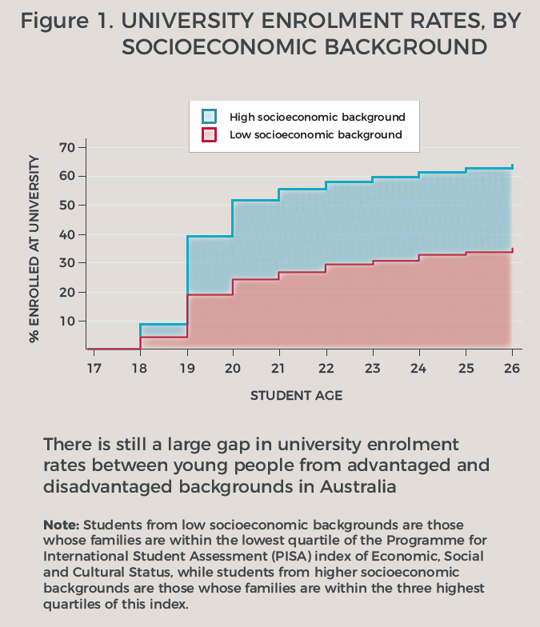

More significantly, the research demonstrates the critical role schools play in influencing young people’s educational outcomes, acting as both *enabling* and *equalising* agents.

Of the two sets of school factors investigated***,*** *both career guidance and school experiences were associated with an increasing probability to attend university****.*** That is, students who held positive attitudes towards school, who reported having a positive relationship with their teachers, and who received career guidance were more likely to enrol at university across all socioeconomic backgrounds. These school factors are universally beneficial to all students.

Importantly, *not all forms of career guidance were equal* in terms of their influence on university enrolment. The strongest *positive outcomes* were associated with *talks by TAFE or university representatives, and school’s career advisors.* By contrast, employer representative talks and group discussions about careers negatively affected the chances of university enrolment. Figure 10 shows the impact of selected school factors on university enrolments[[8]](#footnote-9).

Figure 10 University enrolment rates by school factors

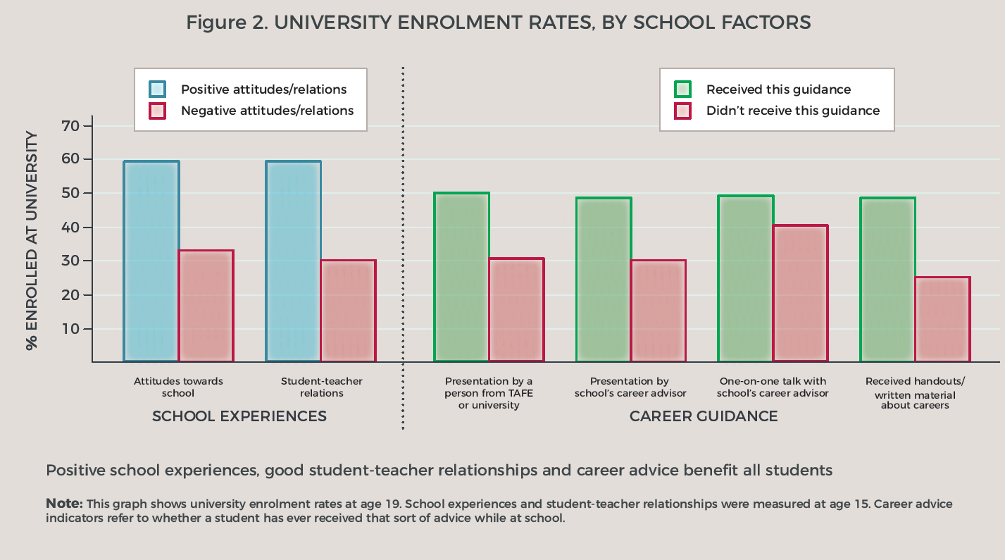

Finally, the level of impact of school factors on university enrolment varied for students from different backgrounds. Talks by school career advisors and university or TAFE representatives, along with positive student−teacher interactions, had *a stronger influence on students from low socioeconomic backgrounds* than on their more advantaged peers.

These findings show school can be central to developing interventions to widen university participation.

## School-based interventions are efficient and effective at closing the university participation gap

School-based interventions can positively influence students’ university enrolment and save government expenditure in the long run. Given the known benefits of tertiary education participation across life domains, having a greater pool of university-educated individuals will be beneficial for individuals and society as a whole.

Policy initiatives aimed at providing career guidance and positive school experiences have the potential to not only increase but also widen university participation amongst young Australians. This is because they can compensate for deficits in important resources, such as higher education aspirations or information, to which young people from low socioeconomic backgrounds often have little access.

Interventions to widen participation in higher education can be implemented at all phases of the student life course. This research highlights the importance of the pre-admission interventions that take place during secondary school, prior to students deciding whether or not to attend university. This is a critical stage and a period during which aspiration-building, appropriate role modelling and targeted information can strongly influence young people’s plans to enrol in university. In contrast, policies that provide support to students once they have enrolled at university miss the opportunity to influence those students who chose not to or could not enrol.

School-based interventions are also cost-effective for government in the long-term. They are preventative strategies and have fewer costs and greater returns on investment than remedial strategies, which compensate for social disadvantage due to poor education.

With lower costs and better potential outcomes, investments into school-based initiatives should be prioritised.

## References

Department of Employment, Education and Training 1990, *A fair chance for all: higher education that’s within everyone’s reach,* Department of Education, Science and Training, Canberra.

Tomaszewski, W, Perales, F & Xiang, N 2017, ‘Career guidance, school experiences and the university participation of young people from low socio-economic backgrounds’, *International Journal of Educational Research*, vol.85, pp.11−23.

# The underrepresentation of women in maths-intensive fields of study: the role of teenage occupational expectations, self-assessed maths competence and subject choice in Year 12

*Helen Law, University of Tübingen*

*This chapter is a summary of a 2018 paper by Law entitled ‘Gender and mathematics: pathways to mathematically intensive fields of study in Australia’,* Advances in Life Course Research*, vol.37, pp.42-56. Here a simplified version of the analyses published in that article are presented.[[9]](#footnote-10)*

## Research problem

While women in Australia and overseas have been increasing their participation in tertiary education, they continue to be underrepresented in maths-intensive fields, including engineering, information technology and the physical sciences (Charles & Bradley 2009). Such a phenomenon may not only hinder women from taking up employment opportunities in the thriving industries that require strong quantitative skills (Graduate Careers Australia 2014), but it may also contribute to the pay gap between men and women (Gerber & Cheung 2008). Across the world in the fields where women are often overrepresented, such as education and humanities, young workers carry a wage penalty. This phenomenon may also reinforce the beliefs in innate gender differences across society, including the view that males are more suitable for maths-intensive studies and careers. When young women, particularly those who are talented in maths, avoid maths-intensive studies because they perceive that those disciplines are not appropriate for their gender, their talents are underutilised, and their individual potentials are wasted.

Recent studies overseas have shown that the male advantage in maths and spatial ability does not explain why men dominate maths-intensive fields (Ceci & Williams 2010a, 2010b). They suggest that factors other than school maths achievement contribute to the underrepresentation of women in maths-intensive fields. Prior research, however, has rarely examined how occupational expectations, self-assessed maths competence and subject choice in secondary school influence the decisions of young Australian men and women to engage in maths-intensive studies.

Gender differences may emerge in occupational expectations and self-assessed maths competence during adolescence (Correll 2001; Tai et al. 2006). As suggested by the social stratification theory of gender essentialism, the gender essentialist ideology, which puts an emphasis on innate differences between males and females, is ubiquitous, particularly in advanced industrial societies, such as Australia (Charles & Bradley 2009). Children internalise gender stereotypical beliefs through socialisation and convert them into gender-typical aspirations and preferences that affect their subject choice in secondary and tertiary education (Blau, Brinton & Grusky 2006; Charles & Bradley 2009). Using the theory of gender essentialism, I assess how occupational expectations, self-assessed maths competence, and subject choice in secondary school may facilitate gendered choices of maths-intensive university studies in Australia (see figure 11).

Figure 11 Key factors that may influence a student’s chance of choosing a maths-intensive university major

**Occupational expectations   
at age 15**

**Self-assessed maths competence at age 15**

**Choice of advanced maths and physical science subjects in Year 12   
(at about age 18)**

**Choice of a maths- intensive bachelor’s degree**

**Gender essentialist ideology in advanced industrial countries, such as Australia**

Data from the 2003 cohort of the Longitudinal Surveys of Australian Youth (LSAY), also known as Y03, offer a great opportunity for examining the issue shown in figure 11 because they provide a wealth of information about students’ occupational expectations and educational experiences regarding maths. I examine the educational pathways of men and women from age 15 years through Year 12 to the engagement in maths-intensive fields at university. Therefore, I restrict the sample for analyses to students who reported that they completed Year 12, enrolled in a bachelor’s degree program between 2004 and 2013, and provided information on their fields of study. Specifically, I selected participants who completed Year 12, with 6747 participants meeting this criterion. Among these participants, 3712 enrolled in a bachelor’s degree program after completing Year 12. A total of 210 participants did not report their fields of study, and therefore the resulting pooled sample for the analyses comprises 3502 participants.

## How do men and women differ in their university major choices, occupational experiences, achievement and self-assessed competence in maths, and subject choices in Year 12?

Table 15 shows that, in the Y03 cohort, men were about four times more likely than women to choose a maths-intensive bachelor’s degree program (28% versus 7%). A striking gender difference exists in occupational expectations: 25% of men expected a maths-intensive career when they were 15 years old, whereas only 7% of women expected such a career. On average, men performed slightly better in maths and had a considerably higher level of self-assessed maths competence when they were 15 years old. While men were more likely to enrol in at least one subject in advanced maths (that is, the highest level of school maths, which involves significant calculus content) in conjunction with at least one subject in physical science in Year 12, men and women did not differ significantly in their enrolment rates in physical science or advanced maths in Year 12.

Table 15 Student characteristics by gender: proportions and means

|  |  |  |  |  |  |  |  |  |  |
| --- | --- | --- | --- | --- | --- | --- | --- | --- | --- |
|  | **Men** |  | **Women** |  | **Min.** |  | **Max.** |  | ***N*** |
| Choice of a maths-intensive degreea | 0.28 |  | 0.07 |  | 0 |  | 1 |  | 3 502 |
| Expected a maths-intensive career at age 15a | 0.25 |  | 0.07 |  | 0 |  | 1 |  | 3 248 |
| Maths achievement at age 15a | 604 |  | 575 |  | 259 |  | 842 |  | 3 502 |
| Self-assessed maths competence at age 15a | 0.55 |  | 0.32 |  | -2.12 |  | 2.42 |  | 3 500 |
| Relevant subject choice in Year 12 |  |  |  |  |  |  |  |  |  |
| Studied advanced maths and physical sciencea | 0.18 |  | 0.10 |  | 0 |  | 1 |  | 3 229 |
| Studied physical science only | 0.26 |  | 0.23 |  | 0 |  | 1 |  | 3 229 |
| Studied advanced maths only | 0.04 |  | 0.03 |  | 0 |  | 1 |  | 3 229 |

Note: Weighted estimates.

a indicates that the difference between men and women is statistically significant at *p* < 0.05.

Source: LSAY Y03.

## What are the relative contributions of occupational expectations, self-assessed maths competence and subject choice in Year 12 to the gender gap in university major choices?

To use maximum information in multivariate analyses, I used Stata 14 to impute missing values on the independent variables resulting from non-responses by chained equations. I used logistic regression models to analyse the Y03 data. I used the KHB decomposition method (Karlson, Holm & Breen 2012) to identify the extent to which each of these factors − students’ occupational expectations, self-assessed maths competence and relevant subject choice in Year 12 − contributes to the gender gap in choosing a maths-intensive university major. For further methodological details, refer to section 5 in Law (2018).

Table 16 presents the results of my multivariate analysis using logistic regression and the KHB method. Controlling for students’ maths achievement at age 15 years, Model 1 indicates that women are less likely to choose a maths-intensive field of study at university. With the inclusion of students’ occupational expectations, self-assessed maths competence and relevant subject choice in Year 12 in Model 2, the gender gap declines by 28%.

Table 16 Factors affecting enrolment in maths-intensive university degree programs: (1) coefficients from logit models and (2) percentage of the gender gap explained

|  |  |  |  |  |  |  |  |
| --- | --- | --- | --- | --- | --- | --- | --- |
|  | **Model 1** | | |  | **Model 2** | | |
|  | Coefficient |  | Standard  error |  | Coefficient |  | Standard  error |
| ***Individual characteristics*** |  |  |  |  |  |  |  |
| Gender (female) | -1.595\*\*\* |  | (0.113) |  | -1.192\*\*\* |  | (0.119) |
| Maths achievement at age 15 | 0.384\*\*\* |  | (0.066) |  | 0.044 |  | (0.074) |
| Expected a maths-intensive career at age 15 |  |  |  |  | 1.418\*\*\* |  | (0.116) |
| Self-assessed maths competence at age 15 |  |  |  |  | 0.370\*\*\* |  | (0.065) |
| Relevant subject choice in Year 12 |  |  |  |  |  |  |  |
| Studied advanced maths and physical science |  |  |  |  | 1.169\*\*\* |  | (0.168) |
| Studied physical science only |  |  |  |  | 0.551\*\*\* |  | (0.129) |
| Studied advanced maths only |  |  |  |  | 0.150 |  | (0.280) |
|  |  |  |  |  |  |  |  |
| Constant | -1.180\*\*\* |  | (0.147) |  | -2.220\*\*\* |  | (0.176) |
|  |  |  |  |  |  |  |  |
| ***Percentage (%) of the gender gap explained  (compared with Model 1)*** |  |  |  |  | 28.1 | | |

Note: The sample for these analyses contains 3502 students in 310 schools with multiple imputations of missing data. All analyses were undertaken using appropriate weights and adjusted for school clustering.   
\*\*\* p < 0.001.

Source: LSAY Y03.

I applied the KHB method to Model 2 to examine the independent contributions of students’ occupational expectations, self-assessed maths competence and relevant subject choice in Year 12 to the gender gap in choosing a maths-intensive university major (see table 17). Students’ expectations of a maths-oriented career at age 15 years holds the most promise of bridging the gender gap because such occupational expectations explain about 16% of the gender gap. The second most important factor to reduce the gender gap is students’ enrolment in advanced maths in conjunction with physical science in Year 12. Such a subject combination explains about 6% of the gender gap. Although self-assessed maths competence does not appear as influential as occupational expectations in bridging the gender gap in the selection of a maths-intensive major, it explains about 5% of the gap.

Table 17 Percentage of the gender gap in the choice of a maths-  
intensive major explained by each factor: the KHB method

|  |  |  |
| --- | --- | --- |
| Expected a maths-intensive career at age 15 |  | 16 |
| Self-assessed maths competence at age 15 |  | 5 |
| Relevant subject choice in Year 12 |  |  |
| Studied advanced maths and physical science |  | 6 |
| Studied physical science only |  | 1 |
| Studied advanced maths only |  | 0.1 |

Source: LSAY Y03.

## Summary

The LSAY Y03 cohort provides valuable information on students’ occupational expectations and educational experiences with respect to maths. Therefore, in this study, I could consider the extent to which students’ occupational expectations, self-assessed maths competence and subject choice in secondary school would contribute to the gender gap in enrolling in a maths-intensive university major. Overall, the gender gap could be reduced by about 28% if women in adolescence were as likely as men: to expect maths-oriented careers; to have more confidence in their maths competence in secondary school; and to engage at higher rates in advanced maths and physical science subjects in Year 12. I found that the expectation of a maths-intensive career had the greatest potential to reduce the gender gap. The study of advanced maths and physical science subjects in Year 12 is the second most important factor in bridging the gender gap. Self-assessment of maths competence appears to be the least important factor, but it still explains part of the gender gap.

Given the prevalence of gender egalitarian ideology since the 1970s, Australian women have been encouraged to pursue tertiary education credentials and professional occupations. Although many women thrive in their careers, the integration of women into the maths-intensive sciences has remained slow. This study implies that talented women, those who could be successful in maths-intensive fields of study and employment, already begin to disengage from maths and related disciplines early in their educational career. This phenomenon is not only a waste of individual talent and potential but also a loss for society, as the Australian economy has a huge demand for skilled workers with strong quantitative skills (Australian Academy of Science 2016). As suggested by the theory of gender essentialism, the underrepresentation of females in maths-intensive disciplines has deep societal and structural roots, which will not be transformed by a few isolated policy interventions. To fully unleash the potential of females in maths-related areas, we need to alleviate the gender stereotypical beliefs and social barriers associated with maths learning and careers.

## References

Australian Academy of Science 2016, *The mathematical sciences in Australia: a vision for 2015*, Australian Academy of Science, Canberra.

Blau, FD, Brinton, MC & Grusky, DB (eds) 2006, *The declining significance of gender?*, Russell Sage Foundation, New York.

Ceci, SJ & Williams, WM 2010a, *The mathematics of sex: how biology and society conspire to limit talented women and girls*, Oxford University Press, New York.

−−2010b, ‘Sex differences in math-intensive fields’, *Current Directions in Psychological Science*, vol.19, no.5, pp.275−79.

Charles, M & Bradley, K 2009, ‘Indulging our gendered selves? Sex segregation by field of study in 44 countries’, *American Journal of Sociology*, vol.114, no.4, pp.924−76.

Correll, SJ 2001, ‘Gender and the career choice process: the role of biased self-assessments’, *American Journal of Sociology*, vol.106, no.6, pp.1691−730.

Gerber TP & Cheung SY 2008, ‘Horizontal stratification in postsecondary education: forms, explanations and implications’, *Annual Review of Sociology*, vol.34, pp.299−318.

Graduate Careers Australia 2014, *An analysis of the gender wage gap in the Australian graduate labour market, 2013*, Graduate Careers Australia, Melbourne.

Karlson, KB, Holm, A & Breen, R 2012, ‘Comparing regression coefficients between same-sample nested models using logit and probit: a new method’, *Sociological Methodology*, vol.42, no.1, pp.286−313.

Law, H 2018, ‘Gender and mathematics: pathways to mathematically intensive fields of study in Australia’, *Advances in Life Course Research*, vol.37, pp.42−56.

Tai, RH, Li, CQ, Maltese, AV & Fan, X 2006, ‘Planning early for careers in science’, *Science*, vol.312, no.5777, pp.1143−4.

# Juxtaposing maths self-efficacy and self-concept as predictors of long-term achievement outcomes

*Philip Parker, Australian Catholic University*

*The following is a summary of Parker, PD, Marsh, HW, Ciarrochi, J, Marshall, S & Abduljabbar, AS, ‘Juxtaposing math self-efficacy and self-concept as predictors of long-term achievement outcomes,* Educational Psychology*, vol.34, pp. 29-48.*

Theories of skill-biased technological change have highlighted the increasing returns that come from investing in higher education (Goldin & Katz 2007). Australia has recognised the implications of this change and has focused policy on increasing higher education in efforts to remain internationally competitive. The Bradley review of 2008 raised concerns about the waste of talent that diminished Australia’s international competitiveness due to declining numbers of people with a tertiary degree (Bradley et al. 2008). In 2011, Senator Christopher Evans, the then Minister for Tertiary Education, Skills, Jobs, and Workplace Relations, argued that it was critical to cultivate the capability of ‘the reserve of talented young Australians who don’t consider university as an option for them’. In 2012 the Prime Minister, Julia Gillard emphasised that ‘to win the economic race, we must first win the education race. For our children to get the jobs of the future, we must give them a great education now’.

Much of the focus on increasing young people’s chances of entering higher education has been on improving retention through schooling, providing programs to disadvantaged youth, and intervening to improve young people’s academic skills. Yet, the choice to enter university is not only dependent on children’s intellectual ability or position in society: non-cognitive factors — motivation, self-concept and self-regulation — are also factors that determine how young people make choices. Focusing on non-cognitive development is a move in the right direction. But more research is needed into which non-cognitive factors are important for which outcomes. Here, I summarise research I undertook on the role that maths self-efficacy and maths self-concept may play in predicting: future achievement; university entry; and university course selection, using the 2003 cohort of the Longitudinal Surveys of Australian Youth (LSAY).

## Self-beliefs

Self-beliefs predict a range of important outcomes across several life domains (Bandura 1986; Marsh 2007). Research has shown that self-efficacy plays an important role in task choice, achievement goals and goal pursuit (see Bong & Skaalvik 2003; Marsh, Walker & Debus 1991). In addition, there is now extensive evidence that self-efficacy predicts academic achievement, controlling for prior achievement (see Pajares & Schunk 2001). There is also convincing evidence that academic self-concept predicts later achievement, controlling for prior achievement (see Marsh 2007). Self-concept also predicts performance in high-stakes university entrance exams (Marks, MacMillan & Hillman 2001), and university entry, controlling for prior achievement (Parker et al. 2012).

Both self-efficacy and self-concept are important predictors and yet rarely are they contrasted to determine their relative contributions to academic outcomes. This may be due to a belief that they are similar. This is not the case. Children’s academic self-concepts are based on normative judgments about relative ability within a particular context. The context includes time (am I better today than I was yesterday), domain (am I better at maths than I am at English), and social (am I better than my classmates; see Parker, Van Zanden & Parker 2018 for a review). Self-concept is usually measured by asking participants to make global judgments like ‘I am good at maths’.

Self-efficacy measures participants’ positive beliefs about their ability to complete a specific task. For example, self-efficacy may be measured by asking a participant ‘can you calculate the area of a room in square metres?’. Research has found that self-efficacy and self-concept have independent though roughly equal effects on achievement (Valentine et al. 2004). However, we would not expect them to have the same effect on academic choices because children form their self-concept evaluations based on their relative strengths (I think I am good at maths, both because I am better than others and because I am better at maths than I am at English). This ipsative comparison of relative strengths leads us to hypothesise that self-concept would be a better predictor than self-efficacy of judgments requiring youth to choose between different university courses (should I complete an engineering degree or an English literature degree?). We call these horizontal choices, and our focus was on whether youth chose to undertake degrees in science, technology, engineering, and mathematics (STEM) at university. Because self-efficacy is related to concrete ability, we would expect it to be a better predictor of whether or not to continue on in education. We call these vertical choices. For vertical choices we focused on whether youth went to university.

Putting all of these pieces together, we expected achievement in maths and science to predict maths self-concept and self-efficacy positively. We also expected literary achievement to predict maths self-concept negatively and not be related to self-efficacy. We then expected both self-concept and self-efficacy to predict a student’s university entrance scores, controlling for prior achievement. University entrance scores are now called Australian Tertiary Admission Ranks (ATARs) but at the time of testing they carried different names, according to the state in which the child was schooled. Finally, controlling for prior achievement and university entrance scores, we expected maths self-efficacy to predict university entry but not STEM university majors. We expected the opposite pattern for maths self-concept. This model is presented in figure 12.

Figure 12 Simplified hypothesised model

Note: expected positive path are in red and negative paths are in blue

To test these hypotheses, we used the 2003 LSAY, which followed a representative sample of Australian youth from the ages of 15 to 22 years old. The initial time wave of this database is the 2003 Programme for International Student Assessment (PISA) sample, where science, maths and reading achievement tests, mathematics self-concept and mathematics self-efficacy were collected. We extracted university entrance scores, university entrance, and STEM major selection from the remaining waves of LSAY. We used structural equation modelling using cluster robust estimation to test the model presented in figure 12. The results are presented in table 18.

Table 18 Model results: adjusted for covariates

|  |  |  |  |  |  |  |
| --- | --- | --- | --- | --- | --- | --- |
|  |  | **Self-efficacy** | **Self-concept** | University entrance score | **University entry** | **STEM course** |
| Self-efficacy |  | - | - | .16(.02)\*\*\* | .06(.03)\* | .05(.05) |
| Self-concept |  | - | - | .09(.02)\*\*\* | .01(.02) | .17(.04)\*\*\* |
| TER |  | - | - | - | 1.21(.08)\*\*\* | -.02(.07) |
| Achievement |  |  |  |  |  |  |
| Maths |  | .42(.02)\*\*\* | .58(.03)\*\*\* | .26(.03)\*\*\* | .20(.10)\*\*\* | .01(.10) |
| Reading |  | -.22(.03)\*\*\* | -.32(.04)\*\*\* | .16(.03)\*\*\* | .31(.10)\*\*\* | -.04(.13) |
| Science |  | .37(.02)\*\*\* | .17(.03)\*\*\* | .05(.04) | .09(.10) | .10(.12) |
| R-square |  | .41 | .25 | .43 | .57 | .06 |

*Notes.* \* p < .05, \*\* p < .01, \*\*\* p < .001. Standard errors are in parentheses. Model adjusted for socioeconomic status, year level at first wave of testing, gender, immigrant status, and Indigenous status.

We found that achievement predicted both self-beliefs. Controlling for prior achievement and a host of covariates, we also found that self-concept and self-efficacy were significant predictors of university entrance scores. Further, we found that self-efficacy was a significant predictor of university entry, and self-concept was a significant predictor of STEM course selection. The results provide longitudinal support for the distinct value of self-efficacy and self-concept in predicting high-stakes outcomes.

## Implications

When academic outcomes are based on progression — what we call vertical decisions — then descriptions of competence such as those found in self-efficacy are likely to be among the most important non-cognitive predictors. This is because an individual’s decision on whether to go to university depends on their expectations of being successful in that arena. For outcomes which depend on the choice between academic domain options — what we call horizontal decisions — self-concept may be the most important non-cognitive factor. This is because self-concept reflects normative assessments — am I better at this than that — rather than positive statements about whether I can do a specific task. Thus, self-concepts help young people to make choices from a range of similar options, meaning that individuals who are gifted in all academic areas are likely to qualify for university but their choice of whether to take a STEM major will depend on whether they consider their maths or verbal abilities as their main strength (Parker et al. 2012). This may well have implications for efforts to increase participation in STEM. In particular it will not be enough for young people to think of themselves as good at science and maths; they may also need to think of themselves as relatively better at these subjects than literacy, history, and the humanities (Parker et al. 2012).

Since Heckman (2006), research has bloomed on the role of non-cognitive factors in predicting academic outcomes. This research has cut across disciplines, making non-cognitive research one of the most interesting areas in which to work. From this body of research, we can now say with some confidence that success in life requires more than just ‘smarts’, and educational policy would be wise to consider how to promote helpful non-cognitive skills. What we now need is more nuanced research on which non-cognitive factors are helpful for what outcome under which conditions. LSAY data are well placed to contribute to this much needed area of research.

## 

## References

Bandura, A 1986, ‘The explanatory and predictive scope of self-efficacy theory’, *Journal of Social and Clinical Psychology*, vol.4, pp.359−73.

Bong, M & Skaalvik, EM 2003, ‘Academic self-concept and self-efficacy: how different are they really?’, *Educational Psychology Review*, vol.15, pp.1−40.

Bradley, D, Noonan, P, Nugent, H, & Scales, B 2008, *Review of Australian higher education*, Department of Education, Employment and Workplace Relations, Canberra.

Evans, C 2011, speech from the Australian Financial Review Higher Education Conference, 28 June 2011.

Gillard, J 2012, ‘A national plan for school improvement’, speech to National Press Club, Canberra, 3 September 2012.

Goldin, C & Katz, LF 2007, *The race between education and technology: the evolution of US educational wage differentials, 1890 to 2005*, NBER working paper no.12984, National Bureau of Economics Research, Washington, DC.

Heckman, JJ 2006, ‘Skill formation and the economics of investing in disadvantaged children’, *Science*, vol.312, pp.1900−12.

Marks, G, MacMillan, J, & Hillman, K 2001, *Tertiary entrance performance: the role of student background and school factors*, Australian Council for Educational Research, Camberwell, Vic.

Marsh, HW 2007, *Self-concept theory, measurement and research into practice: the role of self-concept in educational psychology*, British Psychological Society, Leicester, UK.

Marsh, W, Walker, R & Debus, RL 1991, ‘Subject-specific components of academic self-concept and self-efficacy’, *Contemporary Educational Psychology*, vol.345, pp.331−45.

Pajares, F & Schunk, D 2001, ‘Self-beliefs and school success: self-efficacy, self-concept, and school achievement’, in RJ Riding & SG Rayner (eds), *International perspectives of individual differences,* Ablex Publishing, Westport, CT, pp.239−66.

Parker, PD, Marsh, HW, Ciarrochi, J, Marshall, S & Abduljabbar, AS 2014, ‘Juxtaposing math self-efficacy and self-concept as predictors of long-term achievement outcomes’, *Educational Psychology*, vol.34, pp.29−48.

Parker, PD, Schoon, I, Tsai, Y, Nagy, G, Trautwein, U & Eccles, J 2012, ‘Achievement, agency, gender, and socioeconomic background as predictors of postschool choices: a multi-context study’, *Developmental Psychology*, vol.48, pp.1629−42.

Parker, PD, Van Zanden, B & Parker, R B 2018, ‘Girls get smart, boys get smug: historical changes in gender differences in math, literacy, and academic social comparison and achievement’, *Learning and Instruction*, vol.54, pp.125−37.

Valentine, JC, DeBois, DL & Cooper, H 2004, ‘The relation between self-beliefs and academic achievement: a meta-analytic review’, *Educational Psychologist*, vol.39, pp.34−41.

# 

# Section 5: Employment and post-school outcomes

Transitions for young people continue to change, and the duration of post-school education and training has increased substantially over recent decades. LSAY provides a rich source of information on patterns of post-school outcomes for participants, whether this is going on to further study, attempting to join the workforce, or taking a gap year.

Following a cohort over a decade allows us to track progress from secondary school through to employment. Previous LSAY data have shown that attaining higher levels of education leads to finding work at faster rates: young people who complete Year 12 or a post-school qualification find employment more quickly than those who leave school early (Fitzpatrick et al. 2011). However, it is crucially important that data are also collected about those who do not make the transition as successfully and may find themselves disengaged.

Data from the surveys also show that there are differences by gender. More highly educated women gain employment faster than women who are less educated, but this difference is not evident for men (Fitzpatrick et al. 2011).

The research included in the fourth section of this book uses data from a range of cohorts and time periods, and, despite examining a diverse range of topics, all focus on the post-education outcomes of young people. The first paper in this section looks at the occupational expectations of young people, using data from across the first two decades of LSAY. Sikora examines how the educational and occupational plans of young people affect their later education and employment. Stanwick, in the paper that follows, discusses research investigating the increasing rates of taking a gap year, and how this affects the likelihood of being in full-time employment at the age of 24 years. In the next paper, Anlezark uses data from Y03 to investigate whether engaging in casual work while at secondary school is beneficial, using post-school outcomes to gauge whether it helps in terms of gaining employment. Finally, Forrest looks at the consequences for young people who are not in education, employment, or training (NEET).

## Reference

Fitzpatrick, D, Lester, L, Mavromaras, K, Richardson, S & Sun, Y 2011, *From education to employment: how long does it take?,* NCVER, Adelaide.

# Adolescent occupational expectations: two decades of LSAY-based research

*Joanna Sikora, Australian National University*

## Introduction

For decades, the Longitudinal Surveys of Australian Youth (LSAY) have been one of the best sources of information about the occupational expectations and attainments of young Australians. With comprehensive data collections going back to the 1990s, these surveys have provided high-quality information on the extent to which the educational and occupational plans of teenagers predict their attainments later in life and how this varies by gender and socioeconomic background.

This review presents the key insights from research on expectations that focused on the concepts of teenage ambition, lost talent and occupational uncertainty. Of particular interest are the consequences of teenage career plans and the gender divide in science-related occupational expectations. This last theme is related to recent efforts to enhance gender equity in Australian science through the Science in Australia Gender Equity program (SAGE) and similar initiatives.

## Teenage ambition: most youth hope to enter the professions – is this unrealistic?

Figure 13 Occupational plans LSAY Y09

**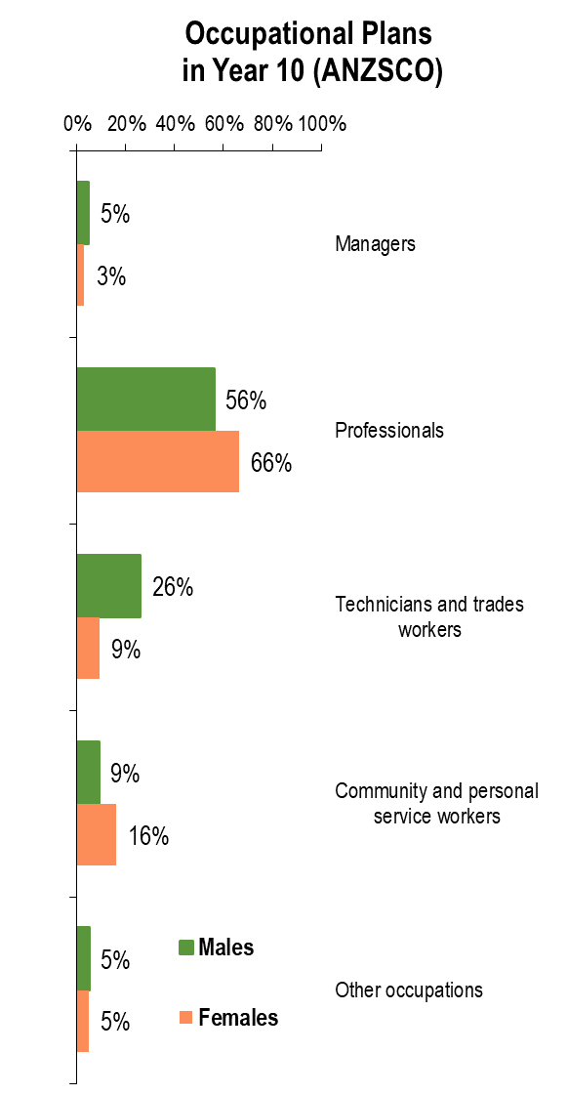**The LSAY data on different cohorts of Australian teenagers who were 15 years of age sometime between 1999 and 2015 consistently show that youth have very ambitious occupational expectations, with most of them expecting a career in professional occupations, which require a university degree at entry. This is illustrated in figure 13, which shows the breakdown of occupational plans among 15-year-olds in the first wave of LSAY Y09 (Sikora & Biddle 2015). The categories are one-digit groups of the Australian and New Zealand Standard Classification of Occupations (ANZSCO). In 2009, 56% of 15-year-old boys and 66% of girls in the same age group planned to become professionals, while the proportions of professionals in the adult population were significantly lower than these figures (Sikora & Biddle 2015). Such a discrepancy raises concerns that many adolescents have unrealistic future plans, which will generate discontent and high levels of stress. The positive interpretation of this phenomenon, however, points out that occupational ambition in young people encourages them to aim for university education, which in the long run is more likely to lead to desirable rather than negative outcomes, even if not all young people realise their most ambitious expectations. Notwithstanding that, occupational optimism, that is, the expectation to enter the highly skilled professional jobs, might be more prevalent among adolescents from advantageous socioeconomic backgrounds. An important question is whether students from less affluent backgrounds are likely to adjust their initially ambitious expectations down even if, at school, they are above-average achievers.

## What is talent loss in the context of educational and occupational expectations? Does Australia lose much teenage talent?

Researchers investigating occupational optimism have long been interested in students’ socioeconomic status (SES) as a potential determinant of adolescent ambitions (Sikora & Saha 2011). In this context, different definitions of talent loss have been proposed, but all of them hinge on measuring student expectations at different life stages and then determining whether these become less ambitious as students mature and gain more awareness of the potential social-structural barriers to their attainment (Sikora & Saha 2011).

For instance, LSAY Y98 secondary students were asked about their occupational expectations in 1999 and 2001, that is, in Years 10 and 12. Figure 14 presents the proportions of students who lowered or failed to realise their educational or occupational expectations. Four understandings of talent loss are considered in turn. First, ‘lowered educational expectations’, are taken to be equivalent to the changes in students’ initial expectations to attend university. A student is assumed to have experienced talent loss if initially, that is, in 1999, they reported an intention to go to university, but at some point between 1999 and 2001 they made a permanent switch to obtaining a non-university qualification. According to this definition, 15% of students whose academic performance placed them in the top 50% lowered their educational expectations in upper secondary school (figure 14).

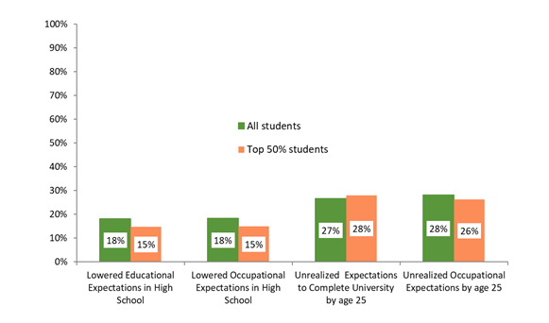 Figure 14 Prevalence of talent loss in LSAY Y98

The second definition of talent loss depicts changing occupational expectations from highly skilled professional destinations to careers that require more on-the-job and less formal training. Students who initially planned to work in professional or managerial occupations and later reported other occupations as their expected careers are considered to have made a downward adjustment in terms of occupational status. Among the top 50% achievers, there were 15% of such students. Finally, over one-quarter of Y98 participants failed to achieve their teenage goals by the time they had turned 25, which can be also seen as talent loss, at least for strong academic performers. These are the remaining two types of talent loss. However, it must be borne in mind that for some of these young people the realisation of their early ambitions might have occurred after their 25th birthday, so these are not conservative estimates.

Overall, the occurrence of talent loss has been no more than moderate among young Australians, which is reassuring, given the need for well-educated workers in the Australian economy. However, one concerning aspect of the pattern in figure 14 is the fact that students from lower SES backgrounds had a significantly stronger propensity for downward adjustments of their initially ambitious educational and occupational expectations, all else being equal. Thus, Australian teenagers who come from disadvantaged socioeconomic backgrounds are more likely to experience some form of talent loss.

## What proportion of Australian youth does not know what job they want in adulthood? Does it matter if they don’t know? How?

Figure 15 Occupational uncertainty LSAY Y06

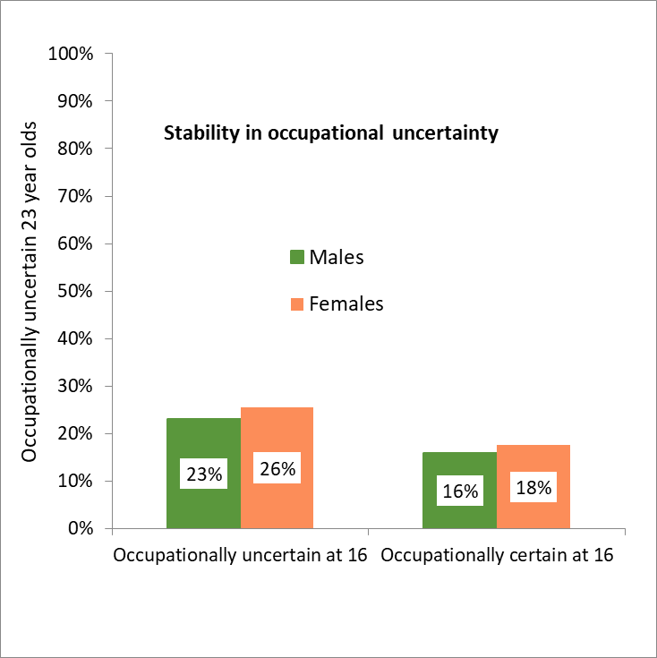The LSAY data on teenage occupational expectations also highlight that some young people are unable to articulate the occupation they want to pursue at the age of 30 years (Sikora 2018). In the older tradition of youth studies this occupational uncertainty was usually construed as a form of social disadvantage, or aimlessness, mostly because teenagers from disadvantaged socioeconomic backgrounds were more likely to be occupationally uncertain; the occupationally uncertain youth in the United States were found to attain less than their more vocationally decided peers (Sikora 2018). In the last two decades, however, a counter-argument has been proposed, in which occupational uncertainty in adolescence was not viewed as a cause for concern but rather a form of flexibility, which enables youth to explore several potential roles and which can be beneficial in the preparation for the volatile and fluid labour market of the 21st century. The analysis of this issue for the cohort who were 15 years of age in 2006 (figure 15) shows that occupational uncertainty, which is essentially not being able to name the occupation in which one wants to work on their 30th birthday, persists from adolescence to young adulthood. Twenty-six per cent of females who are occupationally uncertain at age 15 were also unsure what their future career would be when they reached 22 years of age. The corresponding figure for males was 23%. This contrasted with 16% and 19% for men and women respectively who did have some career plan at the age of 15 years but could not articulate what they wanted to do when they were asked again around their 22nd birthday. So, teenage uncertainty raises the chances of occupational uncertainty in young adulthood by 45% (the estimates in figure 15 are adjusted predicted probabilities from table 2 in Sikora 2018, which controlled for academic achievement, enjoyment of school and student socioeconomic background, as well as Indigenous and migration status). What is not shown in figure 15 is that occupationally uncertain young adults have lower expected lifetime earnings than their comparable peers. The disadvantage is not as large as what was found in the United States, nevertheless, the negative effect is statistically significant, amounting to about a 6% decrease in expected lifetime earnings. So, in Australia occupational uncertainty among young adults is a form of aimlessness rather than beneficial flexibility. This is the case both for young men and women.

## Do boys and girls prefer different jobs? Are girls in recent cohorts as likely as boys to expect a career in science?

Figure 16 Gender gap in science-related career expectations

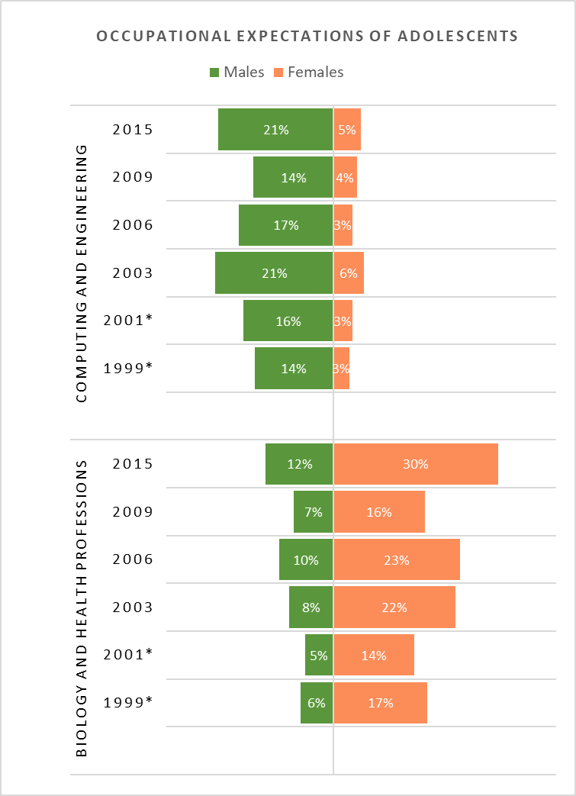

The careers that teenagers expect to pursue vary significantly between boys and girls. This gender divide is particularly interesting to consider in the context of science professions because of the often-voiced concerns about women’s underrepresentation in Australian science (Sikora 2014b). However, not all areas of science are affected by female underrepresentation. The fields of science related to biology, environmental sciences, health services and medicine attract more teenage females than males. In contrast, computing, engineering and mathematics appeal to relatively few young women (Sikora 2014a; Sikora & Pokropek 2012).

This gender segregation in the science-related career expectations of adolescents is an ongoing phenomenon. Figure 16 shows the breakdown by gender for youth who were about 15 years of age in 1999, 2001, 2003, 2006, 2009 and 2015. In all cohorts the gender gap is evident, so the efforts to encourage boys and girls to opt for non-traditional areas of science specialisation so far have had only moderate success. Why do more males opt for different areas of science than females? One of the most common explanations is that girls are socialised to choose occupations they think of as working with other people or helping others, while boys are socialised to opt for occupations that deal with technological problem-solving and construction. Therefore, even when young people of different genders have comparable mathematical aptitudes, they often choose to apply their quantitative skills in different fields of science (Sikora & Pokropek 2012). Adolescent expectations also reflect to some degree the actual segregation in the labour force: women are underrepresented in computing, engineering and mathematics but not at all or considerably less so in biology, health services or environmental sciences.

\*The samples in 1999 and 2001 are grade-based, while all later samples are age-based.

## Are teenage expectations consequential? How many 25-year-olds still plan on entering science careers chosen at age 15?

Teenage expectations to enter specific occupations would have little information value if they were poor predictors of the later educational and occupational attainment of young people (Sikora 2015). In fact, they are quite good predictors. This does not mean, however, that adolescents do not change their minds, as they enter adulthood. Figure 17 shows that vocational orientation towards science begins relatively early; of males who knew at age 15 that science occupations were not of interest to them, 88% were still of this view at the age of 22, and of these males, 93% still thought so when they turned 25. The corresponding proportions of females were very similar. Science-oriented teenagers, boys and girls alike, tended to switch to non-science occupational plans as they got older.

Figure 17 Stability of science-related career expectations LSAY Y06 (Sikora 2019)

**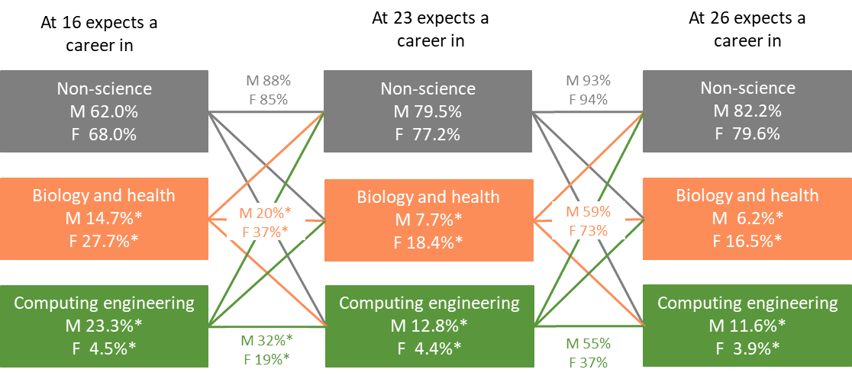**

Note*:* \*Statistically different at p = .05 between males and females

Of 14.7% of teenage males interested in biology or health-related occupations, only 20% retained the same preference until age 22, but still this was over twice the average preference among males at 23%, which was only 7.7% of males. Over the next three years 59% of those males kept the same occupation plan, contributing to the overall 6.2% males who still planned to work in biology or health at the age of 25. For women, the exit rates in this expectation pathway were lower, reducing from 27.7% to 16.5% by the age of 25, but many females in this group also switched to a non-science occupation, with only 37% retaining their initial plan (which, nevertheless, was significantly higher than 20% of men). Plans stabilised for females between the ages of 22 and 25, as 73% of the 18.4% women who wanted a biology- or health-related job at age 22 years still wanted one at age 25 years.

The stability in teenage plans concerning computing and engineering, where males are overrepresented, formed a different pattern. Youth in this pathway also tend to switch to non-science jobs as they get older, but females are more likely than males to abandon this career plan between the ages of 16 and 23 years (as 32% of teenage men retain it in contrast to only 19% of females). Later, the exit rates are similar for men and women, as they were in case of the biology and health career plans. Yet, the proportion of women who plan a computing or engineering career, although very low, remains very stable at ages 15, 22 and 25. Women switch to non-science but at rates that leave about 4% of them always in this career expectation path. These patterns raise questions for future research. For instance, what are the key reasons why youth abandon their teenage plans to specialise in science? The analyses shown here suggest that interventions at tertiary level to bridge the gender segregation in these science fields come too late, unless their sole goal is to help students who have already started a science degree not to drop out. The real challenge, however, is to raise the supply of science applicants to tertiary institutions and, particularly, to encourage more males and females to form an interest in careers in science fields that are atypical for their sex or gender (Sikora 2014b).

## Summary

While the two decades of LSAY-based research on the occupational expectations of young Australians delivered many important insights into the role that youth motivation plays in educational and occupational careers and attainments, many questions remain open. Some of them concern the consequences of unrealised ambitious expectations: do teenagers adjust, or do they suffer if their teenage ambitions remain unrealised? Others are associated with understanding the consequences of talent loss: does the downward adjustment of educational and occupational plans have any serious consequences for youth from lower socioeconomic backgrounds who were above-average school achievers? What are the key processes that sustain the youth focus on professional occupations and what are the key factors that sustain gender segregation in science-related plans across generations? Finally, what are the best ways to retain youth in science-career pathways? As LSAY data collections on the occupational expectations of young Australians continue, data on how and why occupational expectations matter in Australia will hopefully provide comprehensive answers to these questions.

## References

Sikora, J 2014a, ‘Gender gap in school science: are single-sex schools important?’*, Sex Roles*, vol.70, no.9−10, pp.400−15.

−−2014b, *Gendered pathways into the post-secondary study of science*, NCVER, Adelaide.

−−2015, ‘Gender segregation in Australian science education: contrasting post-secondary VET with university’, in C Imdorf, K Hegna & L Reisel (eds), *Comparative social research: gender segregation in vocational education*, Emerald, Bingley, UK, pp.263−89.

−−2018, ‘Aimless or flexible? Does uncertainty in adolescent occupational expectations matter in young adulthood?’, *Australian Journal of Education*, vol.62, no.2, pp.154−68.

--2019, ‘Is it all about early occupational expectations? How the gender gap in two science domains reproduces itself at subsequent stages of education: Evidence from longitudinal PISA in Australia. *International Journal of Science Education*, 1-22.

Sikora, J & Biddle, N 2015, ‘How gendered is ambition? Educational and occupational plans of Indigenous youth in Australia’, *International Journal of Educational Development*, vol.42, pp.1−13.

Sikora, J & Pokropek, A 2012, ‘Gender segregation of adolescent science career plans in 50 countries’, *Science Education*, vol.96, no.2, pp.234−64.

Sikora, J & Saha, L 2011, *Lost talent? The occupational ambitions and attainments of young Australians*, NCVER, Adelaide.

# Who takes a gap year and why?

*John Stanwick, NCVER*

*The analyses in this section have been drawn from a 2012 NCVER briefing paper by M Lumsden and J Stanwick, entitled* Who takes a gap year and why? *The analyses in that briefing paper, in turn, were drawn to a large extent from a 2012 NCVER report by D Curtis, P Mlotkowski and M Lumsden, entitled* Bridging the gap: who takes a gap year and why?

Taking a gap year, that is a break between finishing school and starting university, is an increasingly popular choice among young people. There is also an increasing number of activities that young people undertake during their gap year. While it was originally a break between finishing school and commencing university, it now involves a wide variety of (structured) activities, including travel, volunteering, military service, employment and non-university study.

A few conceptual issues surround the term ‘gap year’, in terms of its length, its intention, the age group to which it is intended to apply, and the routes to and from the gap year. This has led to several definitions of ‘gap year’ within the literature. However, for the purposes of meaningful comparisons to inform policy, a tight definition is more useful. Curtis, Mlotkowski and Lumsden (2012) use the following definition for their analyses:

*An individual who commenced university one to two years after completing Year 12. This includes those who accept and defer their university placement for one to two years.*

The data for the analyses have been taken from four cohorts of the Longitudinal Surveys of Australian Youth (LSAY) – Y95, Y98, Y03 and Y06. Prior to 2008, information on gap taking was inferred from activities undertaken after completing Year 12, rather than being explicitly asked in the LSAY questionnaires. However, since 2008, respondents in the relevant cohorts have been explicitly asked whether their main activity after completing Year 12 was taking a gap year.

## Incidence of gap-year taking

The incidence of gap-year taking has been on the rise over time. Examining information across the LSAY cohorts (using the definition by Curtis, Mlotkowski & Lumsden 2012), table 19 shows that, while 10% of school leavers who went on to university in 1999−2000 took a gap year, this had risen to 25% in 2006−07 and 24% in 2009−10.

Table 19 Gap-year taking over time by study status (%)

|  |  |  |  |  |
| --- | --- | --- | --- | --- |
| **Gap-taking status** | **Gap-taking years** | | | |
|  | 1999−2000 | 2002−03 | 2006−07 | 2009−10 |
| No gapa | 85 | 78 | 69 | 76 |
| 1-year gap | 7 | 12 | 20 | 22 |
| 2-year gap | 3 | 4 | 5 | 1 |
| Later entrantsb | 5 | 5 | 6 | 0 |
| Total (%) | 100 | 100 | 100 | 100 |
| Percentage gap takers | 10 | 16 | 25 | 24 |
| Number of gap takers | 366 | 549 | 846 | 753 |

Notes: a No gap: those that go directly from Year 12 to university.

b Later entrants are those who begin university more than two years after completing school. For 2009−10 data are limited on later entrants. These are not included as gap takers.

Data are for students who commenced university.

The proportion of university commencers taking more than two-year gaps is limited by the span of the data collections. Numbers may not sum to 100 because of rounding.

Source: 1999−2000 and 2002−03 columns sourced from Curtis, Mlotkowski and Lumsden (2012); 2006−07, and 2009−10 refers to the LSAY Y03 and Y06 cohorts respectively, unpublished data.

Some of the reasons that may explain the increase in gap-year taking include:

* labour market conditions: good economic conditions where jobs are relatively easy to find; young people may take advantage of this to gain work experience
* financial cost associated with study: some students undertake a gap year for financial reasons, such as working to earn money to allay the costs associated with study, or to take advantage of the Youth Allowance scheme, as it was at that time
* gap-year ‘industry’: there is now an industry devoted to the gap year (see <http://www.gapyear.com>); in addition, many initiatives and schemes have been developed to entice young people to take a gap year.

The inclusion of ‘taking a gap year’ as a specific category of activity in LSAY after completing Year 12, allows the comparison of intentional versus unintentional gap taking. Looking at the post-Year 12 plans of 17-year-olds interviewed in 2008 (from the Y06 cohort), 9.7% or 514 Year 12 students indicated ‘take a gap year’ as their immediate post-school plan. However, table 19 indicates that 753 students who went on to university in 2009−10 (Y06 cohort) took a gap year. This implies that there may have been some ‘unintentional’ gap taking.

Other data in LSAY provide information on the proportion of young people who actually commence university according to post-school intentions and gap-year status. This analysis shows that a proportion of students not stating university as a post-school intention take a gap year and actually go on to commence university. For these students, the gap year may have provided an opportunity to reflect on their aspirations and realign their goals.

## Characteristics of gap-year takers

The incidence of taking a gap year varies by the socio-demographic characteristics of the young people as well as by school-related characteristics. Previous research, by Milne, Kennedy and Ward (2009), has found that gap-year incidence varies by factors such as home location (increased incidence outside capital cities) and academic achievement (those with lower academic achievement). Birch and Miller (2007) additionally found those offered low-preference courses and being from an English-speaking background to be more likely to take a gap year. However, they found no difference by gender.

The analysis of the four cohorts of LSAY also found similar characteristics. In addition, there was a greater occurrence of gap-year taking among those who were employed full-time or part-time in Year 12 by comparison with those who were not employed for the Y03 and Y06 cohorts (data not available for the other two cohorts). There was little difference in gap-year taking between females and males.

It was also found that the incidence of gap-year taking increased across all characteristics over time. For some characteristics, the incidence increased to a large extent. For example, while 8% of young people whose parental education background was ‘technical qualification’ were gap-year takers in 1999−00, 26% were in 2009−10.

## The activities of gap-year takers (including economic activity)

The following table shows the activities of gap-year takers.

Table 20 The main activities of gap-year takers at average age of 18.7 years, 2006−07 and 2009−10

|  |  |  |  |  |
| --- | --- | --- | --- | --- |
| Main activity | 2006−07 | | 2009−10 | |
|  | *N* | % | *N* | % |
| Studying for qualification (non-university) | 132 | 16 | 78 | 10 |
| Other study | 77 | 9 | 44 | 6 |
| Work full-time | 181 | 21 | 171 | 23 |
| Work part-time | 261 | 31 | 214 | 28 |
| Working time: unknown | 3 | 0 | 3 | 0 |
| Looking for work | 11 | 1 | 18 | 2 |
| Home duties/looking after children | 3 | 0 | 5 | 1 |
| Travel or holiday | 51 | 6 | 47 | 6 |
| Other/unknown\* | 127 | 15 | 173 | 23 |
| Total | 846 | 100 | 753 | 100 |

Notes: \* Unknown includes people who said their main activity was work, but for whom no information was available on their work. For 2009−10 data are limited on two-year gap takers.

Due to rounding, percentages may not sum to 100.

Numbers are weighted counts.

Sources: LSAY Y03 and Y06 cohorts, unpublished data.

Table 20 shows a wide variety of activities undertaken during the gap year. About half of the students worked either full-time or part-time during their gap year. Of interest is the proportion of students who undertake some form of non-university study during their gap year (25% in 2006−07 and 16% in 2009−10). This may be study for VET qualifications, or even school subjects to improve their then tertiary entrance rank or TER, now known as the Australian Tertiary Admission Rank (ATAR).

One of the reasons people undertake a gap year is economic; that is, they undertake paid work during their gap year. However, taking a gap year was also linked to the receipt of Youth Allowance. Ryan (2013), in research on student income support and participation in education and training in Australia, found evidence that receiving the Youth Allowance while in tertiary study (as the scheme was then) was associated with an increased probability of taking a gap year. Ryan’s analysis was conducted on the Y95 and Y98 cohorts of LSAY. Subsequent to that time period, however, some changes were made to the Youth Allowance in order to better target young people from low-to-middle income families as its main beneficiaries, its original intention. At that time, there was also still some ongoing concern about equitable access for regional students, and the Australian Government announced changes designed to address this, noting that the data from LSAY show that students from regional and remote areas undertook a gap year to a greater extent than those from metropolitan areas.

## What study do they undertake post-gap year?

Using the Y03 and Y06 cohorts of LSAY, an examination of first year university students showed similar enrolment patterns across fields of education by gap-year status. Gap-year students were slightly more likely to be enrolled in the fields of education and creative arts than their non-gap-year counterparts, particularly so for the Y03 cohort. For this cohort, 16% of gap-year students enrolled in creative arts courses and 12% in education courses in their first year of university compared with 10% and 7% respectively for non-gap-year students.

## What are their outcomes at age 24?

One of the purposes of taking a gap year is to refine study and career goals, with this theoretically translating into good study and employment outcomes down the track.

Study outcomes were examined for the Y98 cohort of LSAY when the participants were 24 years old. The analysis showed that 12% more non-gap-year students had completed their course and 11% fewer were still studying their first university course than gap-year students. This is not particularly surprising, as the gap-year students started their course one to two years after the non-gap-year students. LSAY does not collect information on post-school study grades; however, other research (Jones 2004; Stehlik 2008) suggests that gap-year takers receive higher grades.

Similarly, an analysis of employment outcomes at age 24 years is limited, as the gap-year takers would on average have had less time to make an impression on the labour market. The analysis found that there were 12% more non-gap takers employed full-time and 11% fewer employed part-time than gap-year takers. (The proportion not employed was very similar.) Furthermore, 15% more non-gap-year takers were employed at higher occupational levels than gap-year takers.

What would be more illuminating would be longer-term employment outcomes, say at age 30 years. Do the gap-year takers catch up, or even surpass the non-gap-year takers later when they have settled into their career paths?

In addition to employment and social outcomes, gap-year taking can lead to other broader outcomes. For example, Jones (2004) in a review of gap-year provisions in England, discusses the social capital benefits of taking a gap year. These include increased participation in civil society, a wide interest in politics and a greater ability to relate to the broader society. He also mentions other benefits, including increased confidence; obtaining skills in financial management, languages or first aid; and lower rates of involvement in risky behaviour.

## Conclusions

Gap-year taking is a ‘phenomenon’ that has increased considerably over time in Australia and with it the variety of activities undertaken during the gap year. The LSAY data allowed us to track the incidence of gap taking among young Australians and to examine their characteristics, activities and short-term outcomes at age 24 years. At this age many gap takers are still ‘catching up’, so it is not known from this analysis whether they have better longer-term outcomes.

So, there is still a question to be answered as to whether undertaking a gap year is of benefit and for which groups of young people. As one example, the analysis has identified that young people with lower academic achievement are more likely to undertake a gap year. More analysis is required to understand whether undertaking a gap year for this group of young people does provide an overall benefit.

## References

Birch, ER & Miller, PW 2007, ‘The characteristics of ‘gap-year’ students and their tertiary academic outcomes’, *Economic Record*, vol.83, no.262, pp.329−44.

Curtis, D, Mlotkowski, P & Lumsden, M 2012, *Bridging the gap: who takes a gap year and why?*, NCVER, Adelaide.

Jones, A 2004, *Review of gap year provision*, Research report RR555, Department for Education and Skills, London.

Lumsden, M & Stanwick, J 2012, *Who takes a gap year and why?*, LSAY briefing paper 28, NCVER, Adelaide.

Milne, TA, Kennedy, M & Ward, KL 2009, *GAP year plus: preparing professionals, professionally* (discussion paper), viewed April 2012, <https://www.waceinc.org/papers/vancouver/Australia/Milne,%20Kennedy,%20Ward.pdf?>

Ryan, C 2013, *Student income support and education and training participation in Australia*, NCVER, Adelaide.

Stehlik, T 2008, ‘Mind the gap: researching school leaver aspirations’, paper presented at the NCVER National Vocational Education and Training Research Conference (No Frills), Launceston, 9−11 July 2008.

# Does combining school and work affect school and post-school outcomes?

*Alison Anlezark was Manager of LSAY at NCVER from 2007-2013*

*This paper is based on a report of the same title by A Anlezark and P Lim, published in 2011.*

## Background

One of the distinctive characteristics of Australia’s secondary schooling system is the sizable proportion of students working part-time, estimated to be between 30% and 60%. On the demand side, the changing structure of the Australian workforce has seen employers seeking more flexible, casual workers, particularly in the hospitality and retail sectors, for which young people are well suited (Biddle 2007). On the supply side, there are plentiful numbers of young people who are staying on at school and who see part-time work as a means of gaining some financial independence from their parents. Young people make decisions about work according to its availability, their desire for financial independence, their ability to travel to the work location and whether or not their parents want them to work. Rarely are the jobs that young people choose to work in while at school selected as intentional career pathways (Howieson, McKechnie & Semple 2006; Robinson 1999; Smith & Green 2005).

A good match is evident between supply (young people) and demand (employers) for student workers, but is this a good thing for young people? Are students able to manage the competing demands of combining school and work? Does combining school and work have a beneficial or detrimental impact on their school and post-school outcomes?

The purpose of this research is to explore these questions using data from the Longitudinal Surveys of Australian Youth (LSAY) relating to students who were aged 15 years in 2003, comprising a group of 10 370 young people.

Consistent with previous research, we find some negative effects from combining school and work on school and post-school study outcomes for those working longer hours, but positive effects on post-school employment.

## Research approach

Following a descriptive analysis on hours worked while at school between Years 9 and 12, a summary of the characteristics of students who combine school and work is provided to complete the picture. The statistical analysis looks at the effect of hours on school and post-school outcomes, allowing for the background and aspirational characteristics of the individual. School outcomes are measured as retention to Years 11 and 12, as well as students’ tertiary entrance ranks (TERs). Post-school outcomes are measured in terms of full-time post-school study and full-time employment for Year 12 completers.

Our choice of a measure of work was selected as a range of hours worked in any given year level, which provides greater sensitivity than using a single measure of cumulative hours worked across all year levels, or a binary variable of work and no work. Hours of work are summed across all jobs, and because the LSAY interviews are conducted between July and January each year, they may also include school holiday jobs. However, due to the timing of the LSAY interviews, this only applied to the September school holidays.

We used a series of gender-specific regression models to describe the characteristics of those who are most likely to combine school and work in each school year level between Years 10, 11 and 12. From these models we derive propensity scores to control for background characteristics in the later models of post-school outcomes. The propensity scores were derived for working in each of Years 10, 11 and 12 separately for males and females. A series of logistic regression models, in which the response variable is working or not working, were fitted against the following background characteristics:

* school sector
* locality
* socioeconomic status (parental occupation)
* academic achievement (in maths, problem-solving, reading and science)
* participation in VET in Schools in 2004
* intention to complete Year 12
* future intentions (study, apprenticeship, other work etc.).

Regression models were then used to determine the effect of working hours on school and post-school outcomes. The four investigations undertaken are (separately for males and females):

* Year 11 and 12 retention: logistic regression of retention to Year 11 and Year 12 against working hours in Year 10 (for Year 11) and working hours in Year 11 (for Year 12)
* ordinary least squares (OLS) regression of Year 12 TER score against working hours in Year 12
* full-time study status in either of the two years post-Year 12 completion: logistic regression against working hours in Year 12
* full-time employment in 2007 (including apprenticeships and traineeships) for those who did not undertake any full-time study in the two years after completing Year 12: logistic regression against working hours in Year 12.

Each regression model used one or a combination of treatment variables, which categorises the number of hours worked in each school year level between Years 10, 11 and 12.

## Results

### Descriptive analysis

The Australian Bureau of Statistics (ABS) reports participation in employment amongst 15 to 19-year-olds still at school in its monthly Labour Force Survey. In August[[10]](#footnote-11) 2008, for the 800 000 15 to 19-year-olds who were still at school, around a third (or 297 000) were working (in either full-time or part-time employment). The proportions combining school and work are illustrated in figure 18.

Figure 18 Proportion of 15 to 19-year-olds at school who are employed, August 1986–2008

Source: ABS labour force status (ST LM3) by sex, age (15−24), age 15−19 years only, at school, from April 1986.

In 2008, females were more likely to work than males, increasing by around 10 percentage points per decade since 1986. Their rates have declined, however, since peaking at 40.5% in 2006. The trend for males was similar to females between 1986 and 2008, although a little more modest, peaking at 30.5% in 2001. The proportion of males combining school and work has remained relatively constant between 2006 and 2008.

In the LSAY Y03 cohort, almost half of all students in Years 9 through to 12 were combining part-time work and school, with slightly higher rates for females[[11]](#footnote-12).

Table 21 Percentage of respondents working in each school year level, Y03, 2003–07

|  |  |  |  |  |
| --- | --- | --- | --- | --- |
| Working | Year 9 | Year 10 | Year 11 | Year 12 |
| **Average age at interview** | **15.7** | **16.7** | **17.7** | **18.7** |
| Males (n) | 204 | 1903 | 2069 | 1654 |
| % working | 39.3 | 47.1 | 51.0 | 51.9 |
| Average hours worked\* | 11.8 | 12.8 | 12.4 | 12.1 |
| Females (n) | 168 | 2193 | 2623 | 2230 |
| % working | 45.3 | 54.4 | 60.3 | 62.4 |
| Average hours worked\* | 9.9 | 11.4 | 11.2 | 10.8 |
| **All (n)** | **372** | **4096** | **4692** | **3884** |
| % working | 41.8 | 50.7 | 55.8 | 57.4 |
| Average hours worked\* | 10.9 | 12.1 | 11.7 | 11.4 |

Note: \* Based on only those who are in employment while undertaking the given school year level. It also excludes those whose working status is undefined, or who stated they worked for more than 40 hours a week when at school.

Students worked on average 11 to 12 hours per week.

Table 22 Summary statistics of working and working hours by year level, Y03 cohort

|  |  |  |  |  |
| --- | --- | --- | --- | --- |
|  | Year 9 | Year 10 | Year 11 | Year 12 |
| No. in year level | 890 | 8077 | 8405 | 6762 |
| No. working in year level | 372 | 4096 | 4692 | 3884 |
| % of all students working | 41.8 | 50.7 | 55.8 | 57.4 |
| Mean working hours (for those working) | 10.9 | 12.1 | 11.7 | 11.4 |
| No. working ≥ 15 hours per week | 57 | 817 | 874 | 664 |
| Mean working hours (≥ 15 hours per week) | 20.2 | 20.4 | 20.1 | 20.7 |
| % of all students working ≥ 15 hours per week | 6.4 | 10.1 | 10.4 | 9.8 |
| % of working students working ≥ 15 hours per week | 16.7 | 21.0 | 19.2 | 17.7 |

Note: All figures are unweighted to provide an indication of the absolute level of working and working hours.

### Average hours worked by student characteristics

Since we saw little variation in the characteristics of students by school-year level, we focused on Year 12. Students who combine school and work are a reasonably homogenous group, in terms of work intensity, with limited variation in hours of work by background characteristics, apart from locality. Year 12 male students living in remote areas work for relatively more hours when in Year 12 (14.0) than their metropolitan counterparts (11.8), but this trend is not evident for females.

However, where there is variation, those most likely to work do not always work the longest hours. For example, we know that females are more likely to work in Year 12 than males, but males work on average longer hours (12.1) than females (10.8). Similarly, those from a medium−high socioeconomic status (SES) are most likely to work but work on average fewer hours than those from lower-SES quartiles. Receipt of Youth Allowance does not appear to be a good differentiator of average hours worked in Year 12.

Table 23 Average hours worked in Year 12 by student characteristics, by gender

|  | Male | Female |
| --- | --- | --- |
| Characteristic | Mean hrs of work per week | Mean hrs of work per week |
| **Locality** |  |  |
| Metropolitan | 11.8 | 10.7 |
| Regional | 13.0 | 11.0 |
| Remote | 14.0 | 10.4 |
| **School sector** |  |  |
| Government | 12.8 | 11.3 |
| Catholic | 11.3 | 10.4 |
| Independent | 10.8 | 9.1 |
| **SES** |  |  |
| Low-SES quartile | 13.6 | 11.1 |
| Low−medium SES quartile | 12.4 | 11.3 |
| Medium−high SES quartile | 11.7 | 10.9 |
| High-SES quartile | 11.0 | 10.0 |
| **Post-school intentions** |  |  |
| Go to university | 9.9 | 9.5 |
| Get an apprenticeship | 13.5 | 12.8 |
| Get a traineeship | 12.7 | 10.7 |
| Go to a TAFE college | 11.6 | 11.4 |
| Do some other course or training elsewhere | 12.9 | 9.0 |
| Look for work/get a job | 12.4 | 11.5 |
| Other | 15.9 | 12.3 |
| Don't know | 10.2 | 11.9 |
| **Receive Youth Allowance or ABSTUDY** |  |  |
| No | 12.1 | 10.6 |
| Yes | 12.2 | 11.6 |
| Don't know | 12.4 | 9.9 |

Students with post-school plans that relate more to employment (job, apprenticeship, traineeship), on average, work longer hours than Year 12 students with more academic post-school plans (university, TAFE or other training). Those intent on university work the least number of hours in Year 12. Students with university intentions may be moderating their work to gain better Year 12 results, whereas students who have post-school employment plans may have already begun to be less interested in school and be intentionally forming a stronger attachment to the labour market.

## School outcomes

### Impact on school retention

The Y03 LSAY cohort has a male Year 11 to Year 12 retention rate of 85% and a slightly higher female retention rate of 88%.[[12]](#footnote-13) By modelling retention from Year 10 to 11, and Year 11 to 12, rather than as a single measure from Year 10 to 12, we were able to assess the impact of combining school and work at two separate decision points in the school-to-work transition.

The results (predicted probability of continuing to Year 11 from Year 10) of the logistic regressions of hours worked in Year 10 on Year 11 retention are presented in table 24. The predicted probabilities for retention are calculated for each categorical classification of hours worked by applying the regression model values separately for males and females.[[13]](#footnote-14)

Table 24 Predicted probability of Year 10 to Year 11 retention by hours worked in Year 10

|  |  |  |  |  |
| --- | --- | --- | --- | --- |
| Working hours | Males | Diff. from 0 | Females | Diff. from 0 |
| **Year 10** |  |  |  |  |
| Not working | 0.83 | - | 0.85 | - |
| 0 < x < 5 | 0.84 | +0.01 | 0.88 | +0.03 |
| 5 <= x < 10 | 0.77\* | -0.06 | 0.85 | 0.00 |
| 10 < = x < 15 | 0.77\* | -0.06 | 0.83 | -0.02 |
| 15 < = x < 20 | 0.69\* | -0.14 | 0.78\* | -0.07 |
| X > = 20 | 0.59\* | -0.24 | 0.70\* | -0.15 |

Note: \* significantly different from not working.

For males, working more than five hours while in Year 10 leads to a lower Year 11 retention rate of between -6 and -24 percentage points, whereas females can work up to 15 hours before the negative effects are observed, and with lesser impact (between -7 and -15 percentage points).

For retention to Year 12, we see a lesser effect for males than we did with Year 11 retention, with hours worked in Year 11 not affecting Year 12 retention (not statistically significant) until the hours exceed 20 hours a week, and here the penalty is of the order of   
-8 percentage points.

Table 25 Predicted probability of Year 11 to Year 12 retention by hours worked in Year 11

|  |  |  |  |  |
| --- | --- | --- | --- | --- |
| Working hours | Males | Diff. from 0 | Females | Diff. from 0 |
| **Year 11** |  |  |  |  |
| Not working | 0.86 | - | 0.88 | - |
| 0 < x < 5 | 0.85 | -0.01 | 0.88 | 0.0 |
| 5 < = x < 10 | 0.85 | -0.01 | 0.92 | +0.04 |
| 10 < = x < 15 | 0.84 | -0.02 | 0.88 | 0.0 |
| 15 < = x < 20 | 0.84 | -0.02 | 0.86\* | -0.02 |
| X > = 20 | *0.78\** | -0.08 | 0.75\* | -0.13 |

Note: \* significantly different from not working.

For females, working more than 15 hours a week in Year 11 increases the probability of leaving school prior to undertaking Year 12: a couple of percentage points for 15 to 20 hours and 13 percentage points for more than 20 hours of work. Again, as for males, the effect of combining work and study is not as strong for retention to Year 12 as it is for retention to Year 11.

### Impact on school performance (TER score)

Ordinary least squares (OLS) regressions were used to investigate the effect of hours of work in Year 12 on Year 12 performance as measured using TER scores. These regressions considered only those in Year 12 who actually obtained a TER score.[[14]](#footnote-15) The results of the regressions, presented as adjusted mean TER, are contained in table 26 for males and table 27 for females.

Table 26 Mean TER scores by hours worked in Year 12, males

|  |  |  |  |
| --- | --- | --- | --- |
| Hours worked | Mean TER | Difference from  not working | 95% confidence Interval |
| Not working | 75.5 | - | (74.5, 76.5) |
| 0 < x < 5 | 75.4 | -0.1 | (72.5, 78.1) |
| 5 < = x < 10 | 73.4\* | -2.1 | (71.4, 75.3) |
| 10 < = x < 15 | 72.1\* | -3.4 | (70.0, 74.1) |
| 15 < = x < 20 | 73.8^ | -1.7 | (70.1, 76.9) |
| X > = 20 | 70.0\* | -5.5 | (67.1, 73.0) |

Notes: \* significantly different from not working.  
^ the lack of statistical significance is due to sample size and variation in TER scores.

Working a small number of hours (fewer than five) has no detrimental effect on Year 12 achievement for males but working longer than five hours can reduce a respondent’s TER score. The difference between not working and working for more than 20 hours a week for males is on average a reduction of -5.5 TER points.

Table 27 Mean TER scores by hours worked in Year 12, females

|  |  |  |  |
| --- | --- | --- | --- |
| Hours worked | Mean TER | Difference from not working | 95% confidence Interval |
| Not working | 78.1 | - | (77.1, 79.1) |
| 0 < x < 5 | 78.5 | +0.4 | (76.3, 80.7) |
| 5 < = x < 10 | 77.9 | -0.2 | (76.6, 79.3) |
| 10 <= x < 15 | 73.8\* | -4.3 | (72.1, 75.4) |
| 15 <= x < 20 | 72.8\* | -5.3 | (70.2, 75.3) |
| X >= 20 | 73.7 | -4.4 | (71.1, 76.5) |

Notes: \* significantly different from not working.  
^ the lack of statistical significance is due to sample size and variation in TER scores.

Table 27 highlights that females can work up to 10 hours a week in Year 12 before it affects Year 12 performance, but once this threshold is exceeded, the TER performance falls significantly. Females appear to be better able to manage the competing demands of Year 12 and working up to 10 hours a week, with their TER scores affected at higher working hours than males. The effect of working more than 20 hours a week has a similar effect to males, reducing female TER scores on average by 4.4 points.

For both males and females, the detrimental effect of working on TER scores is not linear. Working between 15 and 20 hours appears to have a lower impact on TER scores than working between 10 and 15 hours for males, and for females, working more than 20 hours a week has a lower impact on TER scores than working between 15 and 20 hours a week. In both cases, these scores are not statistically significant and remain lower compared with TER scores for those not working at all. Therefore, we can conclude that there is a generally negative impact on TER scores associated with working for longer than five hours a week in Year 12.

## Post-school outcomes

In this section we look at the effect of working in Year 12 on post-school outcomes for students who have completed Year 12 but who have gone on to post-school full-time study or post-school full-time employment in 2007, that is, one to two years after Year 12 for the majority of students.[[15]](#footnote-16) We restrict our analysis to only Year 12 completers to avoid contaminating the analysis with early school leavers, as time in the labour market matters when assessing employment outcomes.

### Effect of working in Year 12 on post-school full-time-study status

The outcome of interest is whether or not a respondent undertook any post-school full-time education in the two years after completing Year 12. Separate logistic regressions were undertaken for males and females, and the regressions consider the effect of TER score because we know this has an impact on post-school study.

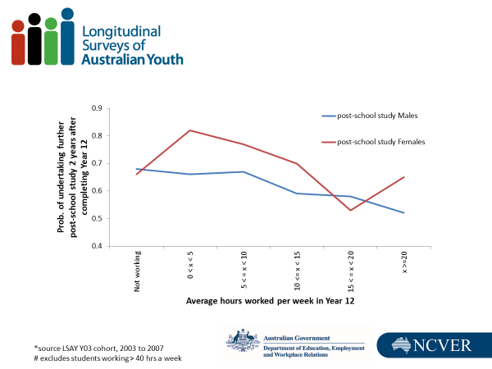Figure 19 Predictive probability of undertaking further study by hours worked in Year 12

Note: # excludes students working >40 hrs a week.

Source: LSAY Y03, 2003−07.

As illustrated in figure 19, the general trend for males was that the more hours worked in Year 12, the less likely they were to undertake post-school full-time study. Working for more than 20 hours in Year 12 reduced the probability that a male would pursue full-time post-school study by -16 percentage points. For females, unlike for males, working for a moderate number of hours (less than 15 hours a week) in Year 12 can have a positive impact on the probability that they will go on to pursue post-school full-time study. However, once hours exceed 15 to 20 hours a week, then, as for males, a negative effect is evident. While we do not know the reason for this, females may be better able to manage the conflicting demands of school and work (as also evidenced in TER results, where females can work slightly longer hours) than their male counterparts.

### Effect of working in Year 12 on post-school full-time employment status

We investigated the impact of hours worked during Year 12 on full-time employment status in 2007 for those who completed Year 12, but who did not undertake any full-time study in the two years after completing Year 12. Logistic regressions were undertaken for the dichotomous variable, in full-time employment or not in full-time employment in 2007.

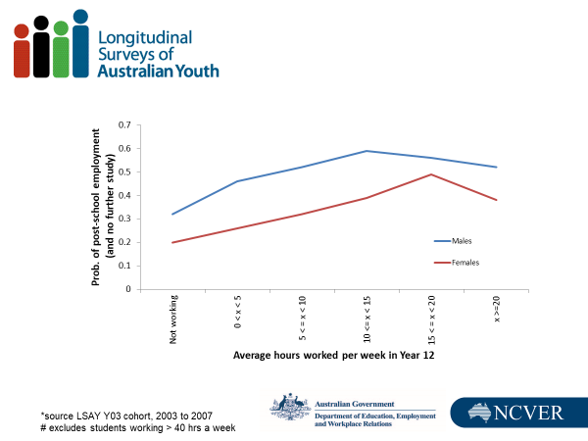Figure 20 Predictive probability of post-school employment by hours worked in Year 12

Note: # excludes students working >40 hrs a week

Source: LSAY Y03, 2003−07.

For males who complete school and pursue no post-school study, working for more than five hours in Year 12 is beneficial over not working at all. However, the rates of return do not increase in a linear manner and working between 10 and 15 hours a week maximises the probability of better post-school employment outcomes.

For females, we see a similar pattern, with positive benefits of combining school and work in Year 12 on post-school employment outcomes. However, females must work for slightly longer hours (15 to 20 hours a week in Year 12) to gain maximum benefit (of +29 percentage points), whereas maximum benefits are realised for males who work between 10 and 15 hours a week (of +27 percentage points).

## Summary of findings

For the Y03 cohort, around half of senior secondary students combined part-time work and school, with the proportion rising with increasing school year level. Students work on average 11 to 12 hours per week, with more females working than males. However, on average, males who combined work and school worked longer hours. Slightly more young people work when in Year 12 than in Year 11, with 52% of males and 62% of females working in Year 12.

Of all of those working, up to 20% were working more than 15 hours per week, although there was a slight decline in this percentage for students who were in Year 12. For those who were working more than 15 hours per week, they were working on average up to 20 hours per week.

Combining school and work has a modest negative impact on school and post-school study outcomes when hours are long (more than 15 to 20 hours a week). Females are better able to balance school and work, with the magnitude of these negative effects generally being less than for males.

Working for relatively few hours a week (around five hours per week) has a positive impact on post-school full-time employment, compared with not working at all. Females must work slightly longer hours than males (10 to 15 hours per week) to realise maximum benefits from working (15 to 20 hours per week), but the magnitude of the effect is comparable with males.

Unlike the negative effects we see for school and post-school study outcomes, we see positive effects from working in Year 12 on post-school employment for both males and females who do not go on to post-school full-time study.

## Discussion

Consistent with other researchers, we found that students who combine school and work are dispersed across the school population, although some groups tend to work longer hours than others. With such a large proportion of students combining school and work, it is not surprising that they do not have a set of strong defining characteristics. However, students who combine school and work are in general in the higher, but not highest, SES quartile, attend Catholic or government schools, are not in receipt of Youth Allowance, and prefer an apprenticeship, traineeship or a job when they leave school.

We found moderately negative effects on school and post-school outcomes of combining school and work of more than 10 hours a week. In contrasting this research with similar studies in different economic conditions, with different cohorts, and a notable growth in the numbers of young people combining school and work (increasing from around a quarter of 15 to 19-year-olds in 1992 to around a third in 2008), we found the same effects for combining school and work on school and post-school outcomes.

This research deconstructed school retention to measure both Year 10 to Year 11, and Year 11 to Year 12 retention. This enables us to better understand the way combining school and work can affect the decision points between Years 10 and 12 while allowing us to more finely model the effect of work in previous school year levels. This approach uncovered the finding that the negative effects of combining school and work on school retention are stronger for those who work in Year 10 than those who work in Year 11. Perhaps this is because those who are working in Year 11 tend to moderate their hours. But, overall, the negative effects of combining school and work are modest, unless the person is working excessive hours (over 15 to 20 hours a week).

Is combining school and work detrimental to school and post-school outcomes? The results of this research point towards moderate hours being preferable. Longer hours appear to be detrimental to educational outcomes but good for employment outcomes, which tends to suggest that those willing to work the longer hours are distancing themselves from the education environment.

## References

ABS (Australian Bureau of Statistics) 2008, *Schools Australia 2007*, cat.no.4221.0, ABS, Canberra, viewed 24 July 2019, <http://www.abs.gov.au/AUSSTATS/abs@.nsf/DetailsPage/4221.02007?OpenDocument>.

Biddle, N 2007, ‘The labour market status of Australian students: who is unemployed, who is working and for how many hours?, *Journal of Education and Work*, vol.20, no.3, July, pp.179−209.

Howieson, C, McKechnie, J & Semple, S 2006, *The nature and implications of the part-time employment of secondary school pupils*, Scottish Executive Social Research, Department of Enterprise, Transport and Lifelong Learning, Scotland.

Robinson, L 1999, *The effects of part-time work on school students*, LSAY research report no.9, Australian Council for Educational Research, Camberwell, Vic.

Smith, E & Green, A 2005, *How workplace experiences while at school affect career pathways*, NCVER, Adelaide.

# Young people not in education, employment or training (NEET)

*Cameron Forrest, NCVER*

*The analyses in this section have been drawn from a 2017 NCVER report,* Who are the persistently NEET young people? *by J Stanwick, C Forrest and P Skujins.*

Not being in education, employment or training (NEET) is recognised internationally as a key indicator of youth disengagement. Young people in this group are less likely to have the skills and experience necessary for a successful transition into employment or further education and consequently are more likely to have poorer outcomes in later life. Although it is normal for young people to be NEET at some point during their transition from education into the labour market, individuals who are NEET for longer periods are at risk of longer-term disengagement and disadvantage (Brynner & Parsons 2002; Furlong 2006). Reducing the incidence and duration of NEET periods is therefore likely to provide wider economic benefits, as well as improving individual outcomes, and so is of considerable interest from a policy perspective.

Because it is quite normal for young people to be NEET for some period of time during their initial transition into the labour market (Quintini, Martin & Martin 2007), cross-sectional or ‘snapshot’ figures may be less useful for understanding the risk factors for, and consequences of, NEET periods than longitudinal data such as those provided by the Longitudinal Surveys of Australian Youth (LSAY). In addition, the comprehensive education and employment biographies provided by LSAY allow for a holistic definition of NEET (see figure 21). Education status, employment status, and NEET status could therefore be derived for each month of the 10-year survey period.

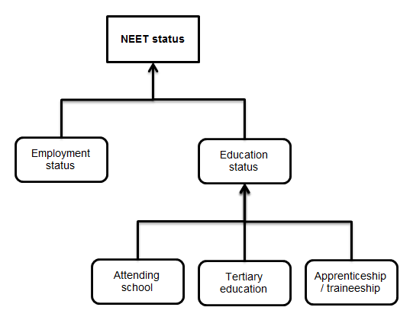Figure 21 Factors considered in the derivation of NEET status

Due to the complexity of the analyses, findings have been reported for the Y03 and Y06 cohorts only, and data have not been weighted. For this reason, the figures reported below are not necessarily representative of the wider Australian population. At the time of the initial study, the Y06 cohort was in its 11th year of collection, and so data were only available until wave 10 (2015). For comparability, analyses involving the Y03 cohort were also restricted to 10 waves of data instead of 11 (that is, the analysis period for Y03 was 2003−2012, and 2006-2015 for Y06).

## Size of the NEET groups

Figure 22 shows the size of the analysis groups, according to whether respondents were not NEET during any given month of the survey period (‘never NEET’), NEET for one month or more at some stage during the survey period (‘ever NEET’), or NEET for a period of six or more consecutive months during the same period (‘persistently NEET’). To account for attrition, these figures represent proportions of the sample who were still present in the survey at wave 10. Note that the figures do not sum to 100% because the ever NEET and persistently NEET groups are not mutually exclusive.

Figure 22 Size of the NEET groups (ages 15−24) in Y03 and Y06 across the full survey period

A higher proportion of the Y06 cohort was NEET at some point during the survey period by comparison with the Y03 cohort (39.2% versus 25.8%), an unexpected finding, given that only three years separated the survey periods for the two cohorts. The same was also true for the persistently NEET group (17.1% versus 10.7%). As previously mentioned, due to the greater risks associated with becoming NEET during adolescence, these categories were also produced for waves 1 to 5 of the survey period, when participants were aged 15 to 19 years. The results are presented in figure 23.

Figure 23 Size of the NEET groups (ages 15−19) in Y03 and Y06 between waves 1 and 5

The increased proportions comprising the ‘never NEET’ groups reflect the decreased opportunity to become NEET, given the temporal dependencies of the derivations. Nevertheless, the discrepancies between the Y03 and Y06 cohorts are more pronounced here, with 18.1% of the Y06 cohort who were still present in wave 10 experiencing some NEET period before the age of 19 years, compared with just 3.1% of the Y03 cohort. Although explanations for this effect are not immediately clear, it is likely that the timing of the Global Financial Crisis (GFC) impacted on these groups in different ways. In 2009, when the economic impact of the GFC became more pronounced in Australia, Y06 respondents were aged about 18 years and beginning to transition into the labour market. Conversely, the Y03 cohort was aged about 21 years and may have had an advantage in the additional three years to transition from school into employment or further education.

## How long do NEET periods last?

On average, between the ages of 15 and 24, LSAY participants spent between 2.3 months (Y03) and 3.9 months (Y06) in the NEET state. However, these figures are heavily influenced by the number of respondents who were not NEET at any stage throughout that period; when restricted to individuals who were NEET at some point during the 10 years, those figures rose to 9.0 months (Y03) and 9.9 months (Y06).

This effect became more pronounced when examining individuals who were persistently NEET during the survey period: for Y03, persistently NEET individuals spent an average of 17.7 months NEET, and this increased to 18.7 months for Y06 respondents. Finally, individuals who were persistently NEET between the ages of 15 and 19 years spent 24.8 months (Y06) to 28.6 months (Y03) NEET, representing as much as 31.6% of all months covered by the survey period. This in particular seems to indicate a ‘scarring effect’, such that NEET periods in adolescence are likely to extend or lead to additional NEET periods in early adulthood.

## Which demographic factors are associated with NEET periods?

Socio-demographic factors that were significantly associated with persistent NEET periods included, in decreasing order of significance:

* having children (*V* = .13 = .31)[[16]](#footnote-17)
* Year 12 non-completion (*V* = .12 - .23)
* coming from a lower socioeconomic background (*V* = .09 - .13)
* coming from a provincial geographic location (*V* = .05 - .06)
* female gender (Y03 only, *V* = .09)
* Indigeneity (Y06 only, *V* = .05).

Although significant, many of these effects were small; having children and Year 12 non-completion were the factors that were most notable and consistently correlated with persistently NEET periods.

## What predicts NEET periods in young adulthood?

The final analyses of the report comprised a series of regressions predicting NEET periods from a range of demographic and social factors. To do so, the survey periods were split into two halves, reflecting ages 15 to 19 and ages 20 to 24 years. Outcomes between ages 20 and 24 could therefore be predicted from factors measured between ages 15 and 19, thereby controlling for the direction of causality.

Significant predictors of persistently NEET periods between the ages of 20 and 24 are presented in table 28. Findings are reported in terms of odds ratios (OR), which represent the relative likelihood of becoming persistently NEET. For example, an individual in the Y06 cohort who was persistently NEET between the ages of 15 and 19 years was 5.39 times more likely to be persistently NEET between the ages of 20 and 24 compared with someone who was not persistently NEET between the ages of 15 and 19. This again points to a scarring effect of NEET periods experienced during adolescence. Other predictors included socioeconomic status, Year 12 non-completion, and female gender (Y03 only). However, by far the most significant predictor was having children between the ages of 15 and 19 (OR = 4.42 – 7.97); that is, respondents who had children during adolescence were up to eight times more likely to be NEET for a period of six months or more during early adulthood. This has profound implications for policy. Should childcare responsibilities be considered a ‘legitimate’ reason to not be in any form of employment, education, or training? Is it appropriate to include young mothers and fathers alongside individuals who choose not to work when drafting employment and welfare legislation? The diversity of circumstances among the NEET group suggests that no single intervention can serve as a panacea for youth disengagement.

Table 28 Significant predictors of persistently NEET periods between ages 20 and 24

|  |  |  |
| --- | --- | --- |
|  | Odds Ratios | |
|  | **Y03** | **Y06** |
| Had children between ages 15 and 19 | 4.42 | 4.97 |
| Persistently NEET period between ages 15 and 19 | 3.03 | 5.39 |
| Non-completion of year 12 | 2.24 | 1.73 |
| Lowest SES quartile (as compared with highest) | 1.88 | 2.12 |
| Female gender | 1.89 | - |

## Summary

These findings confirm in the Australian context effects which have been reported internationally relating to the risks and consequences of NEET periods. There are particularly high risks associated with persistent NEET periods during adolescence. Failure to complete Year 12 and having children during adolescence appear to have the strongest effects on long-term outcomes. However, the diversity of the NEET group indicates that a range of targeted interventions may be necessary to address youth disengagement in its entirety. Furthermore, the possible effect of the GFC on NEET rates suggests that wider economic circumstances should be considered alongside individual choice when drafting policy solutions. The legitimacy of activities other than employment or education, such as childcare, must also be addressed in any future NEET discussions.

## References

Brynner, J & Parsons, S 2002, ‘Social exclusion and the transition from school to work: the case of young people not in education, employment or training (NEET)’, *Journal of Vocational Behaviour*, vol.60, pp.289−303.

Furlong, A 2006, ‘Not a very NEET solution: representing problematic labour market transitions among early school-leavers’, *Work, Employment and Society*, vol.20, no.3, pp.553−69.

Quintini, G, Martin, J & Martin, S 2007, *The changing nature of the school-to-work transition process in OECD countries*, IZA discussion paper no.2582, IZA, Bonn, viewed 5 April 2016, <http://ftp.iza.org/dp2582.pdf>.

Stanwick, J, Forrest, C & Skujins, P 2017, *Who are the persistently NEET young people?*, NCVER, Adelaide.

# Section 6: An overview of school-to-work transitions

As this collection of papers has shown, LSAY data and research findings demonstrate that transitions of young people in Australia continue to change over time, signalling the considerable need for longitudinal research to guide the development of youth policy.

The Global Financial Crisis of 2008 had a significant impact on full-time employment rates. This was especially true for younger people: the proportion of young people in full-time employment has decreased, while the number in part-time employment has increased (NCVER 2014). The proportion of those not in the labour force has also increased. Comparisons across the Y95, Y98, Y03 and Y06 cohorts show a decline in the number of young people gaining their first full-time job by the age of 21 (NCVER 2014), although this may be due in some part to increasing rates of participation in education.

The richness of the LSAY data has made it suitable for sophisticated types of analyses, such as the sequence analysis methods used in the final paper presented in this collection. Ranasinghe and Chew have used sequence analysis across the whole dataset of the Y06 cohort. The discussion presented in the paper demonstrates the importance of vocational education and training (VET) in providing pathways to employment, while also showing the impact of labour market fluctuation and incidence rates of those who experience longer periods of being not in education, employment or training (NEET).

## Reference

NCVER (National Centre for Vocational Education Research) 2014*, Youth transitions in Australia: a moving picture*, Research summary*,* NCVER, Adelaide.

# School-to-work transitions: untangling the pathways

*Rasika Ranasinghe, Office of the South Australian Productivity Commission (OSAPC)   
Emerick Chew, NCVER*

It is well established that a successful transition to the labour market has long-term social and economic implications at the individual and societal level. However, the journey from education to the world of work is no longer linear or straightforward. Increasingly, young people spend more time in initial education, delay entry to the labour market and move between an assortment of part-time or temporary jobs. The growing complexity of school-to-work transitions means that they need to be understood as a process and not merely as single events.

This study aims to provide an alternative to conventional point-in-time analyses by capturing the full richness of the transition experience, both visually and analytically. By identifying the different types of pathways taken by young people in their journey from school to work, this research presents a typology of transitions and investigates the possible factors associated with the different pathways and their implications for labour market, education and social policy.

## Sequence analysis approach to youth transitions − an overview

Sequence analysis methodology was first used in the biological sciences and is a relatively recent approach to analysing labour market transitions. Sequence analysis methods consider multiple transitions simultaneously, as well as their complexity and timing, allowing a fuller understanding of the entire process.

Some examples of studies that incorporate sequence analysis in exploring youth transitions include Dorsett and Luccino (2014), Schoon and Lyons-Amos (2016) and Anders and Dorsett (2017) for the UK, and McVicar and Anyadike-Danes (2002) for Northern Ireland. They identify the different pathways taken by young people and the factors that determine them. An emerging common theme amongst them is that entrenched disadvantages can push young people into long-term unemployment or disengagement and social exclusion. The specific risk factors identified include low education attainment, early marriage or child bearing, and coming from a disadvantaged socioeconomic background.

One of the few studies that uses sequence analysis for labour market transitions in Australia and also has a youth focus is that by Fry and Boulton (2013). Their work provides a descriptive analysis of the transition pathways in Australia that are likely to evolve over the life cycle. Using the Household, Income and Labour Dynamics in Australia (HILDA) survey data, they identify five pathways: three associated with increasing education levels and transitions to work; one associated with churning in and out of work; and one dominated by young women withdrawing from the labour force to raise children. Their findings indicate that churning in and out of work is the dominant pathway for youths, representing about 52% of all youths in the study. They however do not extend the analysis to identify potential risk factors for certain types of pathways. The current study aims to fill that research gap by providing an in-depth analysis of youth using LSAY data to identify a typology of pathways and possible associated factors.

## Data and methodology

The analysis is based on data from the 2006 cohort of the Longitudinal Surveys of Australian Youth (LSAY), a nationally representative survey that tracks 15-year-old students as they move from school to further education or other destinations until they are 25 years of age. The first wave of the 2006 cohort consists of 14 170 students from across Australia who participated in the Programme for International Student Assessment (PISA) that year. The survey captures detailed information on education activities and employment, as well as socioeconomic and demographic characteristics, making it ideally suited for this analysis. The study sample is limited to the 3186 individuals who completed all 10 waves of the survey from 2007 to 2016.

Based on the survey data, it is possible to identify monthly education and labour market activities of respondents between 2007 and 2016. Using the information available, seven monthly activity states were derived: school, university, vocational education and training (VET, including apprenticeships and traineeships), employed full-time, employed part-time, unemployed, and not in the labour force (NILF) or not in employment, education or training (NEET). For analytical purposes, the activities are defined to be education-dominant and mutually exclusive. For example, if a young person is reported as engaged in both VET and employed for a given month, the monthly activity status would be classified as VET. If a young person is engaged in multiple education activities for a given month, for example, VET and university, then the monthly activity status would be classified as university.[[17]](#footnote-18) This classification is necessary to keep the number of monthly activity states manageable, given that the number of possible sequences grows substantially as the number of states increases, adding significantly to the complexity of the data and computational tasks.

The analytical approach utilised in this study consists of three steps. First, the sequence of activities for each individual is derived and the dissimilarity (or distance) between each possible pair of sequences is quantified. Then, the distance between sequences to classify them into clusters of pathways (cluster analysis) is used. Finally, the possible factors that determine the probability of belonging to a certain pathway using a multinomial logistic regression model are identified. This methodology allows us to estimate the likelihood of belonging to a pathway for a given set of background characteristics.

Measuring the dissimilarity between sequences is the starting point in all sequence analysis methods. The most appropriate type of distance measure depends on the research question(s) and the data available. Following on from the discussion by Studer and Ritschard (2016) on the review of various distance measures, this analysis utilises the chi-square distance, which focuses on the time spent in each state within the sequences, while retaining the contemporaneity of sequences. Given that the data contain a cohort of individuals of the same age, who are likely to make transitions at similar times, the chi-square measure is an ideal distance measure for the analysis. There are however noted limitations of this distance measure, including applying only to pairs of sequences of the same length and the inability to account for the level of dissimilarity between specific states.

In grouping similar sequences into pathways, cluster analysis is applied on the chi-square distance matrix obtained from sequence analysis, using the hierarchical agglomerative Ward’s method. The clustering process in Ward’s method is based on the error sum-of-squares (ESS) from each pair of clusters being combined, defined as the sum of the squared distances of individuals from the centre of the cluster. With hierarchical clustering, the ESS is initially zero (since every individual is in their own cluster), and it grows as clusters are merged. Ward’s method selects the pairs of clusters that result in the minimum increase in the ESS.

The second part of cluster analysis involves deciding on the appropriate number of clusters, which involves striking a balance between low variation within clusters and sufficient variation between clusters, while being analytically meaningful. Several statistical measures, as compiled by Studer (2013), were used to assess the quality of the clusters obtained including but not limited to Hubert’s Gamma, average silhouette width and the Calinski-Harabasz index. A ‘majority rule’ approach was adopted to decide on the number of clusters. That is, the number of clusters that the majority of the statistical measures recommended was chosen. As such, five clusters emerged as the representative pathways in the study sample, which were also meaningful within a socioeconomic context.

## A typology of young people’s pathways

The five pathways uncovered by the analysis are described below. Analytical and data constraints limit the ability to generalise the results of this study. However, the initial LSAY sample is representative of the youth population of Australia, and thus is useful in providing important insights on their transition pathways.

**Pathway 1:** **Higher education and work**

* The majority of young people are in this pathway, which has an extended period of higher education followed by employment (60% of the sample).

**Pathway 2: Early entry to full-time work**

* About one-quarter of the sample (23%) follows an ‘express pathway’ to employment, distinguished by a short spell of post-school education or training (mostly VET), leading to full-time work in about one year after leaving school.

**Pathway 3:** **Mix of higher education and VET**

* Around 8% of the sample follow this pathway of an extended period of higher education and VET activity, combined with short and intermittent episodes of employment, eventually leading to employment or further VET activity.

**Pathway 4:** **Mixed and repeatedly disengaged**

* Young people in this pathway display signs of labour market churning and periods in NILF/NEET. While only a small proportion of the sample (5%) falls into this category, persistent churning indicates tenuous labour market attachment.

**Pathway 5:** **Mostly working part-time**

* Consists of 4% of the sample who enter the labour market relatively early and are mostly employed part-time.

## Visualising the pathways

Figure 1 presents two visualisations of the pathways. Sequence index plots illustrate the activity sequences through the use of colour-coded horizontal stacked bars to illustrate how individuals move between states over time. Individuals are numbered along the vertical axis and time is shown on the horizontal axis. It provides a longitudinal perspective of the sequences and allows the pathway to be observed in its entirety.

Modal plots provide yet another perspective on the transition pathways by illustrating the most frequent activity undertaken in each month, and the proportion of individuals undertaking that activity. They are useful in identifying the dominant activity at different times. In other words, it depicts the most popular activity undertaken by young people each month.

Figure 24 Visualising the pathways

Pathway 1: Higher education and full-time work (60% of the sample)

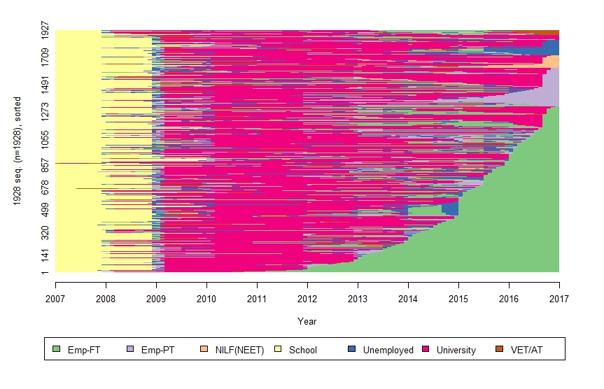Sequence Index plot

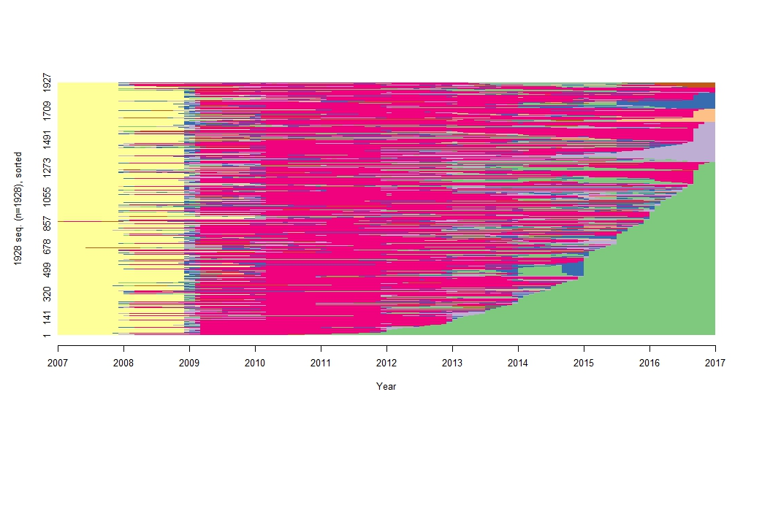

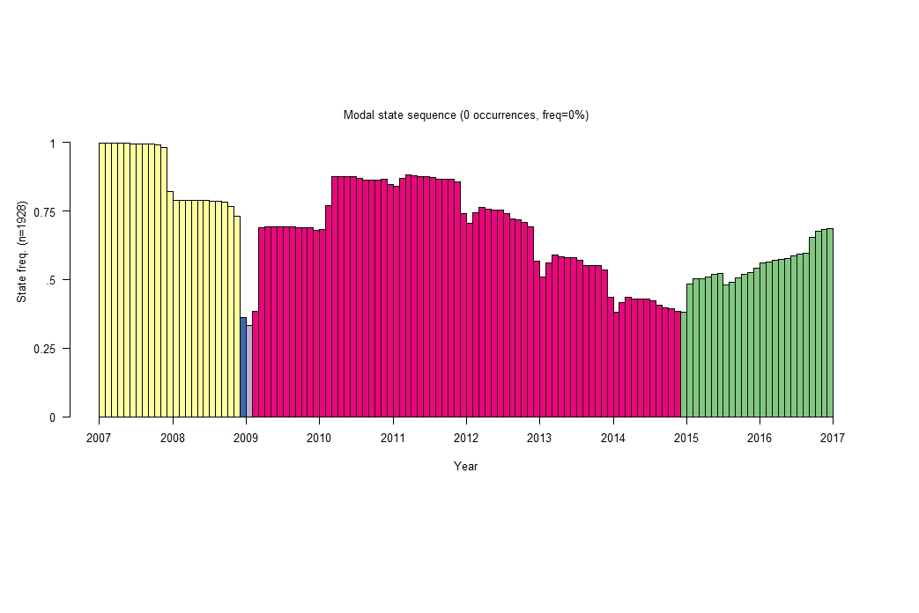Modal plot

Pathway 2: Early entry to full-time work (23% of the sample)

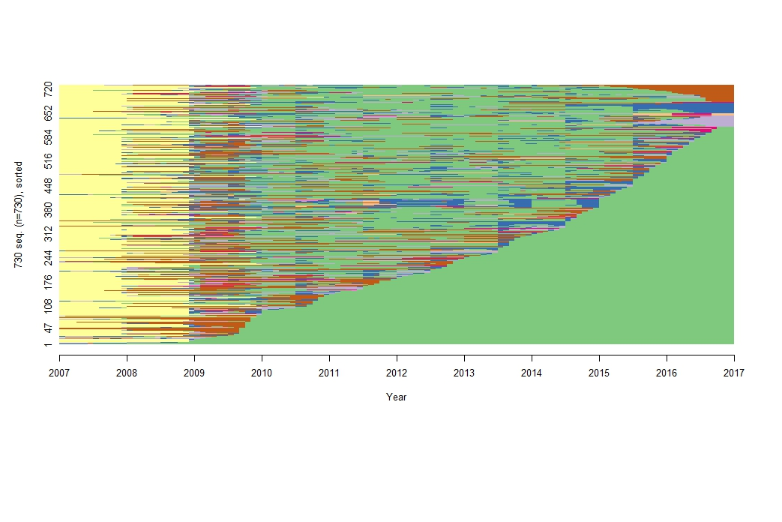Sequence Index plot

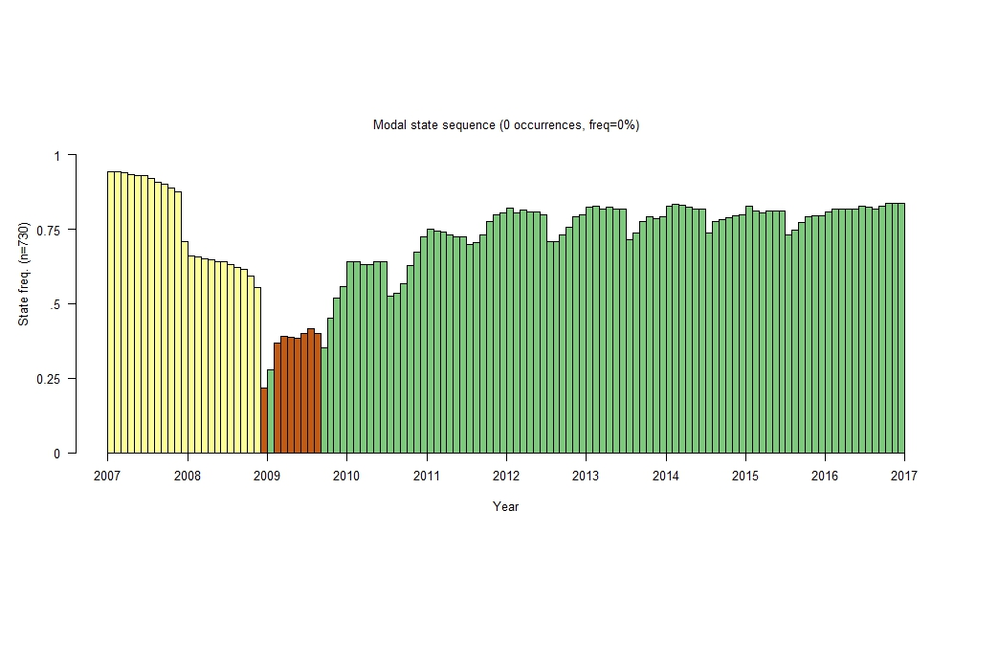Modal plot

Pathway 3: Mix of higher education and VET (8% of the sample)

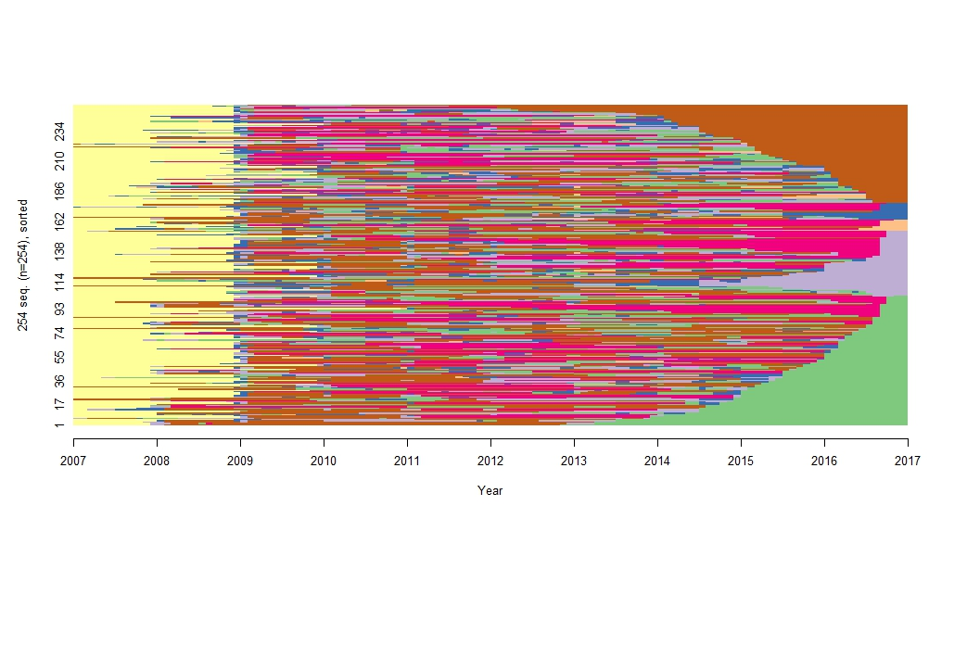Sequence Index plot

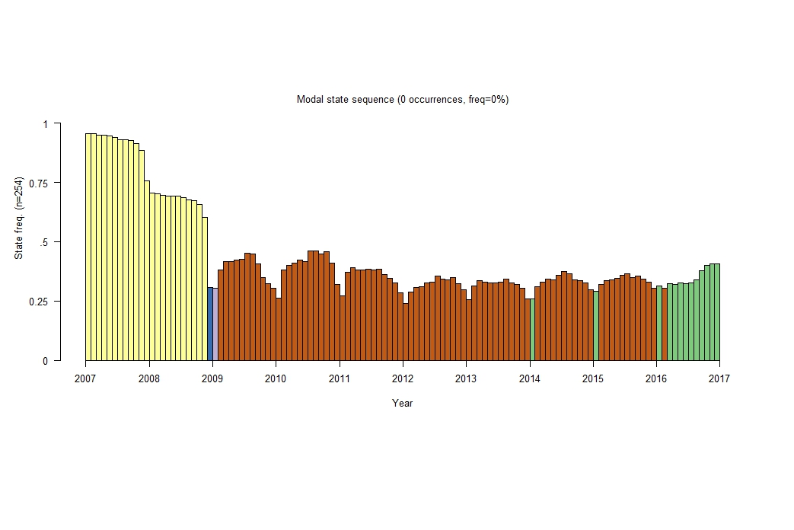Modal plot

Pathway 4: Churning and NILF (5% of the sample)

Sequence Index plot

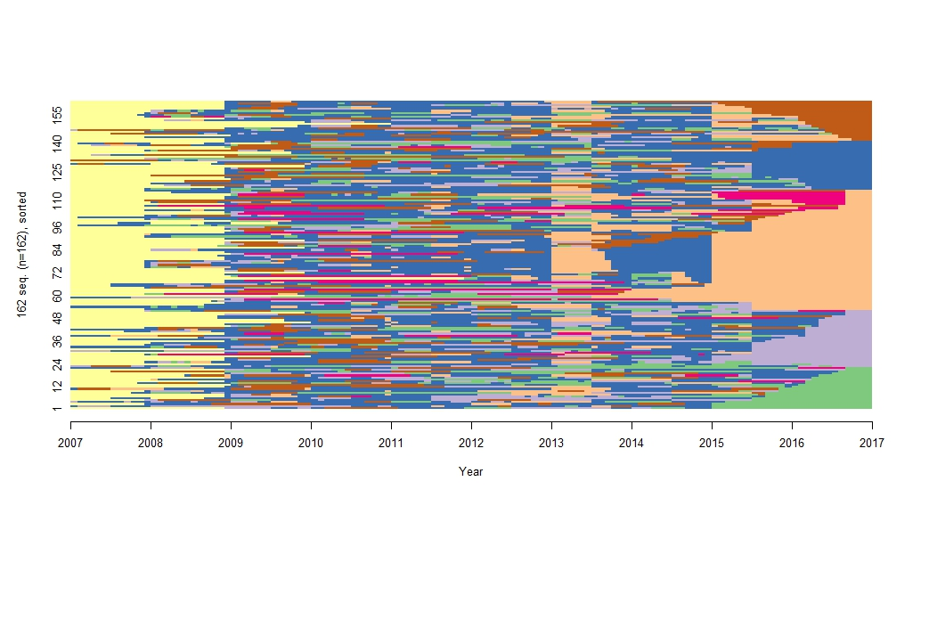Modal plot

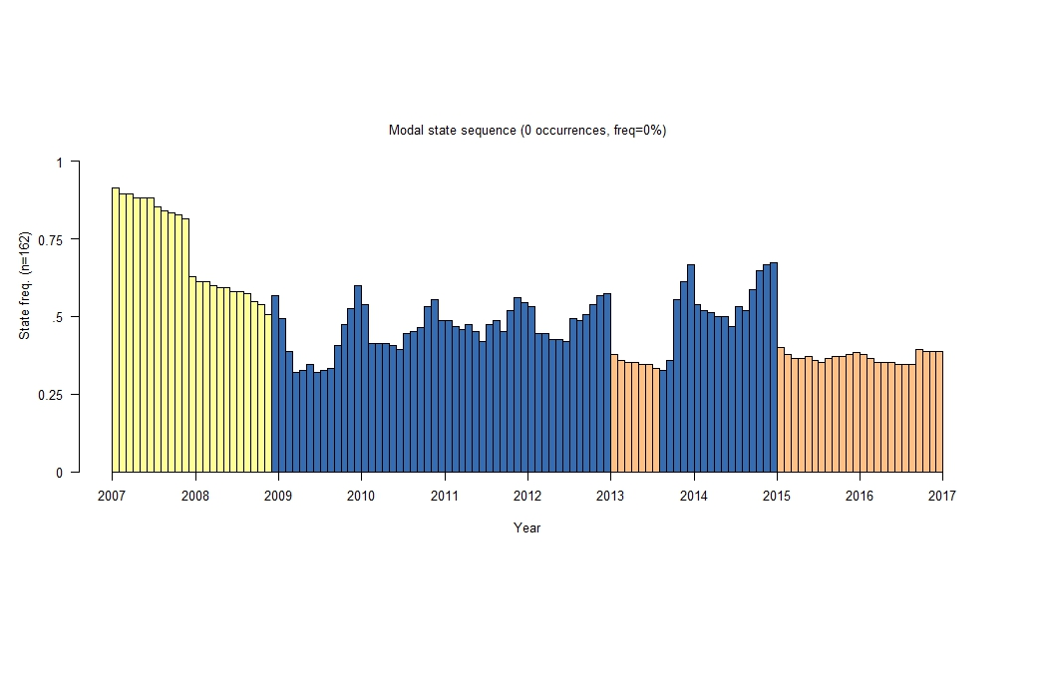

Pathway 5: Mostly working part-time (4% of the sample)

Sequence Index plot

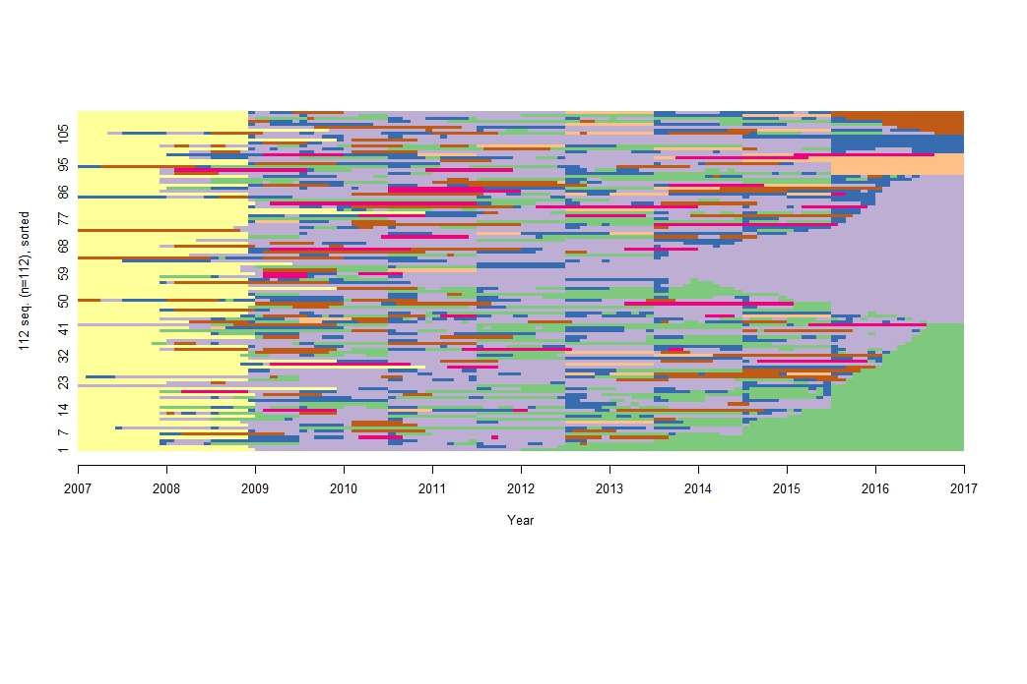Modal plot

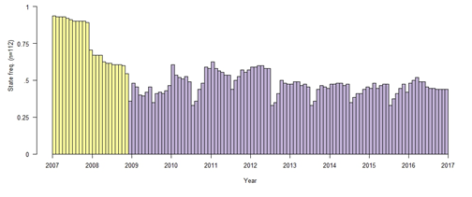

## Drivers of pathways and policy implications

As evident from the results of the multinomial logistic regression modelling, shown in table 29, individual socioeconomic and demographic characteristics play a significant role in influencing the probability of following a given pathway. Within the framework of logistic regression, it is possible to estimate the percentage change in the probability of entering a specific pathway for a given characteristic. The average marginal effects were obtained and are reported in Table 29.

Table 29 Average marginal effects on pathway outcomes. Change in the probability of following a certain pathway for a given characteristic compared with the reference category

|  |  |  |  |  |  |
| --- | --- | --- | --- | --- | --- |
|  | Pathway 1 | Pathway 2 | Pathway 3 | Pathway 4 | Pathway 5 |
|  | Higher education and work | Early entry to Full-time work | Higher education and VET | Mixed and repeatedly disengaged | Mostly working part-time |
| Male  (ref: female) | -0.09\*\* | 0.14\*\* | -0.03\*\* | -0.02\*\* | -0.01 |
| Indigenous  (ref: non-Indigenous) | -0.13\*\* | 0.02 | 0.03 | 0.03 | 0.05\* |
| Overseas background  (ref: non-overseas background) | 0.11\*\* | -0.07\*\* | -0.01 | -0.01 | -0.01\* |
| Socioeconomic status (SES)  (ref: top quartile) |  |  |  |  |  |
| Second quartile | -0.05\* | 0.04\* | 0.02 | -0.02 | 0.00 |
| Third quartile | -0.18\*\* | 0.12\*\* | 0.03\* | 0.01 | 0.01 |
| Lowest quartile | -0.20\*\* | 0.12\*\* | 0.02 | 0.04\* | 0.02\* |
| Metropolitan location  (ref: non-metropolitan location) | 0.04\* | -0.03\* | 0.00 | -0.01 | 0.00 |
| Mathematics achievement PISA  (ref: top quartile) |  |  |  |  |  |
| Second quartile | -0.08\*\* | 0.08\*\* | 0.02 | -0.01 | -0.01 |
| Third quartile | -0.12\*\* | 0.11\*\* | 0.01 | 0.01 | -0.01 |
| Lowest quartile | -0.25\*\* | 0.16\*\* | 0.03 | 0.04\* | 0.02 |
| Reading achievement PISA  (ref: top quartile) |  |  |  |  |  |
| Second quartile | -0.05\* | 0.03 | 0.01 | -0.01 | 0.02\* |
| Third quartile | -0.11\*\* | 0.08\*\* | 0.01 | 0.01 | 0.02\* |
| Lowest quartile | -0.16\*\* | 0.10\*\* | 0.01 | 0.02 | 0.03\* |
| Vocational studies in school  (ref: no vocational studies in school) | -0.20\*\* | 0.13\*\* | 0.03\* | 0.02\* | 0.02\*\* |
| Sample size | 1928 | 730 | 254 | 162 | 112 |

\*\* significant at the 1% level (p<0.01); \*significant at the 5% level (*p<0.05*).

Studying vocational subjects in secondary school increases the probability of a young person following Pathway 2 (Early entry to full-time work) on average, by 13 percentage points − the highest amongst all pathways. Young people from the lowest quartile of mathematics and reading achievement also have an increased probability of following Pathway 2 on average, by 16 and 10 percentage points, respectively, compared with those in the top quartile. This shows that, for young people with lower achievement scores in school, there are alternative avenues to higher education that provide and facilitate smooth transition to the labour market.

The findings from this study support existing evidence that vocational education is an important element of student pathways, confirming the relevance of policies designed to improve access to, and supply of, information on vocational and other education and training opportunities for young people. Existing Australian Government initiatives such as those stemming from the National Partnership and the VET in Schools program are aimed at supporting these pathways. Further research on how young people engage with the VET system, as well as on the factors associated with completion and labour market outcomes, will provide important insights into further policy planning and design.

The analysis also uncovered a pathway whereby young people experienced frequent labour market churning and disengagement. While this is a diverse and complex group, certain demographic variables, such as low socioeconomic status and low mathematics achievement scores, were identified as increasing the probability of young people being in this pathway. The identification of the factors associated with this group could inform early interventions and assist in the targeting of strategies to help young people at risk. More broadly, though, policy must be sensitive to the fact that there is considerable heterogeneity within this group and that NEET status can be transitory for some youth. In general, pathways that are not heavily focused on education or work tend to be more heterogenous and complex, reflecting the trajectories of young people who might be combining education, work and family, or those who may be experiencing difficult transitions.

Several limitations to this study include the inability of existing methods to accommodate sample weights – either in the sequence analysis or the cluster process – to make the findings representative of the general population of 16 to 25-year-old Australians. Additionally, the study sample is limited to those who completed all 10 waves of the survey, resulting in the loss of information for the cases who failed to complete the survey in these subsequent years. Thus, future research ideas include creating customised weights for the study sample to increase the ability to generalise these findings.

Another useful extension to this study would be to implement the current methodology across different LSAY cohorts. Such an analysis would provide a longer-term picture on how trends in transition patterns have changed over time as the educational and labour market contexts changed. Given that young people are increasingly following a diverse range of post-school pathways, understanding the educational choices of following a vocational or academic pathway will be useful in exploring alternative pathways for different groups of young people. For example, engaging early school leavers through vocational education, and the role of apprenticeships and traineeships as a transitional platform (which are not discussed in this chapter). Examining the relationship between the attitudes and aspirations of young people and their future labour market outcomes is another potential extension of this research. Understanding the factors that moderate them would be particularly relevant in providing effective support for young people in decision-making at key transition points.

## References

Anders, J & Dorsett, R 2017, ‘What young English people do once they reach school-leaving age: a cross-cohort comparison for the last 20 years’, *Longitudinal and Life Course Studies*, vol.8, pp.75−103.

Dorsett, R & Luccino, P 2014, ‘Explaining patterns in the school-to-work transition: an analysis using optimal matching’, *Advances in Life Course Research*, vol.22, pp.1−14.

Fry, J & Boulton, C 2013, *Prevalence of transition pathways in Australia*, Productivity Commission staff working paper, Canberra.

McVicar, D & Anyadike-Danes, M 2002, ‘Predicting successful and unsuccessful transitions from school to work using sequence methods’, *Journal of the Royal Statistical Society*, series A, vol.165, part 2, pp.317−34.

Schoon, I & Lyons-Amos, M 2016, ‘Diverse pathways in becoming an adult: the role of structure, agency and context’, *Research in Social Stratification and Mobility*, vol.46, pp.11−20.

Studer, M 2013, Weighted cluster library manual: a practical guide to creating typologies of trajectories in the social sciences with R. LIVES Working Papers, 24. <http://dx.doi.org/10.12682/lives.2296-1658.2013.24>.

Studer, M & Ritschard, G 2016, ‘What matters in differences between life trajectories: a comparative review of sequence dissimilarity measures’, *Journal of the Royal Statistical Society*, vol.179, part 2, pp.481−511.

P:\PublicationComponents\logos\Social Media\Twitter_blackbox.pngP:\PublicationComponents\logos\Social Media\InBug-16px_0.png

**National Centre for Vocational Education Research**

Level 5, 60 Light Square, Adelaide, SA 5000  
PO Box 8288 Station Arcade, Adelaide SA 5000, Australia

**Phone** +61 8 8230 8400 **Email** [ncver@ncver.edu.au](mailto:ncver@ncver.edu.au)   
**Web** <https://www.ncver.edu.au> <<https://www.lsay.edu.au>>

**Follow us:** <<https://twitter.com/ncver>> <https://www.linkedin.com/company/ncver>

1. These results were in the form of an odds ratio, which compare the probability of two events occurring. An odds ratio of 4 means that one event occurs four times as frequently as the other, irrespective of whether that is 40% of the time versus 10% of the time, or 0.04% of the time versus 0.01% of the time. [↑](#footnote-ref-2)
2. The higher education data are not disaggregated by age. The domestic undergraduate enrolments are of students of all age groups. Although dominated by people aged less than 25 years, there is a substantial number of older students. In 2016, 78% of domestic undergraduate students were <25 years old, the remaining 22% being 25 or older. [↑](#footnote-ref-3)
3. Except for courses below International Standard Classification of Education (ISCED) level 2C. [↑](#footnote-ref-4)
4. There are some programs for which there is no nationally endorsed training package. In these cases, the course must be endorsed by the relevant state board of curriculum. [↑](#footnote-ref-5)
5. An estimate generated by the authors using data from the 2003 and 2006 cohorts of the Longitudinal Surveys of Australian Youth (LSAY). [↑](#footnote-ref-6)
6. Because only total hours in workplace learning is recorded in LSAY, for students who took more than one classroom-based VET subject in a given year and report doing some workplace learning, we do not know whether all of their subjects had a workplace learning component. [↑](#footnote-ref-7)
7. Students from low socioeconomic backgrounds are those whose families are within the lowest quartile of the PISA index of Economic, Social and Cultural Status, while those students from higher socioeconomic backgrounds are those whose families are within the three highest quartiles of this index. [↑](#footnote-ref-8)
8. This graph shows university enrolment rates at age 19 years. School experiences and student−teacher relationships were measured at age 15 years. Career advice indicators refer to whether a student has ever received that sort of advice while at school. [↑](#footnote-ref-9)
9. The research was supported by a PhD top-up scholarship provided by NCVER through the National VET Research program, on behalf of the Australian Government Department of Education and Training. The views and opinions in this chapter are those of the author and do not necessarily reflect the views of the Australian Government, state and territory governments or NCVER. [↑](#footnote-ref-10)
10. August is selected because it coincides with the predominant LSAY survey period. [↑](#footnote-ref-11)
11. The LSAY sample reports a slightly higher proportion of part-time work than the ABS estimates, which can be explained by different survey methodologies. [↑](#footnote-ref-12)
12. The Y03 cohort has a Year 12 completion rate of 83%, which is significantly higher than the national average reported for 2007 by the ABS of around 75% (ABS 2008). [↑](#footnote-ref-13)
13. The predicted probabilities are calculated based on the results of the regression at the average propensity score and for each level of working hours with the other hours set to zero. [↑](#footnote-ref-14)
14. It is possible for a student to complete Year 12 and not obtain a TER; however, we restrict the analysis to those with a TER score because the focus of our analysis is on the impact of combining school and work on TER score. [↑](#footnote-ref-15)
15. The effect of combining school and work in Year 12 is only considered as this is the year most immediate to the post-school outcome. [↑](#footnote-ref-16)
16. Cramér’s *V* is a measure of effect size ranging from -1 to 1. It can broadly be interpreted in the same way as Pearson’s *r*: .1 is a small effect, .3 is a moderate effect, and .5 is a large effect. [↑](#footnote-ref-17)
17. For those who were engaged in multiple activities for a given month, the activity status was determined based on the following order: school, university, VET, employed full-time, employed part-time, unemployed and not in the labour force. [↑](#footnote-ref-18)