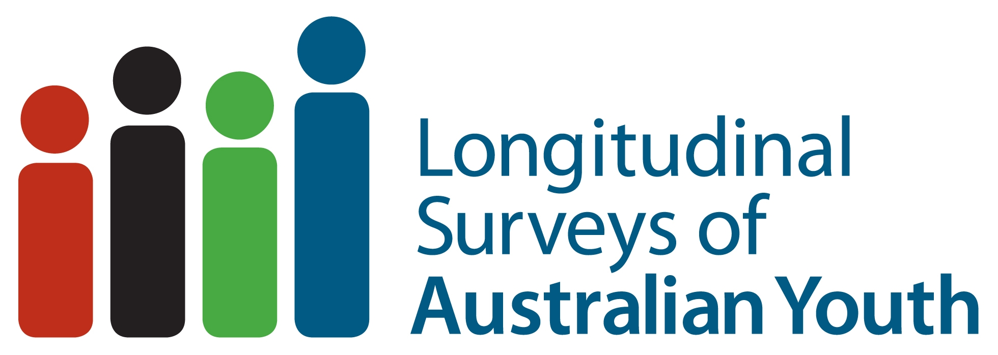
LONGITUDINAL SURVEYS OF AUSTRALIAN YOUTH

RESEARCH SYNTHESIS

Are we there yet? Making the successful transition to adulthood

NCVER

INTRODUCTION
There was a time when leaving school marked the beginning of adulthood. Even though this transition has now lengthened, the traditional markers of a successful transition remain the same: getting a good job, becoming a responsible citizen, establishing a household and having a family.
- These markers are seen when young people have:
- gained sufficient education, including literacy and numeracy skills, to give them the ability to complete Year 12 and to keep on learning at the post-school level, as well as at work and from life
- well-informed career plans
- gained high-quality employment, as seen through their level of earnings, job status and security, job satisfaction, and training and promotional opportunities
- good mental and physical health and stable social relationships.

GETTING ON TRACK
Being either in full-time education or work, or a combination of both – in other words, being fully engaged in society – is a good indicator that a young person is on the right track. Some may take a different, less direct route towards achieving this but it is not necessarily a bad thing; they too may be involved in meaningful activities such as travel, or caring for children or others, or doing volunteer work.

Who might get off track?
But there is a minority who struggles to make a successful transition. They often leave school early and, when they do, find it difficult getting a job. This can increase the chances of further periods of unemployment and be the beginning of a vicious cycle.
This group of young people is sometimes referred to as being ‘at risk’, a term we should use cautiously, given that the period of youth transition is by its very nature a time of flux when many young people are trying to decide the direction in which they wish to head. Nevertheless, policy-makers and educators need to be aware of the types of things that can hinder a successful transition. These include: having poor literacy and numeracy; living outside a metropolitan area, where there is limited access to further education and to jobs; coming from a low socioeconomic background; and having parents with little education or who are long-term unemployed.

WHAT HELPS YOUNG PEOPLE ACHIEVE A SUCCESSFUL TRANSITION?
Being from a less advantaged background does not have to determine a young person’s destiny. Various interventions can help young people overcome obstacles.

School
A good experience at school is important, both for its educational benefits but also because it means the student feels part of a community. For example, getting involved in extra-curricular activities, including sport, has a positive impact on education participation and aspirations.
Good student–teacher relationships are central, particularly for those with low educational motivation or little support from home. Teachers can also help students make subject choices that are relevant to post-school plans for work and study. Well-informed and appropriate careers advice can also motivate low academic achievers to stay at school. And having a wider choice of subjects, both vocational and academic, can encourage students to remain at school for longer.

Financial support
For those living in poverty, it is likely to take more than a positive school environment to get them on the right track. Income support to complete school and go onto post-compulsory education is an important ingredient in making the transition from child to adult a success.

Part-time work
Working part-time while at school can provide young people with valuable work experience and skills, such as team work and time management, which will help them in their future jobs. But too much part-time work can have a negative impact on school performance; finding the right balance between the two can be difficult.

FURTHER READING
Anlezark, A 2011, At risk youth: a transitory state?, LSAY briefing paper 24, NCVER, Adelaide.
Anlezark, A & Lim P 2011, Does combining school and work affect school and post-school outcomes?, NCVER, Adelaide.
Karmel, T & Liu, S 2011, Which paths work for which groups of young people?, LSAY research report 57, NCVER, Adelaide.Liu, S & Nguyen N 2011, Successful youth transitions, LSAY briefing paper 25, NCVER, Adelaide.
Semo, R 2011, Social capital and young people, LSAY briefing paper 26, NCVER, Adelaide.
This research synthesis is part of series produced by the National Centre for Vocational Education Research (NCVER), drawing on research analysing data from the Longitudinal Surveys of Australian Youth (LSAY). LSAY is a research program funded by the Australian Department of Education, Employment and Workplace Relations (DEEWR) with support from state and territory governments. It follows young people as they move from school to further work and study, providing valuable information to better understand young people’s pathways from school and the factors that influence their choices. NCVER manages the analytical and reporting services of the LSAY program on behalf of the Department. Further information about the LSAY program can be found at www.lsay.edu.au.

National Centre for Vocational Education Research Ltd Level 11, 33 King William Street, Adelaide, South Australia
M PO Box 8288, Station Arcade, SA 5000 Australia T +61 8 8230 8400 F +61 8 8212 3436 W www.ncver.edu.au E ncver@ncver.edu.au

© Commonwealth of Australia, 2011
With the exception of the Commonwealth Coat of Arms, the Department’s logo, any material protected by a trade mark and where otherwise noted all material presented in this document is provided under a Creative Commons Attribution 3.0 Australia <http://creativecommons.org/licenses/by/3.0/au> licence.
The details of the relevant licence conditions are available on the Creative Commons website (accessible using the links provided) as is the full legal code for the CC BY 3.0 AU licence <http://creativecommons.org/licenses/by/3.0/legalcode>.
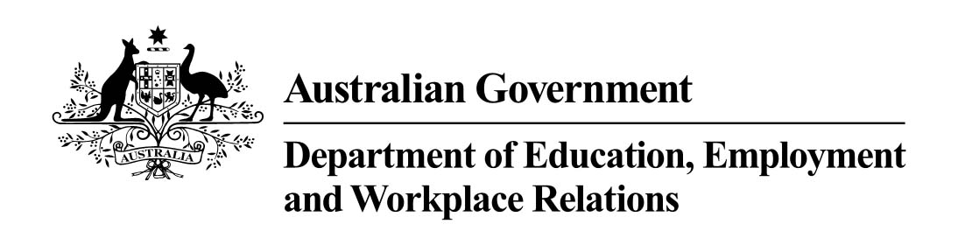
The Creative Commons licence conditions do not apply to all logos, graphic design, artwork and photographs. Requests and enquiries concerning other reproduction and rights should be directed to the National Centre for Vocational Education Research (NCVER).
This document should be attributed as NCVER 2011, Are we there yet? Making the successful transition to adulthood, NCVER, Adelaide.
This work has been produced by NCVER through the Longitudinal Surveys of Australian Youth (LSAY) Program, on behalf of the Australian Government and state and territory governments, with funding provided through the Australian Department of Education, Employment and Workplace Relations.
The views and opinions expressed in this document are those of the authors and do not necessarily reflect the views of the Australian Government or state and territory governments.
TD/TNC 105.03
Published by NCVER, ABN 87 007 967 311 <www.ncver.edu.au>

