The factors affecting the educational and occupational aspirations of young Australians — support document

Sinan Gemici, Alice Bednarz, Tom Karmel and Patrick Lim

NCVER

This document was produced by the authors based on their research for the report *The factors affecting the educational and occupational aspirations of young Australians>*, and is an added resource for further information. The report is available on LSAY’s website: <www.lsay.edu.au>.

The views and opinions expressed in this document are those of the author(s) and do not necessarily reflect the views of the Australian Government or state and territory governments.

### ­

### 

**© Commonwealth of Australia, 2014**

G:\pub_prod\PublicationComponents\logos\Creativecommons\CC BY logo.eps

With the exception of the Commonwealth Coat of Arms, the Department’s logo, any material protected by a trade mark and where otherwise noted all material presented in this document is provided under a Creative Commons Attribution 3.0 Australia <http://creativecommons.org/licenses/by/3.0/au> licence.

The details of the relevant licence conditions are available on the Creative Commons website (accessible using the links provided) as is the full legal code for the CC BY 3.0 AU licence <http://creativecommons.org/licenses/by/3.0/legalcode>.

The Creative Commons licence conditions do not apply to all logos, graphic design, artwork and photographs. Requests and enquiries concerning other reproduction and rights should be directed to the National Centre for Vocational Education Research (NCVER).

This document should be attributed as Gemici, S, Bednarz, A, Karmel, T & Lim, P 2014, *The* f*actors affecting the educational and occupational aspirations of young Australians: support document*, NCVER, Adelaide.

This work has been produced by NCVER through the Longitudinal Surveys of Australian Youth (LSAY) Program, on behalf of the Australian Government and state and territory governments, with funding provided through the Australian Department of Education, Employment and Workplace Relations.

Published by NCVER, ABN 87 007 967 311

Level 11, 33 King William Street, Adelaide, SA 5000  
PO Box 8288 Station Arcade, Adelaide SA 5000, Australia

P +61 8 8230 8400 F +61 8 8212 3436 E [ncver@ncver.edu.au](mailto:ncver@ncver.edu.au) W <www.ncver.edu.au>

Contents

Tables and figures 4

Section A: Descriptive statistics 5

Section B: Interaction between Indigenous status and academic performance 9

Section C: A structural model of aspirations 11

SEM Background 11

Data screening 11

Direct and indirect influences on aspirations 13

Interpreting coefficients of structural equation models 17

Results by aspiration outcome 19

Direct effects, indirect effects and total effects 20

University plans 20

Occupational aspirations 21

Summary of results 21

Assessing model fit 22

Detailed SEM results by outcome 22

Section D: Creating the ‘perceptions of schooling’ measure 37

References 40

# Tables and figures

## Tables

A1 Descriptive statistics for socio-demographic predictor variables (unweighted) 5

A2 Descriptive statistics for perception of schooling predictor variables (unweighted) 6

A3 Descriptive statistics for outcome variables (unweighted) 8

B1 Cross-tabulation of Indigenous status and plans to complete Year 12 9

B2 Cross-tabulation of Indigenous status, plans to complete Year 12, and PISA score 9

B3 Cross-tabulation of Indigenous status and parents’ higher education aspirations 10

C1 Variances of the predictors 13

C2 Measures comprising each latent construct 14

C3 Summary of total effects across outcomes 21

C4 Summary of the fit criteria to apply, dependant on sample size 22

C5 Summary of model fit statistics across all outcomes (n = 13 628) 22

C6 Covariance matrix for Year 12 aspirations 23

C7 Covariance matrix for university aspirations 26

C8 Covariance matrix for occupational aspirations 28

C9 Correlation matrix for Year 12 aspirations 30

C10 Correlation matrix for university aspirations 32

C11 Correlation matrix for occupational aspirations 34

## Figures

C1 Full structural equation model for Year 12 aspirations 16

C2 Structural model for Year 12 plans 17

C3 Structural model for Year 12 plans 19

C4 Structural model for university plans 20

C5 Structural model for occupational aspirations 21

D1 Scree plot from factor analysis on attitudes toward school 37

D2 Scree plot from factor analysis on perceived student-teacher relations 38

D3 Scree plot from factor analysis on perceived disciplinary climate 38

D4 Scree plot from factor analysis on perceived teacher quality 39

D5 Scree plot from factor analysis on overall perceptions of schooling 39

# Section A: Descriptive statistics

Table A1 Descriptive statistics for socio-demographic predictor variables (unweighted)

|  |  |  |  |
| --- | --- | --- | --- |
| Predictor | Categories | n | % |
| Gender | Female | 7 231 | 50.74 |
|  | Male | 7 020 | 49.26 |
| Indigenous status | Not Indigenous | 13 108 | 91.98 |
|  | Indigenous | 1 143 | 8.02 |
| Immigration background | Australian-born students | 8 396 | 58.92 |
|  | First-generation students | 4 103 | 28.79 |
|  | Foreign-born students | 1 365 | 9.58 |
|  | *Missing* | 387 | 2.72 |
| Family structure | Nuclear family | 10 973 | 77.00 |
|  | Not nuclear family | 2 999 | 21.04 |
|  | *Missing* | 279 | 1.96 |
| Location | Metropolitan | 9 890 | 69.40 |
|  | Not metropolitan | 4 361 | 30.60 |
| Parents’ higher ed. aspirations | Not university | 3 012 | 21.14 |
|  | University | 5 029 | 35.29 |
|  | *Missing* | 6 210 | 43.58 |
| Peers’ higher ed. aspirations | Not university | 3 529 | 24.76 |
|  | University | 3 298 | 23.14 |
|  | *Missing* | 7 424 | 52.09 |
| SES | Continuous | Mean: 0.32 | SD: 0.76 |
|  | *Missing* | 318 | 2.23 |
| Academic performance[[1]](#footnote-1) | Continuous | Mean: 508 | SD: 94.26 |
| Attitudes to school (PISA composite variable) | Continuous | Mean: 0.15 | SD: 1.02 |
|  | *Missing* | 794 | 5.58 |
| Teacher-student relations (PISA composite variable) | Continuous | Mean: 0.09 | SD: 0.98 |
|  | *Missing* | 285 | 2.00 |
| Disciplinary climate (PISA composite variable) | Continuous | Mean: -0.1 | SD: 1.01 |
|  | *Missing* | 290 | 2.04 |
| Teacher quality (PISA composite variable) | Continuous | Mean: 0.21 | SD: 1.04 |
|  | *Missing* | 337 | 2.37 |

Table A2 Descriptive statistics for perception of schooling predictor variables (unweighted)

|  |  |  |  |
| --- | --- | --- | --- |
| Predictor | Categories | n | % |
| ***Attitudes to school*** |  |  |  |
| (a1) School has done little to prepare me for adult life [reverse] [[2]](#footnote-2) | Strongly disagree | 5 073 | 35.60 |
|  | Disagree | 6 176 | 43.34 |
|  | Agree | 2 040 | 14.31 |
|  | Strongly agree | 610 | 4.28 |
|  | *Missing* | 352 | 2.47 |
| (a2) School has been a waste of time [reverse] | Strongly disagree | 6 674 | 46.83 |
|  | Disagree | 6 102 | 42.82 |
|  | Agree | 837 | 5.87 |
|  | Strongly agree | 265 | 1.86 |
|  | *Missing* | 373 | 2.62 |
| (a3) School helped give me confidence | Strongly disagree | 435 | 3.05 |
|  | Disagree | 1 917 | 13.45 |
|  | Agree | 8 674 | 60.87 |
|  | Strongly agree | 2 871 | 20.15 |
|  | *Missing* | 354 | 2.48 |
| (a4) School has taught me things which could be useful in a job | Strongly disagree | 330 | 2.32 |
|  | Disagree | 842 | 5.91 |
|  | Agree | 7 045 | 49.44 |
|  | Strongly agree | 5 702 | 40.01 |
|  | *Missing* | 332 | 2.33 |
| ***Teacher-student relations*** |  |  |  |
| (r1) I get along well with most of my teachers | Strongly disagree | 457 | 3.21 |
|  | Disagree | 1 683 | 11.81 |
|  | Agree | 9 132 | 64.08 |
|  | Strongly agree | 2 670 | 18.74 |
|  | *Missing* | 309 | 2.17 |
| (r2) Most of my teachers are interested in my well-being | Strongly disagree | 563 | 3.95 |
|  | Disagree | 2 581 | 18.11 |
|  | Agree | 9 028 | 63.35 |
|  | Strongly agree | 1 708 | 11.99 |
|  | *Missing* | 371 | 2.60 |
| (r3) Most of my teachers really listen to what I have to say | Strongly disagree | 708 | 4.97 |
|  | Disagree | 3 371 | 23.65 |
|  | Agree | 8 373 | 58.75 |
|  | Strongly agree | 1 448 | 10.16 |
|  | *Missing* | 351 | 2.46 |
| (r4) If I need extra help, I will receive it from my teachers | Strongly disagree | 422 | 2.96 |
|  | Disagree | 1 813 | 12.72 |
|  | Agree | 9 329 | 65.46 |
|  | Strongly agree | 2 328 | 16.34 |
|  | *Missing* | 359 | 2.52 |
| (r5) Most of my teachers treat me fairly | Strongly disagree | 474 | 3.33 |
|  | Disagree | 1 673 | 11.74 |
|  | Agree | 9 583 | 67.24 |
|  | Strongly agree | 2 173 | 15.25 |
|  | *Missing* | 348 | 2.44 |

Table A2 continues on next page.

|  |  |  |  |
| --- | --- | --- | --- |
| Predictor | Categories | n | % |
| ***Disciplinary climate*** |  |  |  |
| (d1) Students don’t listen to what the teacher says [reverse] | Never or hardly ever | 2 118 | 14.86 |
|  | Some lessons | 7 187 | 50.43 |
|  | Most lessons | 3 424 | 24.03 |
|  | Every lesson | 1 207 | 8.47 |
|  | *Missing* | 315 | 2.21 |
| (d2) There is noise and disorder [reverse] | Never or hardly ever | 1 790 | 12.56 |
|  | Some lessons | 6 562 | 46.05 |
|  | Most lessons | 3 984 | 27.96 |
|  | Every lesson | 1 588 | 11.14 |
|  | *Missing* | 327 | 2.29 |
| (d3) The teacher has to wait a long time for students to quiet down [reverse] | Never or hardly ever | 3 615 | 25.37 |
|  | Some lessons | 6 085 | 42.70 |
|  | Most lessons | 3 022 | 21.21 |
|  | Every lesson | 1 189 | 8.34 |
|  | *Missing* | 340 | 2.39 |
| (d4) Students cannot work well [reverse] | Never or hardly ever | 4 463 | 31.32 |
|  | Some lessons | 6 886 | 48.32 |
|  | Most lessons | 1 869 | 13.11 |
|  | Every lesson | 702 | 4.93 |
|  | *Missing* | 331 | 2.32 |
| (d5) Students don’t start working for a long time after the lesson begins [reverse] | Never or hardly ever | 4 335 | 30.42 |
|  | Some lessons | 6 209 | 43.57 |
|  | Most lessons | 2 382 | 16.71 |
|  | Every lesson | 1 000 | 7.02 |
|  | *Missing* | 325 | 2.28 |
| ***Teacher quality*** |  |  |  |
| (t1) The teacher explains beforehand what is expected of students | Never or hardly ever | 1 114 | 7.82 |
|  | Some lessons | 4 568 | 32.05 |
|  | Most lessons | 5 663 | 39.74 |
|  | All Lessons | 2 538 | 17.81 |
|  | *Missing* | 368 | 2.58 |
| (t2) The teacher checks that students are concentrating while working on an assignment | Never or hardly ever | 887 | 6.22 |
|  | Some lessons | 3 896 | 27.34 |
|  | Most lessons | 6 528 | 45.81 |
|  | All Lessons | 2 565 | 18.00 |
|  | *Missing* | 375 | 2.63 |
| (t3) The teacher discusses students’ work after they have finished an assignment | Never or hardly ever | 1 073 | 7.53 |
|  | Some lessons | 4 257 | 29.87 |
|  | Most lessons | 6 111 | 42.88 |
|  | All Lessons | 2 424 | 17.01 |
|  | *Missing* | 386 | 2.71 |

Table A2 continues on next page.

|  |  |  |  |
| --- | --- | --- | --- |
| Predictor | Categories | n | % |
| (t4) The teacher tells students in advance how their work is going to be judged | Never or hardly ever | 963 | 6.76 |
|  | Some lessons | 3 637 | 25.52 |
|  | Most lessons | 5 882 | 41.27 |
|  | All Lessons | 3 383 | 23.74 |
|  | *Missing* | 386 | 2.71 |
| (t5) The teacher asks whether every student has understood how to complete an assignment | Never or hardly ever | 858 | 6.02 |
|  | Some lessons | 3 320 | 23.30 |
|  | Most lessons | 5 815 | 40.80 |
|  | All Lessons | 3 867 | 27.13 |
|  | *Missing* | 391 | 2.74 |
| (t6) The teacher marks students’ work | Never or hardly ever | 703 | 4.93 |
|  | Some lessons | 3 403 | 23.88 |
|  | Most lessons | 4 890 | 34.31 |
|  | All Lessons | 4 828 | 33.88 |
|  | *Missing* | 427 | 3.00 |
| (t7) The teacher gives students the chance to ask questions about an assignment | Never or hardly ever | 424 | 2.98 |
|  | Some lessons | 2 779 | 19.50 |
|  | Most lessons | 5 730 | 40.21 |
|  | All Lessons | 4 899 | 34.38 |
|  | *Missing* | 419 | 2.94 |
| (t8) The teacher poses questions that motivate students to participate actively | Never or hardly ever | 1 148 | 8.06 |
|  | Some lessons | 4 314 | 30.27 |
|  | Most lessons | 5 834 | 40.94 |
|  | All Lessons | 2 559 | 17.96 |
|  | *Missing* | 396 | 2.78 |
| (t9) The teacher tells students how well they did on an assignment immediately after | Never or hardly ever | 2 121 | 14.88 |
|  | Some lessons | 5 186 | 36.39 |
|  | Most lessons | 4 678 | 32.83 |
|  | All Lessons | 1 879 | 13.19 |
|  | *Missing* | 387 | 2.72 |

Table A3 Descriptive statistics for outcome variables (unweighted)

|  |  |  |  |
| --- | --- | --- | --- |
| Outcome | Categories | n | % |
| Aspirations to complete Year 12 | Yes | 10 684 | 74.97 |
|  | No | 1 788 | 12.55 |
|  | *Missing* | 1 779 | 12.48 |
| Aspirations to go on to university | Yes | 4 185 | 29.37 |
|  | No | 4 518 | 31.70 |
|  | *Missing* | 5 548 | 38.93 |
| Occupational aspirations | Continuous | Mean: 67.25 | SD: 23.45 |
|  | *Missing* | 4 866 | 34.14 |

# Section B: Interaction between Indigenous status and academic performance

In the logistic regression model of Year 12 expectations, Indigenous status emerges as a significant predictor with a positive sign. This result contradicts existing statistics (e.g., ABS 2011) by suggesting that Indigenous students have a *higher* probability of completing Year 12 than non-Indigenous students.

First, note that if the ‘Academic performance’ variable is removed from the model, this association disappears, and Indigenous status becomes non-significant. Indeed, if one examines the cross-tabulation of Indigenous status with Year 12 plans in table B1, it can be seen that Indigenous status has little impact on whether students plan to complete Year 12. Thus, one would not expect Indigenous status to be a significant predictor, and if it were, to have a negative sign, since Indigenous students are slightly less likely to intend to complete Year 12.

Table B1 Cross-tabulation of Indigenous status and plans to complete Year 12

|  |  |  |
| --- | --- | --- |
| **Indigenous status** | **Plans to complete Year 12** | |
|  | **Yes (%)** | **No (%)** |
| Non-Indigenous | 87 | 13 |
| Indigenous | 81 | 19 |

Source: LSAY09, 2009 survey, weighted estimates.

So, it was suspected that the relationship between academic performance, Indigenous status and Year 12 plans may be causing this unexpected result. A cross tabulation of academic performance, Indigenous status and Year 12 plans was thus performed (table B2).

Table B2 Cross-tabulation of Indigenous status, plans to complete Year 12, and PISA score

|  |  |  |  |  |  |  |  |
| --- | --- | --- | --- | --- | --- | --- | --- |
| **Indigenous students** | | |  | **Non-Indigenous students** | | |  |
| **Academic performance score** | **Plans to complete  Year 12** | | **n** | **Academic performance score** | **Plans to complete  Year 12** | | **n** |
| Yes (%) | No (%) | Yes (%) | No (%) |
| 0 - 199 | 0 | 100 | 1 | 0 - 199 | 41 | 59 | 7 |
| 200 - 299 | 68 | 39 | 14 | 200 - 299 | 47 | 53 | 67 |
| 300 - 399 | 72 | 28 | 76 | 300 - 399 | 66 | 34 | 977 |
| 400 - 499 | 80 | 20 | 157 | 400 - 499 | 77 | 23 | 3 717 |
| 500 - 599 | 89 | 11 | 96 | 500 - 599 | 93 | 7 | 5 121 |
| 600 - 699 | 95 | 5 | 13 | 600 - 699 | 98 | 2 | 2 220 |
| 700 - 799 | . | . | 0 | 700 - 799 | 100 | 0 | 203 |
| 800 - 899 | . | . | 0 | 800 - 899 | 100 | 0 | 2 |

Source: LSAY09, 2009 survey, weighted estimates.

For those students with PISA academic performance scores in the 200-299 range, the pattern of Yes/No answers is reversed for Indigenous students compared to non-Indigenous students. Indigenous students in this range are *more* likely than non-Indigenous students in this range to complete Year 12.

Another explanation for the unusual result is that it may be related to the parental expectations variable. It could be that parents of Indigenous students have considerably *lower* higher education aspirations than parents of non-Indigenous students, so that Indigenous status requires a positive coefficient to counteract this strong negative relationship. Cursory additional analysis reveals that this hypothesis is not supported by the dataset. First, a cross-tabulation of parental expectations by Indigenous status was examined (table B3). Parents of Indigenous students are slightly less likely to expect their children to attend university than parents of non-Indigenous students. However, the difference is not extreme.

Table B3 Cross-tabulation of Indigenous status and parents’ higher education aspirations

|  |  |  |
| --- | --- | --- |
| **Indigenous status** | **Do your parents expect you to attend university?** | |
|  | **Yes (%)** | **No (%)** |
| Non-Indigenous | 60 | 40 |
| Indigenous | 40 | 60 |

Source: LSAY09, 2009 survey, weighted estimates.

In a final step, the parental expectations variable was removed from the model altogether to see how this would affect the coefficient for Indigenous status. After removing the parental expectations variable, the coefficient for Indigenous status still had a positive sign and was still statistically significant at α = 0.05. In other words, it does not appear that the unusual sign for the Indigenous status coefficient is related to the parental expectations variable.

# Section C: A structural model of aspirations

This section first offers a brief background on structural equation modelling (SEM) before providing detailed SEM results with respect to the three aspiration outcomes of interest in this paper.

## SEM Background

Latent variable structural equation modelling is used to test complex direct and mediated theoretical relationships (or ‘paths’) between latent constructs. In this study, SEM allows us to determine the direction and strength of direct and mediated paths between relevant predictors and young people’s educational and occupational aspiration outcomes.

A structural equation model consists of two parts: the measurement model and the structural model. The structural model is the higher-level portion and consists of the latent variables and the pathways between them, while the measurement model contains the underlying factor models behind each of the latent variables.

The relationship between the observed and unobserved variables is called the ‘measurement model’. Each observed variable has an associated error term to represent measurement error. Meanwhile, each dependent latent variable has a disturbance term, which is an error (residual) term. This disturbance term reflects only omitted causes and not measurement error (Kline 2011).

Structural equation models can experience convergence problems, and researchers are advised to check several properties of the dataset to ensure that the variance matrix is not ill-scaled and that variables in the model are not too highly correlated. See the section ‘Data screening’ for further information and examples.

The primary advantages of structural equation modelling over standard regression modelling are:

* One can examine relationships between both observed and unobserved (latent) variables.
* One can incorporate direct and indirect effects of variables on the outcome.
* One can let factors interact in complex ways to explain the outcome, and test the plausibility of the proposed relationships.

## Data screening

In order for structural equation modelling (SEM) to execute correctly, several properties of the data must be checked. Some of these properties are outlined below; however readers are referred to Kline (2011) for a more comprehensive discussion.

#### Extreme collinearity

If two variables have a correlation of more than 0.85, then they are essentially the same variable, and one of them should be removed from the model to avoid estimation problems (Lei & Wu 2007). In the case of the LSAY 2009 dataset, in wave 1, science performance was very highly correlated with both mathematics performance and reading performance, with correlations greater than 0.9. As such, science performance was removed from the model.

#### Relative variances

In the covariance matrix, the ratio of the largest variance to the smallest variance should be no more than 10, otherwise the covariance matrix is said to be ‘ill-scaled’, which can cause convergence problems (Kline 2011). Any variables with extremely high or low variances can be rescaled by multiplying their scores by a constant, which changes the variance by a factor that equals the squared constant. Importantly, rescaling a variable does not change its correlation with other variables.

In table C1, the variances of all variables used in the SEM dataset for this study are listed in descending order. One can see that the variances of ‘maths’, and ‘reading’ are around 10,000 times bigger than the variances of most other predictors. To rectify this, one must divide ‘maths’, and ‘reading’ by 100, since if all values are scaled by a constant, the variance is scaled by the square of that constant. i.e.:

$\text{Var}\left(cX\right)={c2}^{}\text{Var}\left(X\right)$, where *c* is a constant.

For example:

$\text{Var(maths) = 8916}\text{; }\text{ so} \text{Var}\left(\frac{\text{maths}}{100}\right)={\left(\frac{1}{100}\right)}^{2}×8916=0.8916$.

In other words, the required scaling factor is *c* = $\frac{1}{100}$ = 0.01.

In addition, the variance of the occupational aspirations outcome variable (occ\_asp\_ is around 100 times bigger than most other predictors. To fix this, we need to divide occ\_asp by $\sqrt{100}.$ So the required scaling factor is *c* = $\frac{1}{\sqrt{100}}=0.1$.

We also need to rescale some of the smallest variances. For example, the variance of indigenous status is 10 times smaller than most other variances, so we need to multiply indigenous status by $\sqrt{10.}$ The variance for Year 12 aspirations is also quite small; it was doubled by multiplying it by $\sqrt{2.}$

Before re-scaling, the ratio of the largest variance to the smallest variance was around 137 000. After re-scaling the ratio is only around 6.0, which is well below the cut-off of 10.

Table C1 Variances of the predictors

|  |  |  |  |
| --- | --- | --- | --- |
| Predictor | Variance | Scaling factor | Re-scaled variance |
| Reading performance | 10 182.19 | 0.01 | 1.0182 |
| Mathematics performance | 8 915.95 | 0.01 | 0.8916 |
| Occupational aspirations | 549.73 | 0.1 | 0.5497 |
| SES | 0.5757 | 1 | 0.5757 |
| Immigration background | 0.4469 | 1 | 0.4469 |
| Gender | 0.2500 | 1 | 0.2500 |
| Parents’ higher ed. aspirations | 0.2491 | 1 | 0.2491 |
| Aspire to go on to university | 0.2462 | 1 | 0.2462 |
| Peers’ higher ed. aspirations | 0.2314 | 1 | 0.2314 |
| Location | 0.2124 | 1 | 0.2124 |
| Family structure | 0.1686 | 1 | 0.1686 |
| Aspire to complete Year 12 | 0.1228 | $$\sqrt{2}$$ | 0.2456 |
| Indigenous status | 0.0738 | $$\sqrt{10}$$ | 0.7378 |
| Ratio of largest variance to smallest variance | 137 595 | - | 6.0 |

## Direct and indirect influences on aspirations

Often, there are not only strong relationships between predictors and outcomes, but *among the predictors themselves* (Wall & Li 2003). For example, aside from influencing Year 12 aspirations directly, parental and peer expectations may influence a student’s academic performance and perceptions of school, which in turn impact on aspirations. Structural equation modelling (SEM) can illustrate such relationships by:

* modelling relationships between *one predictor and another*, as well as between a predictor and the outcome (e.g., one can propose that parental expectations have an influence on academic performance in addition to their influence on the aspirations outcome).
* testing whether the network of proposed relationships is plausible, based on whether the model fits the data.

Using SEM, this section proposes an *overall* model of how relevant predictors might interact with each other to shape aspirations both directly and indirectly. SEM can be thought of as a hybrid of factor analysis and path analysis (Weston & Gore 2006), whereby interrelationships between latent constructs can be modelled[[3]](#footnote-3). The use of latent constructs allows for much greater parsimony in the number of predictors: background, academic performance, parental and peer expectations and the overall perceptions of school[[4]](#footnote-4). All SEM procedures were carried out using Mplus software (Muthén & Muthén 2010).

The components of each latent construct are listed in table C2. Note that ‘Perceptions of school’ is considered a ‘second-order’ latent construct, because it has indicators which are themselves latent variables. A first-order latent construct, by contrast, has indicators which are observed variables.

Table C2 Measures comprising each latent construct

|  |  |  |
| --- | --- | --- |
| Latent construct (2nd order) | Latent construct (1st order) | Measures |
|  | Background | Gender |
|  |  | SES |
|  |  | Indigenous status |
|  |  | Location |
|  |  | Family structure |
|  |  | Immigration status |
|  |  |  |
|  | Academic performance | PISA mathematics performance score |
|  |  | PISA reading performance score |
|  |  |  |
|  | Parents and peers | Parents’ higher education aspirations |
|  |  | Peers’ higher education aspirations |
|  |  |  |
| Perceptions of school | Attitudes to school | 4 items related to attitudes towards school (a1-a4)\* |
|  | Student-teacher relations | 5 items related to teacher-student relations (r1-r5)\* |
|  | Teacher quality | 9 items related to teacher quality (t1-t9)\* |
|  | Disciplinary climate | 5 items related to the school’s disciplinary climate (d1-d5)\* |

\*For detailed information on the items, please see table D2 in section D of this support document.

Many different options exist when examining interrelationships between predictors and outcome variables. Guided by prior research (Marjoribanks 2005; Strand & Winston 2008), figure C1 depicts a proposed model for Year 12 aspirations[[5]](#footnote-5). While there may be many other plausible configurations of direct and indirect relationships, the purpose of SEM is to test how well this proposed model fits the data in the LSAY Y09 dataset.

Structural equation models are typically presented in graphical form. Latent variables are represented by ovals, and observed variables are represented by squares. For example, the latent construct of ‘Academic Performance’ is represented by an oval, whereas its measurable components, the student’s maths and reading scores, are represented by squares. Each observed variable has an associated error term, given by ε, to represent measurement error, while each dependent latent variable has a disturbance term, given by *D*, which accounts for any unexplained variance (i.e. omitted causes; Kline 2011). Relationships between manifest and latent variables are referred to as the ‘measurement model’ and are not usually of substantive interest; what is of interest are the interrelationships between latent constructs, which are referred to as the ‘structural model’.

At first glance, the arrows connecting the observed variables to the latent variables may appear to be pointing in the wrong direction. Intuitively, one might expect the arrows to go *from* the observed variables *to* the latent variables. However, in SEM the general assumption is that the true level of the latent variable is ‘borne out’ by what is observed in the manifest variables (Weston & Gore 2006). For example, someone’s true level of academic performance is reflected in their mathematics and reading scores, rather than the other way around[[6]](#footnote-6).

Figure C1 Full structural equation model for Year 12 aspirations

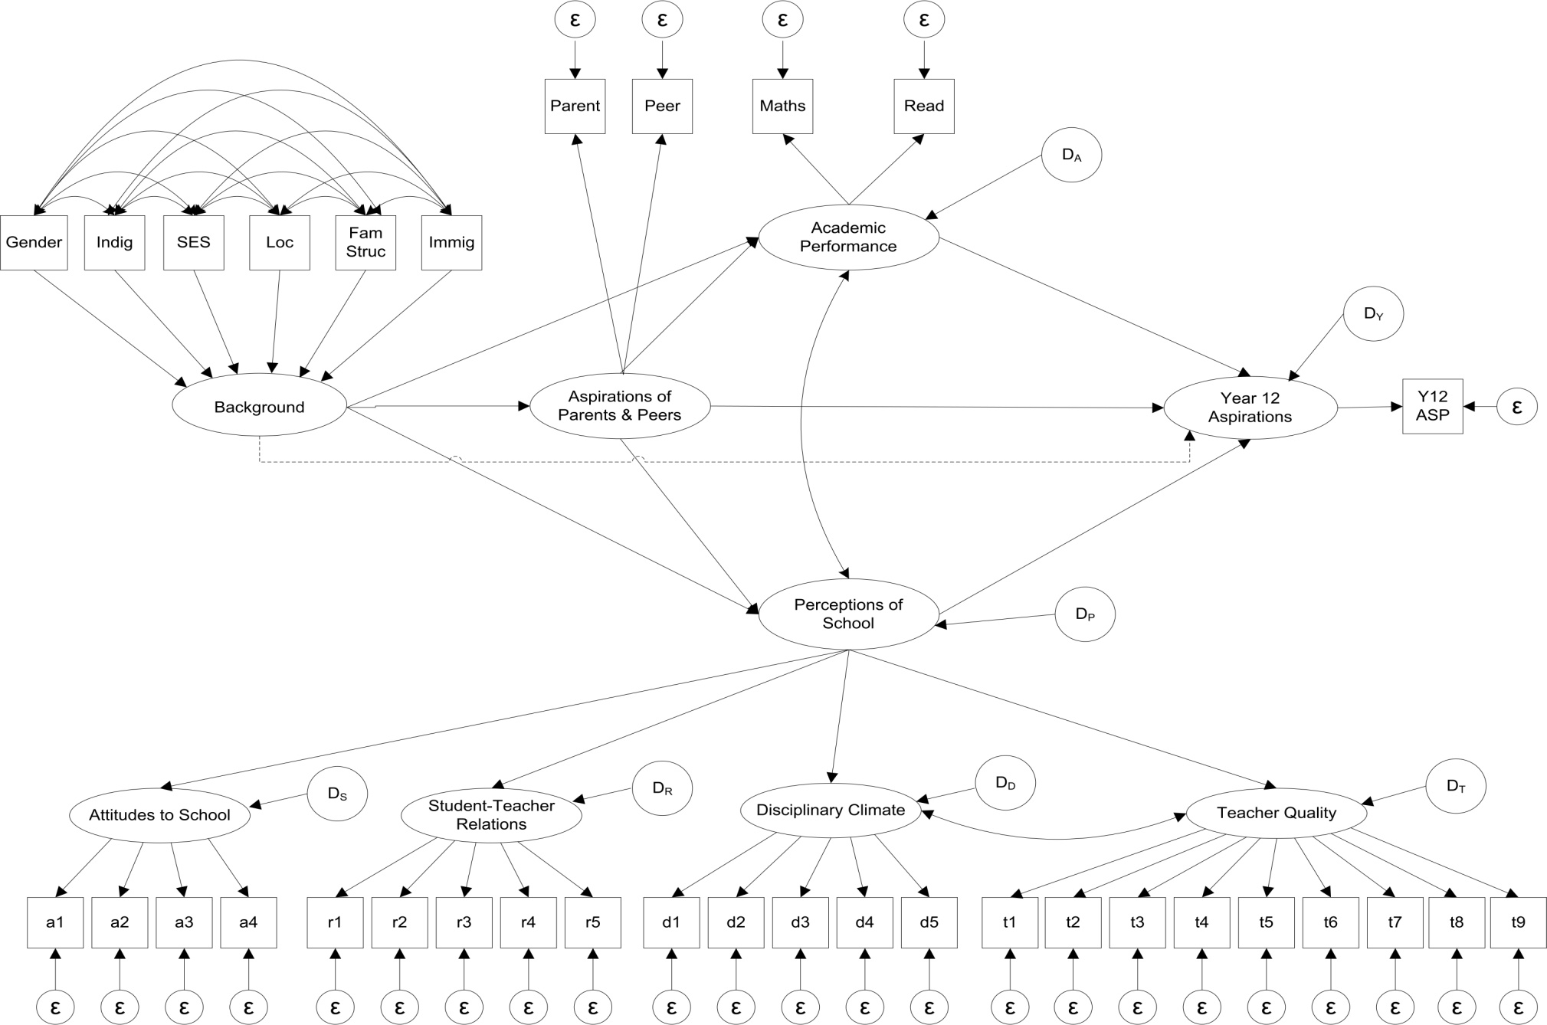

## Interpreting coefficients of structural equation models

#### Calculating direct and indirect effects

One advantage of structural equation modelling over traditional multivariate regression is that both the direct and *indirect* influences of a predictor on the outcome can be examined.

For example, consider figure C2, showing the structural model for Year 12 plans. Consider the “parents and peers” variable. There is a direct path from this variable to the outcome; thus the direct effect of “parents and peers” on Year 12 aspirations is 0.48. The coefficients presented are standardised coefficients. Thus a coefficient of 0.48 means that if parental and peer support increases by one standard deviation while all other variables are held constant, Year 12 aspirations would be expected to increase by 0.48 of a standard deviation.

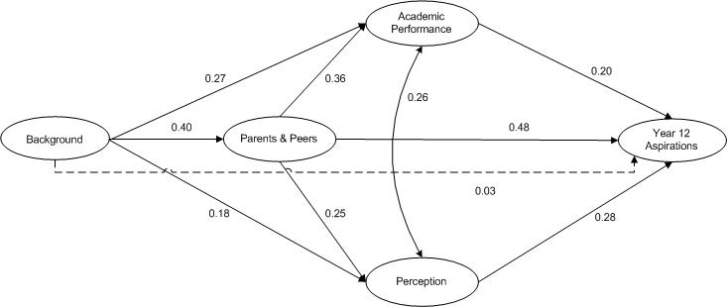Figure C2 Structural model for Year 12 plans

“Parents and peers” also has an influence on Year 12 aspirations via other variables. For instance, there is a path from “parents and peers” to “academic performance”, and then from “academic performance” to “Year 12 aspirations”. So we say that “parents and peers” also has an *indirect* effect on Year 12 aspirations via “academic performance”.

To calculate the size of an indirect effect, the coefficients on the component paths are multiplied together. The rationale behind the multiplication is that “parents and peers” affects “academic performance” by 0.36 of a standard deviation, but only 0.20 (or 20%) of this effect is passed on to “Year 12 aspirations” (Kline 2011). Hence we take 20% of 0.36, or 0.20\*0.36 = 0.072. Notice that the indirect effect usually ends up being much smaller than the direct effect, due to the multiplication of the coefficients, which are always less than 1.

All figures in this section display the standardised coefficients, which enable the relative impacts of predictors to be compared on a common scale, as described. The unstandardised coefficients are given for completeness at the end of this section. Although standardised coefficients are more convenient to interpret, their interpretation rests on the assumption that different standard deviations can be thought of as equivalent. See Grace and Bollen (2005) for further discussion.

A single predictor can have more than one indirect effect on the outcome. Notice that “parents and peers” also has a second indirect effect on the outcome via the “perception” construct. To gain an understanding of the overall effect of one variable on another, one must consider total effects.

#### Calculating total effects

The total effect can be thought of as the overall effect of a predictor on the outcome, accounting for both the direct *and* indirect pathways. The total effect is simply the sum of all direct and indirect effects of one variable on another (Kline 2011). For example, one can calculate the total influence of “parents and peers” (see figure C2) on the outcome as follows:

Total effect = Direct effect + Indirect effects

= 0.48 + Indirect effect via “academic performance” + Indirect effect via “perception”

= 0.48 + (0.36)(0.20) + (0.25)(0.28)

= 0.48 + 0.072 + 0.07

= 0.62.

Thus, the total effect of “parents and peers” on Year 12 plans is 0.62. In other words, increasing “parents and peers” by one standard deviation increases students’ plans to complete Year 12 by 0.62 standard deviations via all presumed direct and indirect causal links between these two variables.

When variables are correlated, as is the case for “academic performance” and “perception”, the double-headed curved path is taken as a path when determining the indirect effects. That is, the double-headed arrow is treated as creating a path from “academic performance” to “perception” to the outcome. Similarly, the double-headed arrow also creates a path from “perception” to “academic performance” to the outcome. The correlation thus is involved in the creation of indirect paths.

Hence our previous calculation needs to be altered slightly, to also take into account the path from “academic performance” to “perception”. For “parents and peers”:

Total effect = Direct effect + Indirect effects

= 0.48 + Indirect effect via “academic performance” + Indirect effect via “perception” +   
 Second indirect effect via “academic performance” + Second indirect effect via “perception”

= 0.48 + (0.36)(0.20) + (0.25)(0.28) + (0.36)(0.26)(0.28) + (0.25)(0.26)(0.20)

= 0.48 + 0.072 + 0.07 + 0.03 + 0.01

= 0.62 + 0.04

= 0.66

Thus the total effect of “parents and peers” on Year 12 plans is 0.66.

To save one having to complete the above calculation for every predictor, SEM software normally lists the total effects as part of the output. The complete SEM output is listed at the end of this section.

## Results by aspiration outcome

For brevity, only results for the structural models (i.e., the substantive models of interest) are shown here. Figure C3 shows the structural model for Year 12 aspirations. All coefficients are standardised (i.e., put on a common scale) so that the relative strength of the paths can be compared. All paths are statistically significant and represented by solid lines, except for the path from ‘Background’ to ‘Year 12 Aspirations’, which is indicated with a dashed line.

Gender differences in the formation of educational aspirations were also examined, yet the models for males and females were not significantly different from each other. The results presented here are thus not split by gender; instead, gender is one of the variables that make up the formative ‘Background’ construct.

Figure C3 Structural model for Year 12 plans

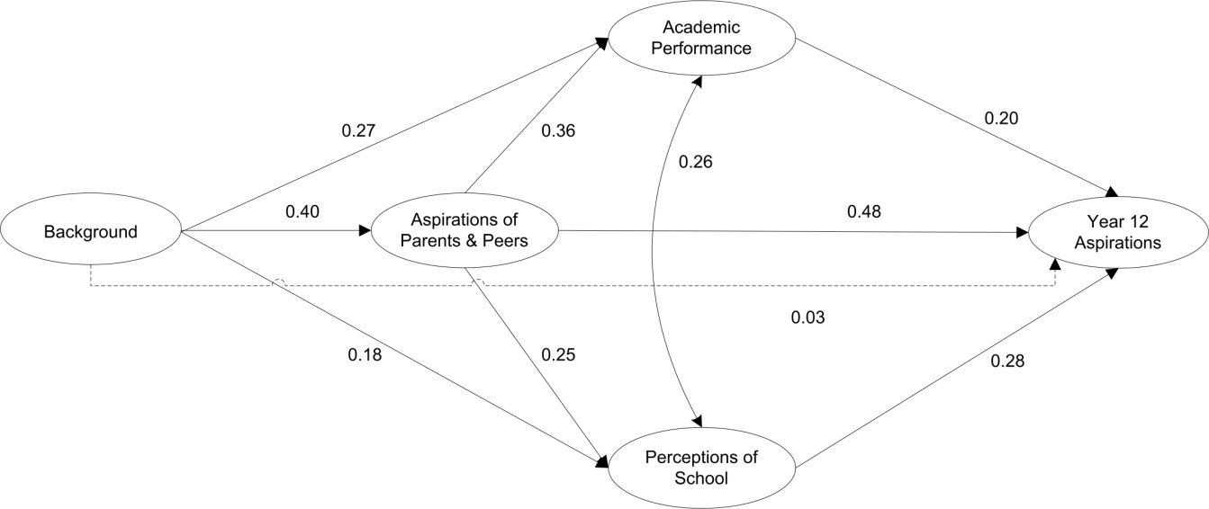

Results show that parental and peer influences have the strongest direct effect on Year 12 aspirations, followed by ‘Perceptions of School’ and ‘Academic Performance’. This is broadly consistent with the results in previous sections of this paper.

What is new here is that the magnitudes of the relationships *between* pairs of predictors are now becoming apparent. For example, parental and peer influences have a moderately strong effect on academic performance, and a lesser influence on perceptions of school. Also, background characteristics have the largest effect on parents and peers (0.40), followed by academic performance (0.27) and perceptions of school (0.18).

Most interestingly, before considering the influence of parents and peers, the direct effect of background characteristics on Year 12 aspirations was the strongest in the model (not shown here). However, once parental and peer influences are added to the model, they, in conjunction with academic performance and perceptions of school, almost entirely mediate the effect of individual background. Of course, with respect to young people’s aspirations, parental and peer influences are, to some extent, born out of individual background. Nonetheless, this finding suggests that background has no direct effect on year 12 aspirations. Instead, background affects Year 12 aspirations via academic performance, perceptions of school and, most strongly, the aspirations of parents and peers.

## Direct effects, indirect effects and total effects

In SEM, the effect of a variable on the outcome can be broken down into two components: direct and indirect effects. For example, consider the ‘Parents and Peers’ construct in figure C3. The direct effect is simply the standardised coefficient associated with the direct path from the variable to the outcome (i.e., 0.48). The interpretation is that if parental and peer support increases by one standard deviation, while all other variables are held constant, Year 12 aspirations would be expected to increase by 0.48 of a standard deviation.

However, the ‘Parents and Peers’ construct also has an influence on Year 12 aspirations via *other* variables (e.g. there is a path from parents and peers 🠢 academic performance 🠢 Year 12 aspirations). This is called an *indirect* effect. To calculate the magnitude of an indirect effect, the coefficients on the component paths are multiplied. The rationale behind the multiplication is that ‘Parents and Peers’ affects ‘Academic Performance’ by 0.36 of a standard deviation, but only 20 per cent of this effect is passed on to ‘Year 12 Aspirations’ (Kline 2011). Hence, the indirect effect of ‘Parents and Peers’ on ‘Year 12 Aspirations’ via ‘Academic Performance’ is 0.20\*0.36 = 0.072.

The total effect is then the sum of the direct and indirect effects (Kline 2011). A more detailed discussion of direct, indirect and total effects (including worked examples) is provided in section D of the accompanying support document.

## University plans

The SEM model for university plans, with standardised coefficients, is shown in figure C4. Note that due to statistical estimation problems, parental expectations had to be removed for the model on university plans.

Figure C4 Structural model for university plans

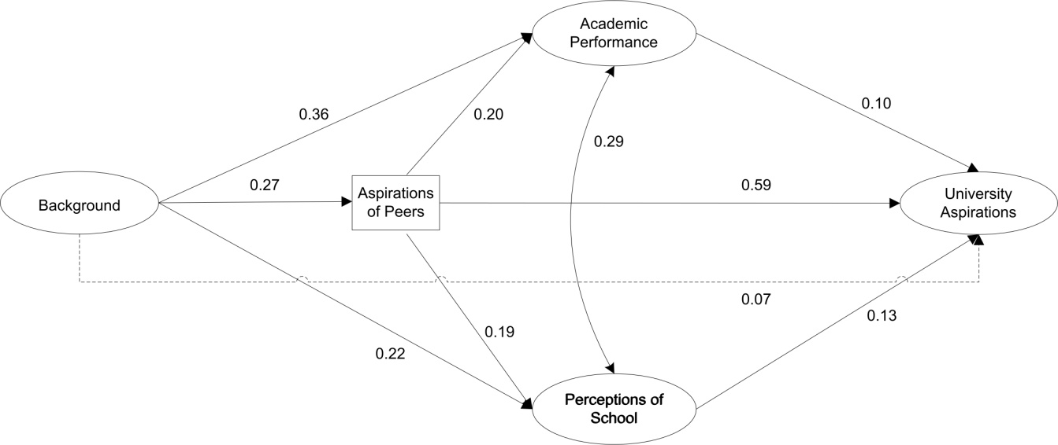

Results suggest that peer plans has by far the strongest influence on a student’s university plans, while academic performance and perceptions of school have only weak influences. In fact, the direct effect of peer plans is approximately six times as strong as the effects of academic performance and perceptions of school. As was the case with Year 12 aspirations, the effect of background is almost entirely mediated by peer plans, academic performance and perceptions of school. However, the exclusion of parental expectations due to estimation problems somewhat weakens the model on university aspirations.

## Occupational aspirations

The structural model for occupational aspirations is given in figure C5.

Figure C5 Structural model for occupational aspirations

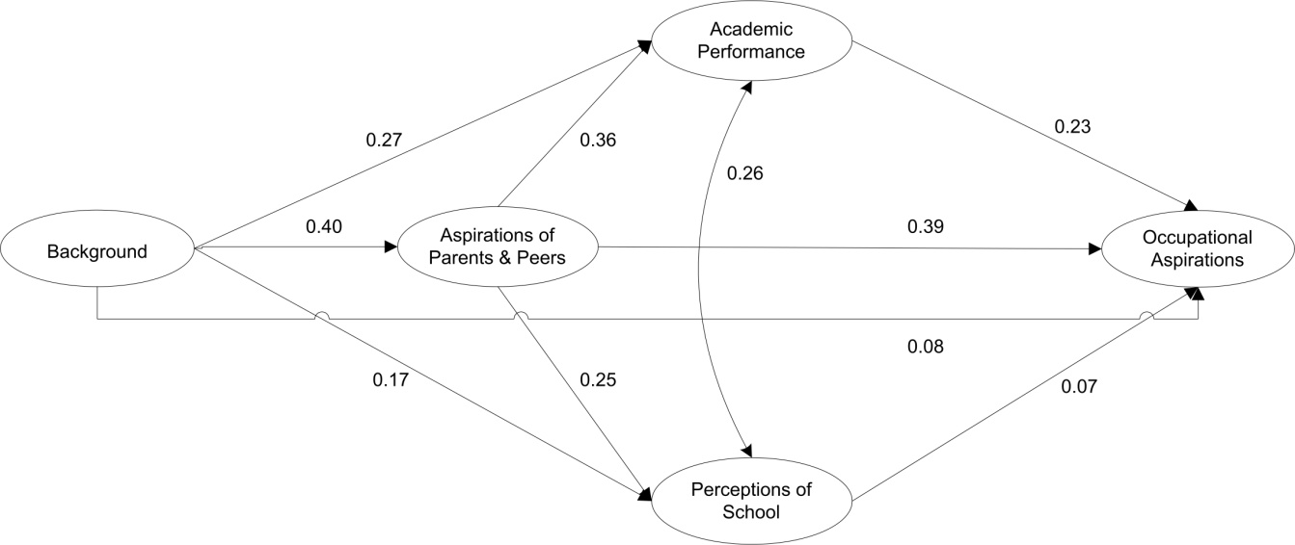

Once again, the strongest influence on the outcome is parental and peer expectations. Parents and peers also have a strong influence on academic performance and perceptions of school. Also, the direct effect of academic performance is roughly *three times* that of perceptions of school. This agrees with the OLS results, where parents’ higher education aspirations was the top predictor, followed by academic performance.

## Summary of results

Table C3 summarises the total effects of the predictors across all three outcome variables.

Table C3 Summary of total effects across outcomes

|  |  |  |  |
| --- | --- | --- | --- |
| Predictor construct | Year 12 aspirations | University aspirations | Occupational aspirations |
| Background | 0.43 | 0.32 | 0.37 |
| Academic performance | 0.27 | 0.14 | 0.24 |
| Parents and peers | 0.66 | 0.65 | 0.65 |
| Perceptions of school | 0.33 | 0.16 | 0.13 |

Overall, the structural equation models indicate that, for each outcome, parents and peers is the most influential predictor. However, a key insight emerges when the SEM findings are compared with the findings from the simple regressions.

The previous tree diagrams suggest that the most influential predictors are (in the case of Year 12 aspirations) academic achievement, followed by parental and peer expectations. While parental and peer expectations still comes up as a very strong predictor, it now appears that background is more important than we first understood from the earlier analysis, due to its indirect effects, particularly through academic performance and parents and peers.

In other words, the structural equation models have led to a deeper understanding of the way background indirectly affects the three outcomes through its influence on parental and peer expectations, academic performance and perceptions of school.

## Assessing model fit

In structural equation modelling, model fit is assessed using several indicators. Model fit indicates the extent to which the proposed network of relations among variables is plausible (Lei & Wu 2007). Exactly which fit indices to use, and the associated cut-offs to apply, is a topic of contention amongst researchers. However, in general, for a structural equation model to be considered a ‘good fit’, the following must hold: the Comparative Fit Index (CFI) should be close to 1, the Root Mean Square Error of Approximation (RMSEA) should be close to zero, and the Standardised Root Mean Square Residual (SRMR) should be close to zero.

The precise cut-offs for each of these indices differs depending on sample size. For sample sizes larger than n= 500, the CFI should be ≥ 0.95, the RMSEA ≤ 0.06 and the SRMR ≤ 0.08 (Weston & Gore 2006). These cut-offs are slightly less stringent for sample sizes under 500 observations, as shown in table C4.

Table C4 Summary of the fit criteria to apply, dependant on sample size

|  |  |  |
| --- | --- | --- |
| Fit index | For sample sizes less than n = 500 | For sample sizes greater than n = 500 |
| CFI | ≥ 0.90 | ≥ 0.95 |
| RMSEA | ≤ 0.10 | ≤ 0.06 |
| SRMR | ≤ 0.10 | ≤ 0.08 |

Source: Weston and Gore (2006)

In addition, the χ2 value should be nonsignificant. A significant χ2 suggests that the model does not fit the data well (Weston & Gore 2006). However, a word of caution is in order, since for large samples, the χ2 is likely to become significant due to increased statistical power, even though the model may be a close fit to the data (Weston & Gore 2006). Thus limited weight should be given to the χ2 statistic for large sample sizes. Note that the three structural equation models presented in this report all satisfy the criteria for sample sizes greater than n=500. The values of the fit indices are presented at the end of this section.

## Detailed SEM results by outcome

Table C5 presents a summary of the model fit statistics for all three outcomes.

Table C5 Summary of model fit statistics across all outcomes (n = 13 628)

|  |  |  |  |  |  |  |
| --- | --- | --- | --- | --- | --- | --- |
| Outcome | χ2 | df | p | RMSEA | RMSEA CI90 | CFI |
| Year 12 Asp. | 7 611.143 | 499 | <0.000 | 0.032 | 0.032-0.033 | 0.974 |
| Uni Asp. | 7 375.864 | 468 | <0.000 | 0.033 | 0.032-0.034 | 0.974 |
| Occ. Asp. | 7 500.759 | 499 | <0.000 | 0.032 | 0.031-0.033 | 0.974 |

Tables C6 to C8 present the covariance matrices for each of the three outcomes, respectively. The correlation matrices are listed in tables C9 to C11. For details on individual variables, please see the LSAY metadata spreadsheet for the Y09 cohort, available from the LSAY website, <http://www.lsay.edu.au/publications/2621.html>.

Note that some variables from the LSAY Y09 dataset have been renamed for the purposes of this study. These variables are listed below, together with the original LSAY variable name:

* PAR\_ASP = st65n02
* PEER\_ASP = st65n03
* MATHS = pv1math
* READING = pv1read
* YR12\_EXP = st64n01
* UNI\_EXP = st65n01
* OCC\_ASP = anzscoq69, recoded to the AUSEI06 scale.

Table C6 Covariance matrix for Year 12 aspirations

|  | PAR\_ASP | PEER\_ASP | MATHS | READING | ST33Q01 |
| --- | --- | --- | --- | --- | --- |
| PAR\_ASP |  |  |  |  |  |
| PEER\_ASP | 0.53 |  |  |  |  |
| MATHS | 0.217 | 0.167 | 0.713 |  |  |
| READING | 0.257 | 0.198 | 0.635 | 0.769 |  |
| ST33Q01 | 0.093 | 0.072 | 0.113 | 0.133 |  |
| ST33Q02 | 0.116 | 0.089 | 0.14 | 0.166 | 0.558 |
| ST33Q03 | 0.1 | 0.077 | 0.12 | 0.142 | 0.479 |
| ST33Q04 | 0.104 | 0.08 | 0.125 | 0.148 | 0.499 |
| ST34Q01 | 0.127 | 0.098 | 0.154 | 0.182 | 0.313 |
| ST34Q02 | 0.136 | 0.105 | 0.164 | 0.194 | 0.334 |
| ST34Q03 | 0.139 | 0.107 | 0.168 | 0.198 | 0.342 |
| ST34Q04 | 0.127 | 0.098 | 0.153 | 0.182 | 0.313 |
| ST34Q05 | 0.133 | 0.102 | 0.161 | 0.19 | 0.327 |
| ST36Q01 | 0.053 | 0.041 | 0.064 | 0.076 | 0.13 |
| ST36Q02 | 0.054 | 0.042 | 0.066 | 0.078 | 0.134 |
| ST36Q03 | 0.057 | 0.044 | 0.069 | 0.081 | 0.14 |
| ST36Q04 | 0.056 | 0.043 | 0.068 | 0.081 | 0.139 |
| ST36Q05 | 0.056 | 0.043 | 0.067 | 0.08 | 0.137 |
| ST38Q01 | 0.058 | 0.045 | 0.07 | 0.083 | 0.143 |
| ST38Q02 | 0.072 | 0.056 | 0.087 | 0.103 | 0.178 |
| ST38Q03 | 0.074 | 0.057 | 0.089 | 0.106 | 0.182 |
| ST38Q04 | 0.071 | 0.055 | 0.086 | 0.102 | 0.176 |
| ST38Q05 | 0.079 | 0.061 | 0.095 | 0.113 | 0.194 |
| ST38Q06 | 0.059 | 0.045 | 0.071 | 0.084 | 0.144 |
| ST38Q07 | 0.08 | 0.062 | 0.097 | 0.115 | 0.198 |
| ST38Q08 | 0.075 | 0.057 | 0.09 | 0.107 | 0.184 |
| ST38Q09 | 0.065 | 0.05 | 0.079 | 0.093 | 0.16 |
| Y12\_EXP | 0.515 | 0.396 | 0.341 | 0.404 | 0.224 |
|  |  |  |  |  |  |
|  | ST33Q02 | ST33Q03 | ST33Q04 | ST34Q01 | ST34Q02 |
| ST33Q03 | 0.596 |  |  |  |  |
| ST33Q04 | 0.62 | 0.533 |  |  |  |
| ST34Q01 | 0.389 | 0.335 | 0.348 |  |  |
| ST34Q02 | 0.416 | 0.357 | 0.372 | 0.693 |  |
| ST34Q03 | 0.425 | 0.365 | 0.38 | 0.708 | 0.756 |
| ST34Q04 | 0.389 | 0.334 | 0.348 | 0.649 | 0.692 |
| ST34Q05 | 0.407 | 0.35 | 0.364 | 0.679 | 0.725 |
| ST36Q01 | 0.162 | 0.139 | 0.145 | 0.178 | 0.19 |
| ST36Q02 | 0.166 | 0.143 | 0.149 | 0.183 | 0.195 |
| ST36Q03 | 0.174 | 0.15 | 0.156 | 0.191 | 0.204 |
| ST36Q04 | 0.173 | 0.149 | 0.155 | 0.19 | 0.203 |
| ST36Q05 | 0.17 | 0.146 | 0.152 | 0.187 | 0.2 |
| ST38Q01 | 0.178 | 0.153 | 0.159 | 0.196 | 0.209 |
| ST38Q02 | 0.221 | 0.19 | 0.198 | 0.243 | 0.259 |
| ST38Q03 | 0.226 | 0.194 | 0.202 | 0.248 | 0.265 |
| ST38Q04 | 0.218 | 0.188 | 0.195 | 0.24 | 0.256 |
| ST38Q05 | 0.242 | 0.208 | 0.216 | 0.265 | 0.283 |
| ST38Q06 | 0.18 | 0.154 | 0.161 | 0.197 | 0.21 |
| ST38Q07 | 0.246 | 0.211 | 0.22 | 0.27 | 0.288 |
| ST38Q08 | 0.229 | 0.196 | 0.204 | 0.251 | 0.268 |
| ST38Q09 | 0.199 | 0.171 | 0.178 | 0.218 | 0.233 |
| Y12\_EXP | 0.279 | 0.24 | 0.25 | 0.306 | 0.327 |
|  |  |  |  |  |  |
|  | ST34Q03 | ST34Q04 | ST34Q05 | ST36Q01 | ST36Q02 |
| ST34Q04 | 0.707 |  |  |  |  |
| ST34Q05 | 0.74 | 0.678 |  |  |  |
| ST36Q01 | 0.194 | 0.178 | 0.186 |  |  |
| ST36Q02 | 0.199 | 0.182 | 0.191 | 0.675 |  |
| ST36Q03 | 0.209 | 0.191 | 0.2 | 0.707 | 0.726 |
| ST36Q04 | 0.207 | 0.189 | 0.198 | 0.701 | 0.72 |
| ST36Q05 | 0.204 | 0.187 | 0.195 | 0.691 | 0.71 |
| ST38Q01 | 0.213 | 0.195 | 0.205 | 0.155 | 0.159 |
| ST38Q02 | 0.265 | 0.242 | 0.254 | 0.192 | 0.197 |
| ST38Q03 | 0.27 | 0.248 | 0.259 | 0.196 | 0.201 |
| ST38Q04 | 0.261 | 0.239 | 0.25 | 0.19 | 0.195 |
| ST38Q05 | 0.289 | 0.265 | 0.277 | 0.21 | 0.215 |
| ST38Q06 | 0.215 | 0.197 | 0.206 | 0.156 | 0.16 |
| ST38Q07 | 0.295 | 0.27 | 0.282 | 0.214 | 0.219 |
| ST38Q08 | 0.274 | 0.25 | 0.262 | 0.198 | 0.204 |
| ST38Q09 | 0.238 | 0.218 | 0.228 | 0.173 | 0.178 |
| Y12\_EXP | 0.334 | 0.306 | 0.32 | 0.127 | 0.131 |
|  |  |  |  |  |  |
|  | ST36Q03 | ST36Q04 | ST36Q05 | ST38Q01 | ST38Q02 |
| ST36Q04 | 0.755 |  |  |  |  |
| ST36Q05 | 0.744 | 0.737 |  |  |  |
| ST38Q01 | 0.167 | 0.165 | 0.163 |  |  |
| ST38Q02 | 0.207 | 0.205 | 0.202 | 0.422 |  |
| ST38Q03 | 0.211 | 0.209 | 0.206 | 0.431 | 0.535 |
| ST38Q04 | 0.204 | 0.202 | 0.199 | 0.417 | 0.517 |
| ST38Q05 | 0.226 | 0.224 | 0.22 | 0.461 | 0.572 |
| ST38Q06 | 0.168 | 0.166 | 0.164 | 0.342 | 0.425 |
| ST38Q07 | 0.23 | 0.228 | 0.225 | 0.469 | 0.582 |
| ST38Q08 | 0.213 | 0.212 | 0.209 | 0.436 | 0.541 |
| ST38Q09 | 0.186 | 0.184 | 0.182 | 0.38 | 0.471 |
| Y12\_EXP | 0.137 | 0.136 | 0.134 | 0.14 | 0.174 |
|  |  |  |  |  |  |
|  | ST38Q03 | ST38Q04 | ST38Q05 | ST38Q06 | ST38Q07 |
| ST38Q04 | 0.528 |  |  |  |  |
| ST38Q05 | 0.584 | 0.564 |  |  |  |
| ST38Q06 | 0.434 | 0.419 | 0.464 |  |  |
| ST38Q07 | 0.595 | 0.575 | 0.636 | 0.473 |  |
| ST38Q08 | 0.552 | 0.534 | 0.591 | 0.439 | 0.602 |
| ST38Q09 | 0.481 | 0.465 | 0.514 | 0.382 | 0.524 |
| Y12\_EXP | 0.178 | 0.172 | 0.19 | 0.141 | 0.194 |
|  |  |  |  |  |  |
|  | ST38Q08 | ST38Q09 | Y12\_EXP |  |  |
| ST38Q09 | 0.487 |  |  |  |  |
| Y12\_EXP | 0.18 | 0.157 |  |  |  |

Table C7 Covariance matrix for university aspirations

|  | PEER\_ASP | MATHS | READING | ST33Q01 | ST33Q02 |
| --- | --- | --- | --- | --- | --- |
| PEER\_ASP |  |  |  |  |  |
| MATHS | 0.155 | 0.713 |  |  |  |
| READING | 0.186 | 0.635 | 0.769 |  |  |
| ST33Q01 | 0.088 | 0.111 | 0.132 |  |  |
| ST33Q02 | 0.109 | 0.138 | 0.164 | 0.556 |  |
| ST33Q03 | 0.094 | 0.119 | 0.142 | 0.48 | 0.596 |
| ST33Q04 | 0.098 | 0.124 | 0.148 | 0.499 | 0.619 |
| ST34Q01 | 0.122 | 0.153 | 0.183 | 0.312 | 0.388 |
| ST34Q02 | 0.13 | 0.164 | 0.196 | 0.334 | 0.414 |
| ST34Q03 | 0.133 | 0.168 | 0.2 | 0.341 | 0.423 |
| ST34Q04 | 0.122 | 0.153 | 0.183 | 0.312 | 0.387 |
| ST34Q05 | 0.127 | 0.161 | 0.192 | 0.327 | 0.405 |
| ST36Q01 | 0.05 | 0.063 | 0.075 | 0.128 | 0.159 |
| ST36Q02 | 0.051 | 0.065 | 0.077 | 0.132 | 0.164 |
| ST36Q03 | 0.054 | 0.068 | 0.081 | 0.138 | 0.171 |
| ST36Q04 | 0.053 | 0.067 | 0.08 | 0.137 | 0.17 |
| ST36Q05 | 0.053 | 0.066 | 0.079 | 0.135 | 0.167 |
| ST38Q01 | 0.055 | 0.07 | 0.084 | 0.142 | 0.177 |
| ST38Q02 | 0.069 | 0.087 | 0.104 | 0.176 | 0.219 |
| ST38Q03 | 0.07 | 0.089 | 0.106 | 0.18 | 0.224 |
| ST38Q04 | 0.068 | 0.086 | 0.102 | 0.174 | 0.216 |
| ST38Q05 | 0.075 | 0.095 | 0.113 | 0.193 | 0.239 |
| ST38Q06 | 0.056 | 0.07 | 0.084 | 0.143 | 0.178 |
| ST38Q07 | 0.076 | 0.096 | 0.115 | 0.196 | 0.244 |
| ST38Q08 | 0.071 | 0.09 | 0.107 | 0.182 | 0.226 |
| ST38Q09 | 0.062 | 0.078 | 0.093 | 0.159 | 0.197 |
| UNI\_EXP | 0.641 | 0.19 | 0.227 | 0.13 | 0.161 |
|  |  |  |  |  |  |
|  | ST33Q03 | ST33Q04 | ST34Q01 | ST34Q02 | ST34Q03 |
| ST33Q04 | 0.535 |  |  |  |  |
| ST34Q01 | 0.335 | 0.348 |  |  |  |
| ST34Q02 | 0.358 | 0.372 | 0.693 |  |  |
| ST34Q03 | 0.366 | 0.38 | 0.708 | 0.757 |  |
| ST34Q04 | 0.335 | 0.348 | 0.648 | 0.693 | 0.708 |
| ST34Q05 | 0.35 | 0.364 | 0.678 | 0.725 | 0.741 |
| ST36Q01 | 0.138 | 0.143 | 0.178 | 0.19 | 0.194 |
| ST36Q02 | 0.141 | 0.147 | 0.182 | 0.195 | 0.199 |
| ST36Q03 | 0.148 | 0.154 | 0.191 | 0.204 | 0.209 |
| ST36Q04 | 0.147 | 0.152 | 0.189 | 0.202 | 0.207 |
| ST36Q05 | 0.145 | 0.15 | 0.187 | 0.2 | 0.204 |
| ST38Q01 | 0.153 | 0.159 | 0.197 | 0.211 | 0.215 |
| ST38Q02 | 0.189 | 0.197 | 0.244 | 0.261 | 0.267 |
| ST38Q03 | 0.193 | 0.201 | 0.25 | 0.267 | 0.272 |
| ST38Q04 | 0.187 | 0.194 | 0.241 | 0.258 | 0.263 |
| ST38Q05 | 0.207 | 0.215 | 0.267 | 0.285 | 0.291 |
| ST38Q06 | 0.153 | 0.159 | 0.198 | 0.212 | 0.216 |
| ST38Q07 | 0.21 | 0.219 | 0.272 | 0.29 | 0.297 |
| ST38Q08 | 0.196 | 0.203 | 0.252 | 0.27 | 0.276 |
| ST38Q09 | 0.171 | 0.177 | 0.22 | 0.235 | 0.24 |
| UNI\_EXP | 0.14 | 0.145 | 0.18 | 0.193 | 0.197 |
|  |  |  |  |  |  |
|  | ST34Q04 | ST34Q05 | ST36Q01 | ST36Q02 | ST36Q03 |
| ST34Q05 | 0.678 |  |  |  |  |
| ST36Q01 | 0.177 | 0.186 |  |  |  |
| ST36Q02 | 0.182 | 0.191 | 0.675 |  |  |
| ST36Q03 | 0.191 | 0.2 | 0.707 | 0.726 |  |
| ST36Q04 | 0.189 | 0.198 | 0.701 | 0.72 | 0.754 |
| ST36Q05 | 0.187 | 0.195 | 0.691 | 0.71 | 0.744 |
| ST38Q01 | 0.197 | 0.206 | 0.155 | 0.159 | 0.167 |
| ST38Q02 | 0.244 | 0.256 | 0.192 | 0.197 | 0.207 |
| ST38Q03 | 0.249 | 0.261 | 0.196 | 0.201 | 0.211 |
| ST38Q04 | 0.241 | 0.252 | 0.19 | 0.195 | 0.204 |
| ST38Q05 | 0.267 | 0.279 | 0.21 | 0.215 | 0.226 |
| ST38Q06 | 0.198 | 0.207 | 0.156 | 0.16 | 0.167 |
| ST38Q07 | 0.272 | 0.284 | 0.214 | 0.219 | 0.23 |
| ST38Q08 | 0.252 | 0.264 | 0.198 | 0.204 | 0.213 |
| ST38Q09 | 0.22 | 0.23 | 0.173 | 0.178 | 0.186 |
| UNI\_EXP | 0.18 | 0.188 | 0.074 | 0.076 | 0.08 |
|  |  |  |  |  |  |
|  | ST36Q04 | ST36Q05 | ST38Q01 | ST38Q02 | ST38Q03 |
| ST36Q05 | 0.737 |  |  |  |  |
| ST38Q01 | 0.165 | 0.163 |  |  |  |
| ST38Q02 | 0.205 | 0.202 | 0.422 |  |  |
| ST38Q03 | 0.209 | 0.206 | 0.431 | 0.535 |  |
| ST38Q04 | 0.202 | 0.199 | 0.417 | 0.517 | 0.528 |
| ST38Q05 | 0.224 | 0.221 | 0.461 | 0.572 | 0.584 |
| ST38Q06 | 0.166 | 0.164 | 0.342 | 0.424 | 0.433 |
| ST38Q07 | 0.228 | 0.225 | 0.469 | 0.582 | 0.595 |
| ST38Q08 | 0.212 | 0.209 | 0.436 | 0.541 | 0.552 |
| ST38Q09 | 0.185 | 0.182 | 0.38 | 0.472 | 0.482 |
| UNI\_EXP | 0.079 | 0.078 | 0.082 | 0.102 | 0.104 |
|  |  |  |  |  |  |
|  | ST38Q04 | ST38Q05 | ST38Q06 | ST38Q07 | ST38Q08 |
| ST38Q05 | 0.564 |  |  |  |  |
| ST38Q06 | 0.419 | 0.464 |  |  |  |
| ST38Q07 | 0.575 | 0.636 | 0.472 |  |  |
| ST38Q08 | 0.534 | 0.591 | 0.438 | 0.601 |  |
| ST38Q09 | 0.466 | 0.515 | 0.382 | 0.525 | 0.487 |
| UNI\_EXP | 0.1 | 0.111 | 0.083 | 0.113 | 0.105 |
|  |  |  |  |  |  |
|  | ST38Q09 | UNI\_EXP |  |  |  |
| UNI\_EXP | 0.092 |  |  |  |  |

Table C8 Covariance matrix for occupational aspirations

|  | PAR\_ASP | PEER\_ASP | MATHS | READING | ST33Q01 |
| --- | --- | --- | --- | --- | --- |
| PAR\_ASP |  |  |  |  |  |
| PEER\_ASP | 0.53 |  |  |  |  |
| MATHS | 0.218 | 0.165 | 0.713 |  |  |
| READING | 0.258 | 0.196 | 0.635 | 0.769 |  |
| ST33Q01 | 0.093 | 0.07 | 0.112 | 0.132 |  |
| ST33Q02 | 0.115 | 0.087 | 0.139 | 0.164 | 0.557 |
| ST33Q03 | 0.099 | 0.075 | 0.119 | 0.142 | 0.48 |
| ST33Q04 | 0.103 | 0.078 | 0.124 | 0.147 | 0.499 |
| ST34Q01 | 0.128 | 0.097 | 0.154 | 0.183 | 0.312 |
| ST34Q02 | 0.137 | 0.104 | 0.165 | 0.195 | 0.333 |
| ST34Q03 | 0.14 | 0.106 | 0.168 | 0.199 | 0.34 |
| ST34Q04 | 0.128 | 0.097 | 0.154 | 0.182 | 0.312 |
| ST34Q05 | 0.134 | 0.102 | 0.161 | 0.191 | 0.326 |
| ST36Q01 | 0.053 | 0.04 | 0.064 | 0.076 | 0.13 |
| ST36Q02 | 0.055 | 0.041 | 0.066 | 0.078 | 0.133 |
| ST36Q03 | 0.057 | 0.043 | 0.069 | 0.082 | 0.139 |
| ST36Q04 | 0.057 | 0.043 | 0.068 | 0.081 | 0.138 |
| ST36Q05 | 0.056 | 0.042 | 0.067 | 0.08 | 0.136 |
| ST38Q01 | 0.058 | 0.044 | 0.07 | 0.083 | 0.142 |
| ST38Q02 | 0.073 | 0.055 | 0.087 | 0.103 | 0.177 |
| ST38Q03 | 0.074 | 0.056 | 0.089 | 0.106 | 0.181 |
| ST38Q04 | 0.072 | 0.054 | 0.086 | 0.102 | 0.175 |
| ST38Q05 | 0.079 | 0.06 | 0.095 | 0.113 | 0.193 |
| ST38Q06 | 0.059 | 0.045 | 0.071 | 0.084 | 0.143 |
| ST38Q07 | 0.081 | 0.061 | 0.097 | 0.115 | 0.197 |
| ST38Q08 | 0.075 | 0.057 | 0.09 | 0.107 | 0.183 |
| ST38Q09 | 0.065 | 0.05 | 0.079 | 0.093 | 0.159 |
| OCC\_ASP | 0.272 | 0.206 | 0.19 | 0.225 | 0.076 |
|  |  |  |  |  |  |
|  | ST33Q02 | ST33Q03 | ST33Q04 | ST34Q01 | ST34Q02 |
| ST33Q03 | 0.596 |  |  |  |  |
| ST33Q04 | 0.62 | 0.534 |  |  |  |
| ST34Q01 | 0.387 | 0.334 | 0.347 |  |  |
| ST34Q02 | 0.414 | 0.357 | 0.371 | 0.693 |  |
| ST34Q03 | 0.423 | 0.364 | 0.379 | 0.708 | 0.757 |
| ST34Q04 | 0.387 | 0.333 | 0.347 | 0.648 | 0.693 |
| ST34Q05 | 0.405 | 0.349 | 0.363 | 0.678 | 0.725 |
| ST36Q01 | 0.161 | 0.139 | 0.144 | 0.179 | 0.191 |
| ST36Q02 | 0.165 | 0.142 | 0.148 | 0.184 | 0.196 |
| ST36Q03 | 0.173 | 0.149 | 0.155 | 0.192 | 0.206 |
| ST36Q04 | 0.172 | 0.148 | 0.154 | 0.191 | 0.204 |
| ST36Q05 | 0.169 | 0.146 | 0.152 | 0.188 | 0.201 |
| ST38Q01 | 0.177 | 0.152 | 0.158 | 0.197 | 0.21 |
| ST38Q02 | 0.22 | 0.189 | 0.197 | 0.244 | 0.261 |
| ST38Q03 | 0.224 | 0.193 | 0.201 | 0.249 | 0.266 |
| ST38Q04 | 0.217 | 0.187 | 0.194 | 0.241 | 0.257 |
| ST38Q05 | 0.24 | 0.207 | 0.215 | 0.266 | 0.285 |
| ST38Q06 | 0.178 | 0.153 | 0.16 | 0.198 | 0.211 |
| ST38Q07 | 0.244 | 0.21 | 0.219 | 0.271 | 0.29 |
| ST38Q08 | 0.227 | 0.195 | 0.203 | 0.252 | 0.269 |
| ST38Q09 | 0.198 | 0.17 | 0.177 | 0.22 | 0.235 |
| OCC\_ASP | 0.094 | 0.081 | 0.084 | 0.104 | 0.112 |
|  |  |  |  |  |  |
|  | ST34Q03 | ST34Q04 | ST34Q05 | ST36Q01 | ST36Q02 |
| ST34Q04 | 0.707 |  |  |  |  |
| ST34Q05 | 0.74 | 0.677 |  |  |  |
| ST36Q01 | 0.195 | 0.179 | 0.187 |  |  |
| ST36Q02 | 0.2 | 0.183 | 0.192 | 0.675 |  |
| ST36Q03 | 0.21 | 0.192 | 0.201 | 0.707 | 0.726 |
| ST36Q04 | 0.208 | 0.191 | 0.199 | 0.701 | 0.72 |
| ST36Q05 | 0.205 | 0.188 | 0.196 | 0.691 | 0.71 |
| ST38Q01 | 0.215 | 0.196 | 0.205 | 0.155 | 0.159 |
| ST38Q02 | 0.266 | 0.244 | 0.255 | 0.192 | 0.197 |
| ST38Q03 | 0.272 | 0.249 | 0.26 | 0.196 | 0.201 |
| ST38Q04 | 0.263 | 0.241 | 0.252 | 0.19 | 0.195 |
| ST38Q05 | 0.291 | 0.266 | 0.278 | 0.21 | 0.215 |
| ST38Q06 | 0.216 | 0.198 | 0.207 | 0.156 | 0.16 |
| ST38Q07 | 0.296 | 0.271 | 0.284 | 0.214 | 0.219 |
| ST38Q08 | 0.275 | 0.252 | 0.263 | 0.198 | 0.204 |
| ST38Q09 | 0.24 | 0.219 | 0.23 | 0.173 | 0.178 |
| OCC\_ASP | 0.114 | 0.104 | 0.109 | 0.043 | 0.045 |
|  |  |  |  |  |  |
|  | ST36Q03 | ST36Q04 | ST36Q05 | ST38Q01 | ST38Q02 |
| ST36Q04 | 0.754 |  |  |  |  |
| ST36Q05 | 0.744 | 0.737 |  |  |  |
| ST38Q01 | 0.166 | 0.165 | 0.163 |  |  |
| ST38Q02 | 0.207 | 0.205 | 0.202 | 0.422 |  |
| ST38Q03 | 0.211 | 0.209 | 0.206 | 0.431 | 0.535 |
| ST38Q04 | 0.204 | 0.202 | 0.199 | 0.417 | 0.517 |
| ST38Q05 | 0.226 | 0.224 | 0.221 | 0.461 | 0.572 |
| ST38Q06 | 0.168 | 0.166 | 0.164 | 0.342 | 0.425 |
| ST38Q07 | 0.23 | 0.228 | 0.225 | 0.469 | 0.582 |
| ST38Q08 | 0.213 | 0.212 | 0.209 | 0.436 | 0.541 |
| ST38Q09 | 0.186 | 0.184 | 0.182 | 0.38 | 0.471 |
| OCC\_ASP | 0.047 | 0.046 | 0.046 | 0.048 | 0.059 |
|  |  |  |  |  |  |
|  | ST38Q03 | ST38Q04 | ST38Q05 | ST38Q06 | ST38Q07 |
| ST38Q04 | 0.528 |  |  |  |  |
| ST38Q05 | 0.584 | 0.565 |  |  |  |
| ST38Q06 | 0.434 | 0.419 | 0.464 |  |  |
| ST38Q07 | 0.595 | 0.575 | 0.636 | 0.472 |  |
| ST38Q08 | 0.552 | 0.534 | 0.591 | 0.439 | 0.602 |
| ST38Q09 | 0.481 | 0.465 | 0.515 | 0.382 | 0.524 |
| OCC\_ASP | 0.06 | 0.058 | 0.065 | 0.048 | 0.066 |
|  |  |  |  |  |  |
|  | ST38Q08 | ST38Q09 | OCC\_ASP |  |  |
| ST38Q09 | 0.487 |  |  |  |  |
| OCC\_ASP | 0.061 | 0.053 | 0.466 |  |  |

Table C9 Correlation matrix for Year 12 aspirations

|  | PAR\_ASP | PEER\_ASP | MATHS | READING | ST33Q01 |
| --- | --- | --- | --- | --- | --- |
| PAR\_ASP |  |  |  |  |  |
| PEER\_ASP | 0.530 |  |  |  |  |
| MATHS | 0.286 | 0.206 | 0.713 |  |  |
| READING | 0.282 | 0.192 | 0.857 | 0.769 |  |
| ST33Q01 | 0.127 | 0.070 | 0.200 | 0.224 |  |
| ST33Q02 | 0.167 | 0.115 | 0.213 | 0.236 | 0.617 |
| ST33Q03 | 0.073 | 0.074 | 0.018 | 0.022 | 0.418 |
| ST33Q04 | 0.105 | 0.043 | 0.085 | 0.095 | 0.469 |
| ST34Q01 | 0.097 | 0.141 | 0.227 | 0.236 | 0.275 |
| ST34Q02 | 0.081 | 0.114 | 0.215 | 0.222 | 0.321 |
| ST34Q03 | 0.109 | 0.154 | 0.193 | 0.199 | 0.305 |
| ST34Q04 | 0.113 | 0.147 | 0.183 | 0.202 | 0.303 |
| ST34Q05 | 0.090 | 0.157 | 0.216 | 0.232 | 0.304 |
| ST36Q01 | 0.099 | 0.120 | 0.155 | 0.162 | 0.134 |
| ST36Q02 | 0.074 | 0.115 | 0.131 | 0.141 | 0.133 |
| ST36Q03 | 0.074 | 0.140 | 0.180 | 0.190 | 0.148 |
| ST36Q04 | 0.075 | 0.128 | 0.179 | 0.197 | 0.181 |
| ST36Q05 | 0.063 | 0.110 | 0.155 | 0.171 | 0.177 |
| ST38Q01 | 0.016 | 0.015 | 0.005 | 0.037 | 0.144 |
| ST38Q02 | 0.028 | 0.003 | 0.003 | 0.038 | 0.182 |
| ST38Q03 | 0.056 | 0.018 | 0.050 | 0.085 | 0.166 |
| ST38Q04 | 0.074 | 0.035 | 0.154 | 0.190 | 0.190 |
| ST38Q05 | 0.028 | 0.053 | 0.058 | 0.099 | 0.184 |
| ST38Q06 | 0.080 | 0.057 | 0.062 | 0.098 | 0.170 |
| ST38Q07 | 0.091 | 0.054 | 0.145 | 0.201 | 0.224 |
| ST38Q08 | 0.040 | 0.045 | 0.056 | 0.092 | 0.172 |
| ST38Q09 | 0.020 | 0.024 | -0.043 | -0.026 | 0.110 |
| Y12\_EXP | 0.568 | 0.260 | 0.425 | 0.444 | 0.307 |
|  |  |  |  |  |  |
|  | ST33Q02 | ST33Q03 | ST33Q04 | ST34Q01 | ST34Q02 |
| ST33Q03 | 0.520 |  |  |  |  |
| ST33Q04 | 0.549 | 0.646 |  |  |  |
| ST34Q01 | 0.418 | 0.345 | 0.335 |  |  |
| ST34Q02 | 0.421 | 0.385 | 0.368 | 0.723 |  |
| ST34Q03 | 0.417 | 0.395 | 0.369 | 0.693 | 0.783 |
| ST34Q04 | 0.406 | 0.372 | 0.392 | 0.591 | 0.638 |
| ST34Q05 | 0.420 | 0.344 | 0.361 | 0.711 | 0.686 |
| ST36Q01 | 0.165 | 0.069 | 0.068 | 0.157 | 0.175 |
| ST36Q02 | 0.147 | 0.083 | 0.067 | 0.159 | 0.175 |
| ST36Q03 | 0.156 | 0.078 | 0.075 | 0.162 | 0.161 |
| ST36Q04 | 0.218 | 0.115 | 0.123 | 0.180 | 0.187 |
| ST36Q05 | 0.206 | 0.126 | 0.121 | 0.186 | 0.200 |
| ST38Q01 | 0.167 | 0.186 | 0.190 | 0.189 | 0.203 |
| ST38Q02 | 0.213 | 0.224 | 0.232 | 0.208 | 0.251 |
| ST38Q03 | 0.213 | 0.207 | 0.210 | 0.214 | 0.248 |
| ST38Q04 | 0.202 | 0.165 | 0.198 | 0.222 | 0.261 |
| ST38Q05 | 0.228 | 0.213 | 0.222 | 0.234 | 0.276 |
| ST38Q06 | 0.191 | 0.172 | 0.195 | 0.189 | 0.211 |
| ST38Q07 | 0.264 | 0.215 | 0.232 | 0.270 | 0.307 |
| ST38Q08 | 0.228 | 0.224 | 0.219 | 0.237 | 0.286 |
| ST38Q09 | 0.161 | 0.188 | 0.186 | 0.184 | 0.232 |
| Y12\_EXP | 0.430 | 0.248 | 0.295 | 0.332 | 0.277 |
|  |  |  |  |  |  |
|  | ST34Q03 | ST34Q04 | ST34Q05 | ST36Q01 | ST36Q02 |
| ST34Q04 | 0.705 |  |  |  |  |
| ST34Q05 | 0.728 | 0.701 |  |  |  |
| ST36Q01 | 0.185 | 0.173 | 0.182 |  |  |
| ST36Q02 | 0.178 | 0.158 | 0.173 | 0.722 |  |
| ST36Q03 | 0.173 | 0.168 | 0.178 | 0.709 | 0.764 |
| ST36Q04 | 0.195 | 0.194 | 0.196 | 0.680 | 0.663 |
| ST36Q05 | 0.222 | 0.203 | 0.211 | 0.650 | 0.652 |
| ST38Q01 | 0.215 | 0.213 | 0.208 | 0.085 | 0.099 |
| ST38Q02 | 0.253 | 0.272 | 0.242 | 0.192 | 0.196 |
| ST38Q03 | 0.249 | 0.280 | 0.227 | 0.193 | 0.181 |
| ST38Q04 | 0.241 | 0.270 | 0.247 | 0.185 | 0.187 |
| ST38Q05 | 0.281 | 0.320 | 0.278 | 0.205 | 0.193 |
| ST38Q06 | 0.214 | 0.242 | 0.214 | 0.153 | 0.147 |
| ST38Q07 | 0.319 | 0.364 | 0.330 | 0.222 | 0.203 |
| ST38Q08 | 0.283 | 0.297 | 0.265 | 0.248 | 0.226 |
| ST38Q09 | 0.236 | 0.247 | 0.208 | 0.155 | 0.156 |
| Y12\_EXP | 0.276 | 0.268 | 0.300 | 0.137 | 0.139 |
|  |  |  |  |  |  |
|  | ST36Q03 | ST36Q04 | ST36Q05 | ST38Q01 | ST38Q02 |
| ST36Q04 | 0.738 |  |  |  |  |
| ST36Q05 | 0.728 | 0.781 |  |  |  |
| ST38Q01 | 0.086 | 0.119 | 0.114 |  |  |
| ST38Q02 | 0.207 | 0.228 | 0.258 | 0.552 |  |
| ST38Q03 | 0.193 | 0.212 | 0.221 | 0.465 | 0.598 |
| ST38Q04 | 0.183 | 0.207 | 0.193 | 0.428 | 0.479 |
| ST38Q05 | 0.211 | 0.249 | 0.251 | 0.442 | 0.550 |
| ST38Q06 | 0.155 | 0.184 | 0.182 | 0.321 | 0.397 |
| ST38Q07 | 0.226 | 0.269 | 0.267 | 0.415 | 0.515 |
| ST38Q08 | 0.231 | 0.259 | 0.267 | 0.390 | 0.512 |
| ST38Q09 | 0.146 | 0.164 | 0.164 | 0.368 | 0.441 |
| Y12\_EXP | 0.175 | 0.175 | 0.167 | 0.113 | 0.113 |
|  |  |  |  |  |  |
|  | ST38Q03 | ST38Q04 | ST38Q05 | ST38Q06 | ST38Q07 |
| ST38Q04 | 0.567 |  |  |  |  |
| ST38Q05 | 0.568 | 0.610 |  |  |  |
| ST38Q06 | 0.395 | 0.431 | 0.422 |  |  |
| ST38Q07 | 0.531 | 0.529 | 0.670 | 0.513 |  |
| ST38Q08 | 0.527 | 0.485 | 0.564 | 0.411 | 0.631 |
| ST38Q09 | 0.505 | 0.461 | 0.509 | 0.436 | 0.502 |
| Y12\_EXP | 0.134 | 0.171 | 0.128 | 0.166 | 0.176 |
|  |  |  |  |  |  |
|  | ST38Q08 | ST38Q09 | Y12\_EXP |  |  |
| ST38Q09 | 0.564 |  |  |  |  |
| Y12\_EXP | 0.143 | 0.063 |  |  |  |

Table C10 Correlation matrix for university aspirations

|  | PEER\_ASP | | MATHS | | READING | | ST33Q01 | | ST33Q02 |
| --- | --- | --- | --- | --- | --- | --- | --- | --- | --- |
| PEER\_ASP | |  | |  | |  | |  | |
| MATHS | 0.206 | | 0.713 | |  | |  | |  |
| READING | 0.192 | | 0.857 | | 0.769 | |  | |  |
| ST33Q01 | 0.070 | | 0.200 | | 0.224 | |  | |  |
| ST33Q02 | 0.115 | | 0.213 | | 0.236 | | 0.617 | |  |
| ST33Q03 | 0.074 | | 0.018 | | 0.022 | | 0.418 | | 0.520 |
| ST33Q04 | 0.043 | | 0.085 | | 0.095 | | 0.469 | | 0.549 |
| ST34Q01 | 0.141 | | 0.227 | | 0.236 | | 0.275 | | 0.418 |
| ST34Q02 | 0.114 | | 0.215 | | 0.222 | | 0.321 | | 0.421 |
| ST34Q03 | 0.154 | | 0.193 | | 0.199 | | 0.305 | | 0.417 |
| ST34Q04 | 0.147 | | 0.183 | | 0.202 | | 0.303 | | 0.406 |
| ST34Q05 | 0.157 | | 0.216 | | 0.232 | | 0.304 | | 0.420 |
| ST36Q01 | 0.120 | | 0.155 | | 0.162 | | 0.134 | | 0.165 |
| ST36Q02 | 0.115 | | 0.131 | | 0.141 | | 0.133 | | 0.147 |
| ST36Q03 | 0.140 | | 0.180 | | 0.190 | | 0.148 | | 0.156 |
| ST36Q04 | 0.128 | | 0.179 | | 0.197 | | 0.181 | | 0.218 |
| ST36Q05 | 0.110 | | 0.155 | | 0.171 | | 0.177 | | 0.206 |
| ST38Q01 | 0.015 | | 0.005 | | 0.037 | | 0.144 | | 0.167 |
| ST38Q02 | 0.003 | | 0.003 | | 0.038 | | 0.182 | | 0.213 |
| ST38Q03 | 0.018 | | 0.050 | | 0.085 | | 0.166 | | 0.213 |
| ST38Q04 | 0.035 | | 0.154 | | 0.190 | | 0.190 | | 0.202 |
| ST38Q05 | 0.053 | | 0.058 | | 0.099 | | 0.184 | | 0.228 |
| ST38Q06 | 0.057 | | 0.062 | | 0.098 | | 0.170 | | 0.191 |
| ST38Q07 | 0.054 | | 0.145 | | 0.201 | | 0.224 | | 0.264 |
| ST38Q08 | 0.045 | | 0.056 | | 0.092 | | 0.172 | | 0.228 |
| ST38Q09 | 0.024 | | -0.043 | | -0.026 | | 0.110 | | 0.161 |
| UNI\_EXP | 0.641 | | 0.248 | | 0.239 | | 0.140 | | 0.279 |
|  |  | |  | |  | |  | |  |
|  | ST33Q03 | | ST33Q04 | | ST34Q01 | | ST34Q02 | | ST34Q03 |
| ST33Q04 | 0.646 | |  | |  | |  | |  |
| ST34Q01 | 0.345 | | 0.335 | |  | |  | |  |
| ST34Q02 | 0.385 | | 0.368 | | 0.723 | |  | |  |
| ST34Q03 | 0.395 | | 0.369 | | 0.693 | | 0.783 | |  |
| ST34Q04 | 0.372 | | 0.392 | | 0.591 | | 0.638 | | 0.705 |
| ST34Q05 | 0.344 | | 0.361 | | 0.711 | | 0.686 | | 0.728 |
| ST36Q01 | 0.069 | | 0.068 | | 0.157 | | 0.175 | | 0.185 |
| ST36Q02 | 0.083 | | 0.067 | | 0.159 | | 0.175 | | 0.178 |
| ST36Q03 | 0.078 | | 0.075 | | 0.162 | | 0.161 | | 0.173 |
| ST36Q04 | 0.115 | | 0.123 | | 0.180 | | 0.187 | | 0.195 |
| ST36Q05 | 0.126 | | 0.121 | | 0.186 | | 0.200 | | 0.222 |
| ST38Q01 | 0.186 | | 0.190 | | 0.189 | | 0.203 | | 0.215 |
| ST38Q02 | 0.224 | | 0.232 | | 0.208 | | 0.251 | | 0.253 |
| ST38Q03 | 0.207 | | 0.210 | | 0.214 | | 0.248 | | 0.249 |
| ST38Q04 | 0.165 | | 0.198 | | 0.222 | | 0.261 | | 0.241 |
| ST38Q05 | 0.213 | | 0.222 | | 0.234 | | 0.276 | | 0.281 |
| ST38Q06 | 0.172 | | 0.195 | | 0.189 | | 0.211 | | 0.214 |
| ST38Q07 | 0.215 | | 0.232 | | 0.270 | | 0.307 | | 0.319 |
| ST38Q08 | 0.224 | | 0.219 | | 0.237 | | 0.286 | | 0.283 |
| ST38Q09 | 0.188 | | 0.186 | | 0.184 | | 0.232 | | 0.236 |
| UNI\_EXP | 0.166 | | 0.172 | | 0.178 | | 0.164 | | 0.195 |
|  |  | |  | |  | |  | |  |
|  | ST34Q04 | | ST34Q05 | | ST36Q01 | | ST36Q02 | | ST36Q03 |
| ST34Q05 | 0.701 | |  | |  | |  | |  |
| ST36Q01 | 0.173 | | 0.182 | |  | |  | |  |
| ST36Q02 | 0.158 | | 0.173 | | 0.722 | |  | |  |
| ST36Q03 | 0.168 | | 0.178 | | 0.709 | | 0.764 | |  |
| ST36Q04 | 0.194 | | 0.196 | | 0.680 | | 0.663 | | 0.738 |
| ST36Q05 | 0.203 | | 0.211 | | 0.650 | | 0.652 | | 0.728 |
| ST38Q01 | 0.213 | | 0.208 | | 0.085 | | 0.099 | | 0.086 |
| ST38Q02 | 0.272 | | 0.242 | | 0.192 | | 0.196 | | 0.207 |
| ST38Q03 | 0.280 | | 0.227 | | 0.193 | | 0.181 | | 0.193 |
| ST38Q04 | 0.270 | | 0.247 | | 0.185 | | 0.187 | | 0.183 |
| ST38Q05 | 0.320 | | 0.278 | | 0.205 | | 0.193 | | 0.211 |
| ST38Q06 | 0.242 | | 0.214 | | 0.153 | | 0.147 | | 0.155 |
| ST38Q07 | 0.364 | | 0.330 | | 0.222 | | 0.203 | | 0.226 |
| ST38Q08 | 0.297 | | 0.265 | | 0.248 | | 0.226 | | 0.231 |
| ST38Q09 | 0.247 | | 0.208 | | 0.155 | | 0.156 | | 0.146 |
| UNI\_EXP | 0.183 | | 0.198 | | 0.092 | | 0.078 | | 0.083 |
|  |  | |  | |  | |  | |  |
|  | ST36Q04 | | ST36Q05 | | ST38Q01 | | ST38Q02 | | ST38Q03 |
| ST36Q05 | 0.781 | |  | |  | |  | |  |
| ST38Q01 | 0.119 | | 0.114 | |  | |  | |  |
| ST38Q02 | 0.228 | | 0.258 | | 0.552 | |  | |  |
| ST38Q03 | 0.212 | | 0.221 | | 0.465 | | 0.598 | |  |
| ST38Q04 | 0.207 | | 0.193 | | 0.428 | | 0.479 | | 0.567 |
| ST38Q05 | 0.249 | | 0.251 | | 0.442 | | 0.550 | | 0.568 |
| ST38Q06 | 0.184 | | 0.182 | | 0.321 | | 0.397 | | 0.395 |
| ST38Q07 | 0.269 | | 0.267 | | 0.415 | | 0.515 | | 0.531 |
| ST38Q08 | 0.259 | | 0.267 | | 0.390 | | 0.512 | | 0.527 |
| ST38Q09 | 0.164 | | 0.164 | | 0.368 | | 0.441 | | 0.505 |
| UNI\_EXP | 0.078 | | 0.073 | | 0.048 | | 0.057 | | 0.065 |
|  |  | |  | |  | |  | |  |
|  | ST38Q04 | | ST38Q05 | | ST38Q06 | | ST38Q07 | | ST38Q08 |
| ST38Q05 | 0.610 | |  | |  | |  | |  |
| ST38Q06 | 0.431 | | 0.422 | |  | |  | |  |
| ST38Q07 | 0.529 | | 0.670 | | 0.513 | |  | |  |
| ST38Q08 | 0.485 | | 0.564 | | 0.411 | | 0.631 | |  |
| ST38Q09 | 0.461 | | 0.509 | | 0.436 | | 0.502 | | 0.564 |
| UNI\_EXP | 0.094 | | 0.058 | | 0.086 | | 0.097 | | 0.079 |
|  |  | |  | |  | |  | |  |
|  | ST38Q09 | | UNI\_EXP | |  | |  | |  |
| UNI\_EXP | 0.074 | |  | |  | |  | |  |

Table C11 Correlation matrix for occupational aspirations

|  | PAR\_ASP | PEER\_ASP | MATHS | READING | ST33Q01 |
| --- | --- | --- | --- | --- | --- |
| PAR\_ASP |  |  |  |  |  |
| PEER\_ASP | 0.530 |  |  |  |  |
| MATHS | 0.286 | 0.206 | 0.713 |  |  |
| READING | 0.282 | 0.192 | 0.857 | 0.769 |  |
| ST33Q01 | 0.127 | 0.070 | 0.200 | 0.224 |  |
| ST33Q02 | 0.167 | 0.115 | 0.213 | 0.236 | 0.617 |
| ST33Q03 | 0.073 | 0.074 | 0.018 | 0.022 | 0.418 |
| ST33Q04 | 0.105 | 0.043 | 0.085 | 0.095 | 0.469 |
| ST34Q01 | 0.097 | 0.141 | 0.227 | 0.236 | 0.275 |
| ST34Q02 | 0.081 | 0.114 | 0.215 | 0.222 | 0.321 |
| ST34Q03 | 0.109 | 0.154 | 0.193 | 0.199 | 0.305 |
| ST34Q04 | 0.113 | 0.147 | 0.183 | 0.202 | 0.303 |
| ST34Q05 | 0.090 | 0.157 | 0.216 | 0.232 | 0.304 |
| ST36Q01 | 0.099 | 0.120 | 0.155 | 0.162 | 0.134 |
| ST36Q02 | 0.074 | 0.115 | 0.131 | 0.141 | 0.133 |
| ST36Q03 | 0.074 | 0.140 | 0.180 | 0.190 | 0.148 |
| ST36Q04 | 0.075 | 0.128 | 0.179 | 0.197 | 0.181 |
| ST36Q05 | 0.063 | 0.110 | 0.155 | 0.171 | 0.177 |
| ST38Q01 | 0.016 | 0.015 | 0.005 | 0.037 | 0.144 |
| ST38Q02 | 0.028 | 0.003 | 0.003 | 0.038 | 0.182 |
| ST38Q03 | 0.056 | 0.018 | 0.050 | 0.085 | 0.166 |
| ST38Q04 | 0.074 | 0.035 | 0.154 | 0.190 | 0.190 |
| ST38Q05 | 0.028 | 0.053 | 0.058 | 0.099 | 0.184 |
| ST38Q06 | 0.080 | 0.057 | 0.062 | 0.098 | 0.170 |
| ST38Q07 | 0.091 | 0.054 | 0.145 | 0.201 | 0.224 |
| ST38Q08 | 0.040 | 0.045 | 0.056 | 0.092 | 0.172 |
| ST38Q09 | 0.020 | 0.024 | -0.043 | -0.026 | 0.110 |
| OCC\_ASP | 0.443 | 0.228 | 0.348 | 0.361 | 0.130 |
|  |  |  |  |  |  |
|  | ST33Q02 | ST33Q03 | ST33Q04 | ST34Q01 | ST34Q02 |
| ST33Q03 | 0.520 |  |  |  |  |
| ST33Q04 | 0.549 | 0.646 |  |  |  |
| ST34Q01 | 0.418 | 0.345 | 0.335 |  |  |
| ST34Q02 | 0.421 | 0.385 | 0.368 | 0.723 |  |
| ST34Q03 | 0.417 | 0.395 | 0.369 | 0.693 | 0.783 |
| ST34Q04 | 0.406 | 0.372 | 0.392 | 0.591 | 0.638 |
| ST34Q05 | 0.420 | 0.344 | 0.361 | 0.711 | 0.686 |
| ST36Q01 | 0.165 | 0.069 | 0.068 | 0.157 | 0.175 |
| ST36Q02 | 0.147 | 0.083 | 0.067 | 0.159 | 0.175 |
| ST36Q03 | 0.156 | 0.078 | 0.075 | 0.162 | 0.161 |
| ST36Q04 | 0.218 | 0.115 | 0.123 | 0.180 | 0.187 |
| ST36Q05 | 0.206 | 0.126 | 0.121 | 0.186 | 0.200 |
| ST38Q01 | 0.167 | 0.186 | 0.190 | 0.189 | 0.203 |
| ST38Q02 | 0.213 | 0.224 | 0.232 | 0.208 | 0.251 |
| ST38Q03 | 0.213 | 0.207 | 0.210 | 0.214 | 0.248 |
| ST38Q04 | 0.202 | 0.165 | 0.198 | 0.222 | 0.261 |
| ST38Q05 | 0.228 | 0.213 | 0.222 | 0.234 | 0.276 |
| ST38Q06 | 0.191 | 0.172 | 0.195 | 0.189 | 0.211 |
| ST38Q07 | 0.264 | 0.215 | 0.232 | 0.270 | 0.307 |
| ST38Q08 | 0.228 | 0.224 | 0.219 | 0.237 | 0.286 |
| ST38Q09 | 0.161 | 0.188 | 0.186 | 0.184 | 0.232 |
| OCC\_ASP | 0.227 | 0.093 | 0.113 | 0.178 | 0.163 |
|  |  |  |  |  |  |
|  | ST34Q03 | ST34Q04 | ST34Q05 | ST36Q01 | ST36Q02 |
| ST34Q04 | 0.705 |  |  |  |  |
| ST34Q05 | 0.728 | 0.701 |  |  |  |
| ST36Q01 | 0.185 | 0.173 | 0.182 |  |  |
| ST36Q02 | 0.178 | 0.158 | 0.173 | 0.722 |  |
| ST36Q03 | 0.173 | 0.168 | 0.178 | 0.709 | 0.764 |
| ST36Q04 | 0.195 | 0.194 | 0.196 | 0.680 | 0.663 |
| ST36Q05 | 0.222 | 0.203 | 0.211 | 0.650 | 0.652 |
| ST38Q01 | 0.215 | 0.213 | 0.208 | 0.085 | 0.099 |
| ST38Q02 | 0.253 | 0.272 | 0.242 | 0.192 | 0.196 |
| ST38Q03 | 0.249 | 0.280 | 0.227 | 0.193 | 0.181 |
| ST38Q04 | 0.241 | 0.270 | 0.247 | 0.185 | 0.187 |
| ST38Q05 | 0.281 | 0.320 | 0.278 | 0.205 | 0.193 |
| ST38Q06 | 0.214 | 0.242 | 0.214 | 0.153 | 0.147 |
| ST38Q07 | 0.319 | 0.364 | 0.330 | 0.222 | 0.203 |
| ST38Q08 | 0.283 | 0.297 | 0.265 | 0.248 | 0.226 |
| ST38Q09 | 0.236 | 0.247 | 0.208 | 0.155 | 0.156 |
| OCC\_ASP | 0.149 | 0.135 | 0.140 | 0.111 | 0.093 |
|  |  |  |  |  |  |
|  | ST36Q03 | ST36Q04 | ST36Q05 | ST38Q01 | ST38Q02 |
| ST36Q04 | 0.738 |  |  |  |  |
| ST36Q05 | 0.728 | 0.781 |  |  |  |
| ST38Q01 | 0.086 | 0.119 | 0.114 |  |  |
| ST38Q02 | 0.207 | 0.228 | 0.258 | 0.552 |  |
| ST38Q03 | 0.193 | 0.212 | 0.221 | 0.465 | 0.598 |
| ST38Q04 | 0.183 | 0.207 | 0.193 | 0.428 | 0.479 |
| ST38Q05 | 0.211 | 0.249 | 0.251 | 0.442 | 0.550 |
| ST38Q06 | 0.155 | 0.184 | 0.182 | 0.321 | 0.397 |
| ST38Q07 | 0.226 | 0.269 | 0.267 | 0.415 | 0.515 |
| ST38Q08 | 0.231 | 0.259 | 0.267 | 0.390 | 0.512 |
| ST38Q09 | 0.146 | 0.164 | 0.164 | 0.368 | 0.441 |
| OCC\_ASP | 0.104 | 0.107 | 0.108 | 0.033 | 0.044 |
|  |  |  |  |  |  |
|  | ST38Q03 | ST38Q04 | ST38Q05 | ST38Q06 | ST38Q07 |
| ST38Q04 | 0.567 |  |  |  |  |
| ST38Q05 | 0.568 | 0.610 |  |  |  |
| ST38Q06 | 0.395 | 0.431 | 0.422 |  |  |
| ST38Q07 | 0.531 | 0.529 | 0.670 | 0.513 |  |
| ST38Q08 | 0.527 | 0.485 | 0.564 | 0.411 | 0.631 |
| ST38Q09 | 0.505 | 0.461 | 0.509 | 0.436 | 0.502 |
| OCC\_ASP | 0.054 | 0.099 | 0.066 | 0.075 | 0.103 |
|  |  |  |  |  |  |
|  | ST38Q08 | ST38Q09 | OCC\_ASP |  |  |
| ST38Q09 | 0.564 |  |  |  |  |
| OCC\_ASP | 0.062 | 0.029 | 0.466 |  |  |

# Section D: Creating the ‘perceptions of schooling’ measure

A single ‘perceptions of schooling’ composite measure was created from four relevant aspects of schooling, including students’ attitudes toward school, their relations to teachers, the perceived disciplinary climate at their school, and their perceived quality of teachers. The single composite measure was used as part of the structural equation model in section C of this support document) to explore how students’ overall perceptions of the school experience mediate other factors, such as individual student background characteristics, academic performance and parental and peer influences.

This section provides scree plots from factor-analysing the individual item responses for each of the four aspects of schooling (figures D1 to D4). Furthermore, a scree plot for the single ‘perceptions of schooling’ composite measure is provided (figure D5), which was created via a second-order factor analysis. This scree plot reflects the importance of all four aspects of schooling in the single perceptions of schooling measure, which in turn is used as part of the comprehensive structural equation model for aspirations. All factor analysis procedures were carried out using Mplus software (Muthén & Muthén 2010).

Figure D1 Scree plot from factor analysis on attitudes toward school

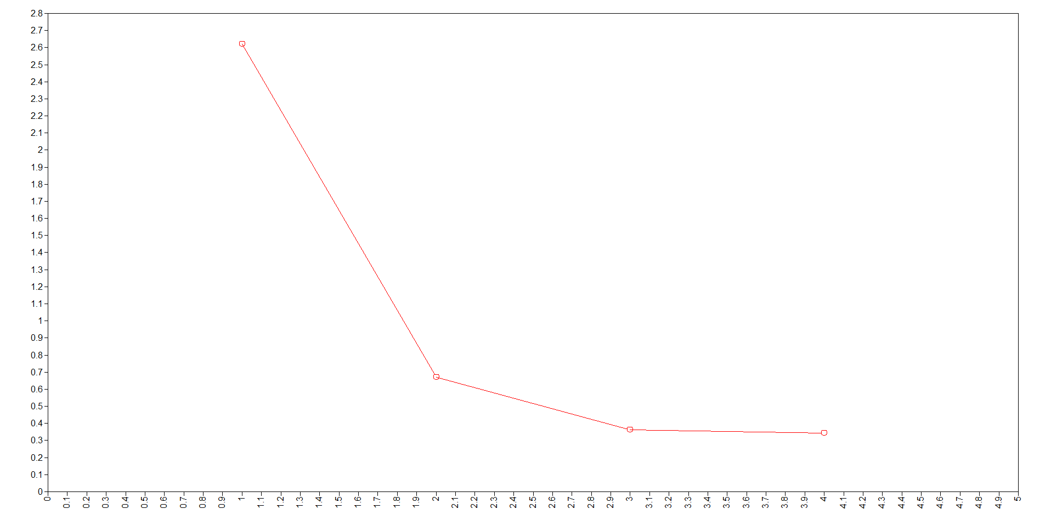

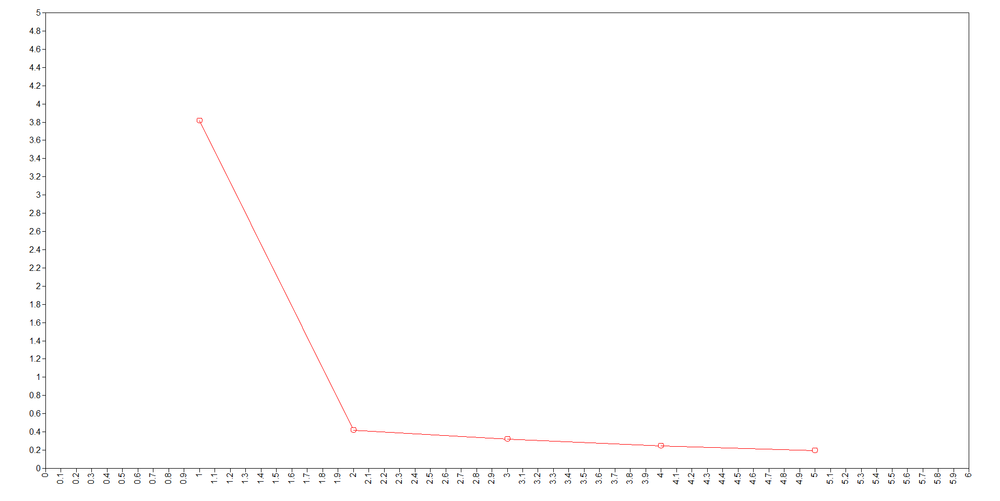Figure D2 Scree plot from factor analysis on perceived student-teacher relations

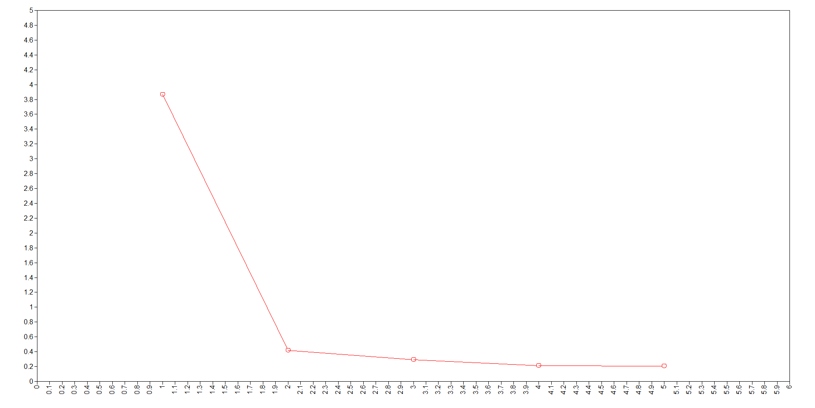Figure D3 Scree plot from factor analysis on perceived disciplinary climate

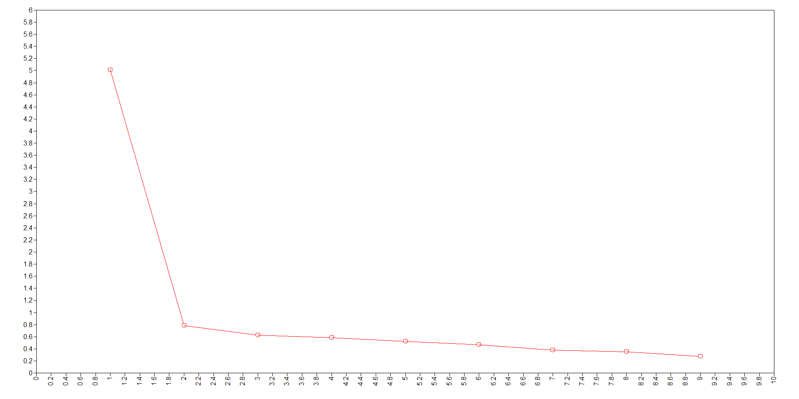Figure D4 Scree plot from factor analysis on perceived teacher quality

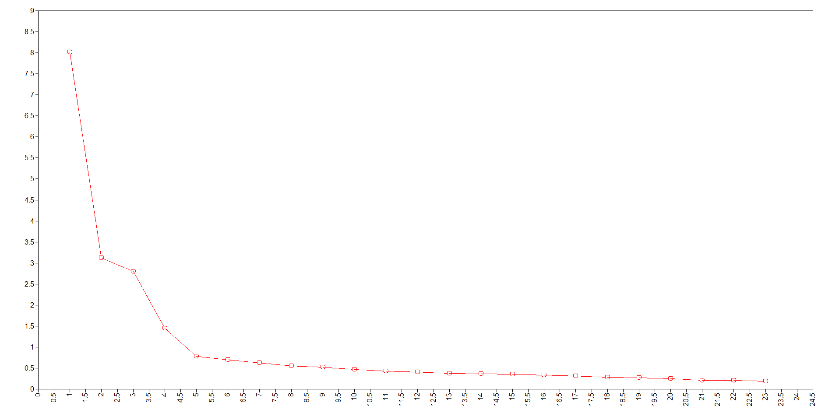Figure D5 Scree plot from factor analysis on overall perceptions of schooling

# References

Australian Bureau of Statistics (ABS) 2011 ‘Education and Indigenous Wellbeing’, cat. no. 4102.0, Australian Social Trends March 2011, Australian Bureau of Statistics, viewed 21 May 2013, <http://www.abs.gov.au/AUSSTATS/abs@.nsf/Lookup/4102.0Main+Features50Mar+2011>.

Edwards, JR & Bagozzi, RP 2000, ‘On the nature and direction of relationships between constructs and measures’, *Psychological Methods*, vol. 5, no. 2, pp. 155-174.

Grace, JB & Bollen, KA 2005, ‘Interpreting the results from multiple regression and structural equation models’, *Bulletin of the Ecological Society of America*, vol. 86, pp. 283-295.

Kline, RB 2011, *Principles and practice of structural equation modeling,* third edition, The Guilford Press, New York.

Lei, P & Wu, Q 2007, ‘Introduction to structural equation modeling: Issues and practical considerations’, *Educational Measurement: Issues and Practice,* vol. 26, no.3, pp. 33-43.

Marjoribanks, K 2005, Family background, adolescents’ educational aspirations, and Australian young adults’ educational attainment, *International Education Journal*, vol 6, no. 1, pp. 104-112

Muthén, LK & Muthén, BO 2010, *Mplus user’s guide, sixth edition*, Los Angeles, CA: Muthén & Muthén.

Strand, S & Winston, J 2008, Educational aspirations in inner city schools, *Educational Studies*, vol.34, no 4, pp. 249-267.

Petter, S, Straub, D, and Rai, A 2007, ‘Specifying formative constructs in information systems research’,  
*MIS Quarterly*, vol. 31, no. 4, pp. 623-656.

Wall, MM & Li, R 2003, ‘Comparison of multiple regression to two latent variable techniques for estimation and prediction’, *Statistics in Medicine*, vol. 22, no. 23, pp. 3671-3685.

Weston, R & Gore, PA 2006, ‘A brief guide to structural equation modeling’, *The Counselling Psychologist*, vol. 34, no.5, pp. 719-751.

1. Academic performance is the average of PISA mathematics performance and reading performance scores. [↑](#footnote-ref-1)
2. [reverse] indicates that this item was reverse-coded when creating the composite perception of schooling scale (see section B of this document). [↑](#footnote-ref-2)
3. A ‘latent’ construct is one that cannot be measured directly (e.g., aspirations, intelligence, etc.). It consists of ‘manifest’ variables that can be measured and are used to proxy the latent construct. [↑](#footnote-ref-3)
4. When examining the effects of mediating variables, the general advantage of using SEM over individual regression models is that all direct and indirect relationships between variables are estimated simultaneously. Moreover, SEM is very efficient at dealing with observations that have partially missing data. [↑](#footnote-ref-4)
5. Similar models were fitted for university aspirations and occupational aspirations. [↑](#footnote-ref-5)
6. The one exception is the ‘background’ construct, where the arrows do in fact point from the latent variable to the observed variables. This is because background is a so-called ‘formative’ construct. A formative construct is *formed* by its measures, as opposed to a reflective construct where the measures are *reflections* of the underlying latent construct (Fornell & Bookstein [1982], cited in Edwards & Bagozzi [2000]). In other words, a formative construct is *defined* by its items, which are assumed to be independent, yet correlated. If one of the items were to be removed, it would affect the meaning of the construct (see Petter et al. [2007] for further explanation). [↑](#footnote-ref-6)